Types of Amendments & Constitutional Amendment Process in India - Indian Polity

Article 368 of the Indian Constitution mentions two types of amendments to the Indian Constitution. One type of amendment is by a special majority of the Parliament (Lok Sabha & Rajya Sabha) and the second type of the amendment is the by a special majority of the Parliament with the ratification by half of the total states. The topic, ‘Types of Amendments’ comes under Indian Polity syllabus of the [IAS Exam](https://byjus.com/ias-exam/) and this article will provide you with the details on it along with the Constitutional Amendment Process in India details.

Amendments of the Indian Constitution – What is Article 368?

To define constitutional amendment process, Article 368 of Part XX of Indian Constitution provides for two types of amendments.

1. By a special majority of Parliament
2. By a special majority of the Parliament with the ratification by half of the total states

But, some other articles provide for the amendment of certain provisions of the Constitution by a simple majority of Parliament, that is, a majority of the members of each House present and voting (similar to the ordinary legislative process). Notably, these amendments are not deemed to be amendments of the Constitution for the purposes of Article 368.

Any of these amendments follow a certain procedure. Hence, this article will talk in detail about the types of amendments in the Indian Constitution, the Constitutional Amendment Process and the scope of amendability.

Types of Amendments in Indian Constitution

The list of types of amendments can be found below. There are three ways in which the Constitution can be amended:

1. Amendment by simple majority of the Parliament
2. Amendment by special majority of the Parliament
3. Amendment by special majority of the Parliament and the ratification of at least half of the state legislatures.

**Recommended Video:**

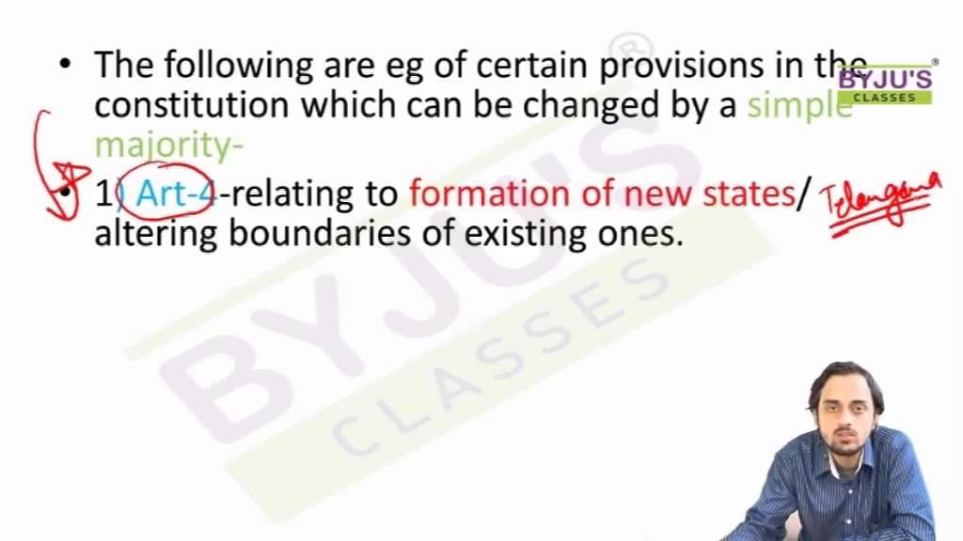

30,525

A brief description of the above types of amendments of the Indian Constitution has been laid down below.

**1. By Simple Majority of Parliament**

A number of provisions in the Constitution can be amended by a simple majority of the two houses of Parliament outside the scope of Article 368. These provisions include:

* Admission or establishment of new states.
* Formation of new states and alteration of areas, boundaries or names of existing states.
* Abolition or creation of legislative councils in states.
* Second Schedule-emoluments,
* Allowances, privileges and so on of the [president](https://byjus.com/free-ias-prep/president/), the governors, the Speakers, judges, etc.
* Quorum in Parliament.
* Salaries and allowances of the members of Parliament.
* Rules of procedure in Parliament.
* Privileges of the Parliament, its members and its committees.
* Use of the English language in Parliament.
* Number of puisne judges in the [Supreme Court](https://byjus.com/free-ias-prep/supreme-court-of-india/).
* Conferment of more jurisdiction on the Supreme Court.
* Conferment of more jurisdiction on the Supreme Court.
* Citizenship-acquisition and termination.
* Elections to Parliament and state legislatures.
* Delimitation of constituencies.
* Union territories
* Fifth Schedule-administration of scheduled areas and scheduled tribes.
* Sixth Schedule-administration of tribal areas.

**2. By Special Majority of Parliament**

* The majority of the provisions in the Constitution need to be amended by a special majority of the Parliament, that is, a majority (that is, more than 50 percent) of the total membership of each House and a majority of two-thirds of the members of each House present and voting. The expression ‘total membership’ means the total number of members comprising the House irrespective of the fact whether there are vacancies or absentees.
* The special majority is required only for voting at the third reading stage of the bill but by way of abundant caution, the requirement for the special majority has been provided for in the rules of the Houses in respect of all the effective stages of the bill.
* The provisions which can be amended by this way include (i) Fundamental Rights; (ii) [Directive Principles of State Policy](https://byjus.com/free-ias-prep/directive-principles-of-state-policy/); and (iii) All other provisions which are not covered by the first and third categories.

**3. By Special Majority of Parliament and Consent of States**

Those provisions of the Constitution which are related to the federal structure of the polity can be amended by a special majority of the Parliament and also with the consent of half of the state legislatures by a simple majority. If one or some or all the remaining states take no action on the bill, it does not matter; the moment half of the states give their consent, the formality is completed. There is no time limit within which the states should give their consent to the bill. The following provisions can be amended in this way:

* Election of the President and its manner.
* Extent of the executive power of the Union and the states.
* Supreme Court and high courts.
* Distribution of legislative powers between
* the Union and the states.
* Any of the lists in the Seventh Schedule.
* Representation of states in Parliament.
* Power of Parliament to amend the Constitution and its procedure (Article 368 itself).

Types of amendments in the Indian Constitution is an important topic under [UPSC Political Science Syllabus](https://byjus.com/free-ias-prep/ias-political-science-and-international-relations-syllabus/) which IAS aspirants may check in the linked article.

 Types of Amendments – Constitutional Amendment Process

The procedure for the amendment of the Constitution as laid down in Article 368 is as follows:

* An amendment of the Constitution can be initiated only by the introduction of a bill for the purpose in either House of Parliament (Lok Sabha & [Rajya Sabha](https://byjus.com/free-ias-prep/the-rajya-sabha/)) and not in the state legislatures.
* The bill can be introduced either by a minister or by a private member and does not require prior permission of the president.
* The bill must be passed in each House by a special majority, that is, a majority (that is, more than 50 per cent) of the total membership of the House and a majority of two-thirds of the members of the House present and voting.
* Each House must pass the bill separately.
* In case of a disagreement between the two Houses, there is no provision for holding a joint sitting of the two Houses for the purpose of deliberation and passage of the bill.
* If the bill seeks to amend the federal provisions of the Constitution, it must also be ratified by the legislatures of half of the states by a simple majority, that is, a majority of the members of the House present and voting.
* After duly passed by both the Houses of Parliament and ratified by the state legislatures, where necessary, the bill is presented to the president for assent.
* The president must give his assent to the bill. He can neither withhold his assent to the bill nor return the bill for reconsideration of the Parliament
* After the president’s assent, the bill becomes an Act (i.e., a constitutional amendment act) and the Constitution stands amended in accordance with the terms of the Act.

Questions from the topic ‘Types of Amendments in Indian Constitution’, have been asked frequently. Candidates preparing for UPSC 2021 must focus on such topics and prepare them according to the upcoming exam.

Scope of Amendability in Indian Constitution

The present position is that the Parliament under Article 368 can amend any part of the Constitution including the Fundamental Rights but without affecting the ‘basic structure’ of the Constitution. However, the Supreme Court is yet to define or clarify as to what constitutes the ‘basic structure’ of the Constitution.

From the various judgements, the following have emerged as ‘[basic features’ of the Constitution](https://byjus.com/free-ias-prep/landmark-cases-relating-basic-structure-constitution/):

1. Supremacy of the Constitution
2. Welfare state (socio-economic justice).
3. Principle of equality
4. Sovereign, democratic and republican nature of the Indian polity.
5. Judicial review
6. Free and fair elections
7. The secular character of the Constitution.
8. Freedom and dignity of the individual
9. Independence of Judiciary
10. Separation of powers between the legislature, the executive and the judiciary.
11. Parliamentary system
12. Limited power of Parliament to amend the Constitution
13. Federal character of the Constitution
14. Rule of law
15. Effective access to justice
16. Unity and integrity of the nation
17. Harmony and balance between Fundamental Rights and Directive Principles
18. Reasonableness