ARCHITECTURAL CHRONOLOGY

HARAPPAN, 2,500 BCE

- Meluha is also the name given to Indus region by Mesopoteans
- The most important features of Harrapan architecture are their superior town planning skills and cities that have been built on a clear geometric pattern or grid layout
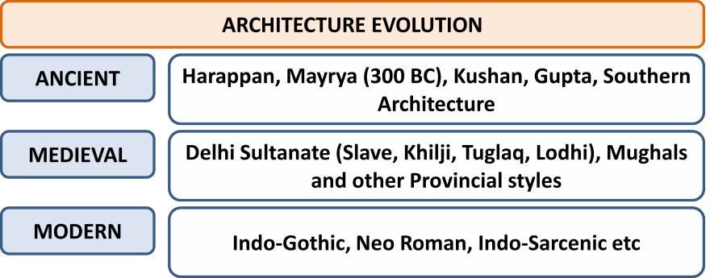
- The Harappan people had constructed mainly three types of buildings
– dwelling houses,
pillared halls and public baths
- Well planned drainage
system which was generally covered and
underground as well. Street drains were also equipped with manholes. Drainage system of
Harappa was more sophisticated than any other civilization and no other civilization has paid so much attention on hygiene as they did.
- Large granaries were found at Harappa and Mohenjodaro.
- All the sites consisted of walled cities which provided security to the people
- Rectangular intersecting roads
- In Egypt dried bricks were used, but in Harappa, burnt bricks were used.
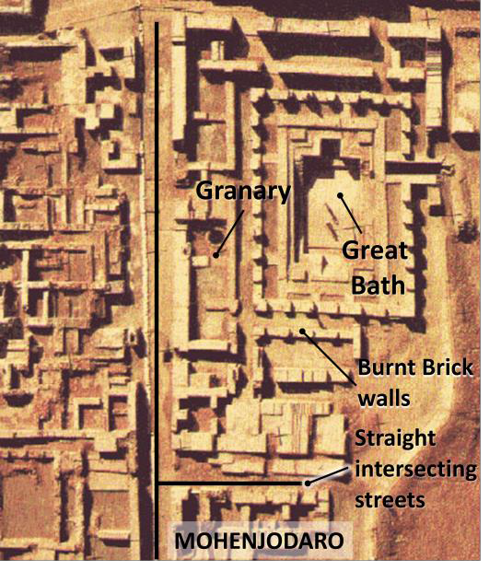
- Most of the cities are divided into citadel – a higher part – and a lower part. Citadels included public buildings including granaries
- Houses made of burnt bricks of uniform sizes
- There are also evidences of big buildings which were perhaps for administrative purposes etc, but there is no proof of temples being built
- Use of stone and wood in buildings also found
- Even double storied houses were there
- Public bath was a common feature – including famous baths like the Great Bath at Mohenjodaro which is significant that most of the houses had private wells and bathrooms.

- Large granaries was another feature of houses and there are also evidences of large public granaries
- There were some specific features at certain places as well. For example, Lothal had a dockyard

VEDIC ARCHITECTURE

- Vedic Aryans were mainly rural society and homes and other buildings were made of perishable materials like wood or clay bricks (Vedic people didn’t use burnt bricks like Harappans, somehow, this knowledge seemed to be lost upon Vedic people) and hence their structures were not very durable like those of Harappan structures.
- The most important feature of the Vedic period was the making of fire altars which soon became an important and integral part of the social and religious life of the people even today. In many Hindu homes and especially in their marriages, these fire altars play an important role even today.

MAURYAN ARCHITECTURE, 3rd Century BCE

- Mauryan architecture exhibits influence of Greeks as Achamaemenian Empire shared borders with Mauryan Empire as well.
- Monolithic Pillars and Capitols and capitols, bell shape of capitol was perhaps influenced by Persian architecture. The monolithic pillar edicts of Asoka with their bell-shaped capitals are somewhat like the victory pillars of the Achamenian emperors which have been found in Persepolis.
  - In Mayryan pillars shaft is made of monolith stone, while in Achaemenid pillars it is made of multiple sandstone pieces. The Mauryan pillars are rock-cut pillars thus displaying the carver’s skills, whereas the Achamenian pillars are constructed in pieces by a mason.
  - Further, Achamenian pillars were not independent, but Mauryan pillars were.
  - Mauryan pillars were made up of Chunar sandstone, taken from Bihar.
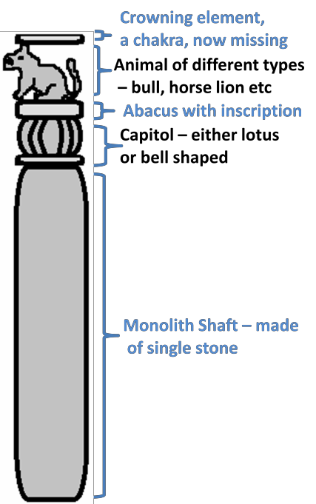
Pillars were erected to mark victories or were symbols of state. Examples are – Bull capitol and Sarnath capitol. Lion capital at Sarnath (now our national emblem) is the most famous of the capitals. This pillar symbolizes Dharmchakraparbartna or
first sermon by Buddha. Capital at Ramparva is another one
apart rom the ones at Nandangarh, Lauriya etc.

- Stupas start during this period with Buddha relics, though there are evidences that they were built during the Vedic period as well. Ashoka is known to have built 84,000 stupas to commemorate various events of Buddha’s life. Stupas at Sanchi and Sarnath were started by Mauryans which were later improved by the other rulers. They were made of brick and were simple with little carvings.
- The ‘rock cut cave architecture’ also made real beginning during Maurya period. Two distinctive features were added by Mauryas – polishing inside the caves and development of artistic gateways. Barabar Hill near Bodh Gaya contains four caves, namely, Karan Chaupar, Lomas Rishi, Sudama and Visva Zopri. Sudama and Lomas Rishi Caves are the earliest examples of rock-cut architecture in India. The Lomash Rishi (with its impressive entrance) and the Sudama caves are examples of such architecture. Lomash Rishi cave was donated to ascetic of Ajeevika sect. These caves cut from solid rock were provided by Ashoka for non-Buddhist monks. Other examples include Nagarjuni Caves, also near Bodh Gaya in Bihar, which has a group of 3 caves (that were also donated to ascetics of Ajeevika sect).

The Edicts of Ashoka are a collection of 33 inscriptions on the Pillars of Ashoka, as well as boulders and cave walls, made by the Emperor Ashoka of the Mauryan dynasty during his reign from 269 BCE to 231 BCE. The Ashokan inscriptions were in local script. Those found in northwest, in the region of Peshawar, are in the Kharoshthi script (derived from Aramaic script used in Iran), near modern Kandhar, the extreme west of empire, these are in Greek and Aramaic, and elsewhere in India these are in the Brahmi script. These inscriptions are dispersed throughout the areas of modern-day Bangladesh, India, Nepal and Pakistan and represent the first tangible evidence of Buddhism. The edicts describe in detail the first wide expansion of Buddhism through the sponsorship of one of the most powerful kings of Indian history. These inscriptions proclaim Ashoka's beliefs in the Buddhist concept of ‘dhamma’ and his efforts to develop the dharma throughout his kingdom. Although Buddhism and the Buddha are mentioned, the edicts focus on social and moral precepts, rather than specific religious practices or the philosophical dimension of Buddhism. Maski edict is a minor rock edict of king ashoka was found in 1919, bearing the name of ashoka instead of Devanampriyadass. This helped to established the fact the devanampriyadass and ashoka were the name of the same king. This minor Rock-edict is the only edict in which Ashoka refers to himself as the king of Magadha.

- In ‘sculptures’ also significant progress was made during Mauryan period. Exquisite Yaksha and Yakshini figures sculpted out of stone and terracotta are prime examples of Mauryan art. Mention of Yaksha and Yakshinis – which are divine figures in folk traditions – are found in many lore of Hindus, Jains, Buddhism etc and even mentioned in Dravidian texts like Shilpaddikam (Yaksh figures are found in many Buddhist stupas, all 24 Jain Teerthankaras are associated with Yakshinis). The most well known of these is the Yakshi from Didarganj, Bihar. Most important characteristic of the Mauryan sculptures is their highly polished surface which is a marvel even today.
- One of the major features of Mauryan sculpture is the terracotta images. Hindu female deities made out of clay have been excavated from Mauryan sites. The forms of the mother goddesses are quite stylish. The sculpture of Sanchi Stupa and the sculpture of Dhameka Stupa in Sarnath are other examples.
- In field of pottery also, Mauryas excelled to the peak and their pottery is known as ‘Northern Black Polished Ware’ in which black color was used with highly lustrous polish. It was a luxury ware and was very mature in its finishing over earlier styles.
- There are no traces of secular or royal buildings made during Mauryan period, but Megasthenes, the Greek ambassador of Selucas Nikator who visited the Mauryan court described Chandragupta Maurya’s palace as an excellent architectural achievement. It was a large palace carved out of wood and this was the reason that such buildings couldn’t survive.

SUNGA, 185-75 Century BCE
- Art was primarily oriented to Buddhist themes and Jataka tales.
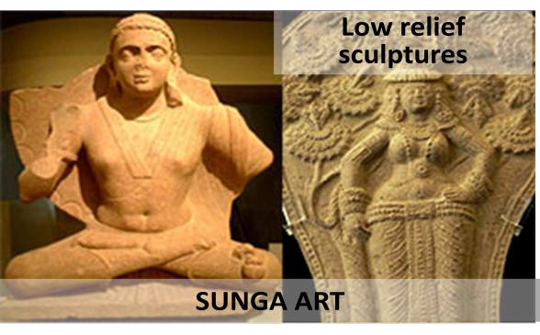
- Bharhut stupa was built by them and they also built highly engraved railing and other parts of Sanchi Stupa as well.
- Stupa at Sanchi has upper as well as lower pradakshinapatha or circumambulatory path.
- The sculpture is not in bold relief.
- Both the male and female figures are adorned with a large number of ornaments.
- Drapery is somewhat heavy and not light as is the case with the sculptures of later periods.
- No efforts seem to have been made for expressing emotions and abstract feelings like peace, serenity, temptation, surprise, sobriety etc.
- Normally, the eyeballs are conspicuous by their absence.
- Female figures are seen decorating their headgears with wreaths and garlands, beads and pieces of cloth.

KUSHAN, 60-240 Century AD

- The emperor himself was a divine authority and Kushan was the first Indian king to issue gold coins at a large scale
- Buddha was first time given a human form during this time
- The Kushans fostered a mixed culture that is best illustrated by the variety of deities – Greco- Roman, Iranian, and Indian –invoked on their coins. At least two major stylistic divisions can be made among artifacts of the period – imperial art of Iranian derivation and Buddhist art of mixed Greco-Roman and Indian sources – mainly Mathura School and Gandhara School. The best examples of the former are gold coins issued during that time.
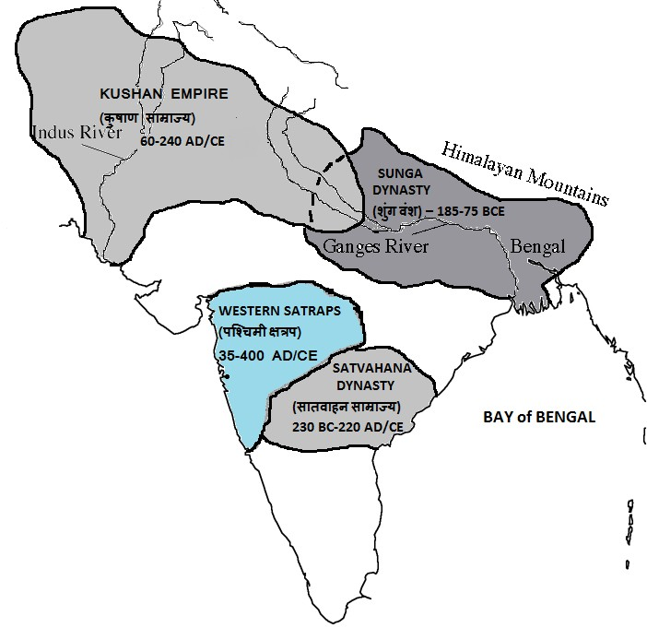

GANDHARA SCHOOL of ART
It was here that Buddha was first represented in human form. Sculpture tradition of Gandhara has confluence of Bactria, Parthia and local Gandhara traditions. Thus, the new Gandhara style of art that developed in sculpture was a fusion of Greco- Roman/Hellenisitc and Indian styles from the 1st to the 5th century. Gandhara art, named after the region of Gandhara now in Pakistan, presents some of the earliest images of the Buddha.
The Bamyan Buddha of Afghanistan were also example of the Gandhara School. Taxila, which is also in Pakistan now, was also another important center of Gandhara art. Kanishka, the greatest of the Kushanas was a great patron of art and architecture.

In all the Buddha depicted in the Gandhara Art is shown making four types of hand gestures and this is a remarkable feature in this art. The gestures are as follows:

  - Abahayamudra: Don’t fear
  - Dhyanamudra: Meditation
  - Dharmachakramudra: A preaching mudra
  - Bhumisparshamudra: Touching the earth.

The characteristic features of the Gandhara School of art were –

    - The subject was Indian
    - The form of art was foreign.
The Gandhara sculptors made images of Lord Buddha in the Greco-Roman style. The images of Buddha resembled Greek God Apollo. Buddha from the Kushan period has Apollonian faces, their hair is in the Graeco-Roman style and their draperies arranged in the style of a Roman toga.

The Gandhara School is represented in sculptures, stucco, and clay as well as in mural paintings. Grey sandstone is primarily used in Gandhara School of Art. The other materials used were Mud, Lime, Stucco (a type of plaster).

The greatest of all Gandhara stupas as the one erected by Kanishka outside the gates of modern Peshawar.

MATHURA SCHOOL OF ART

It is the Buddhist art during times of Kushana and it was largely indegenous.The Mathura School of Art was a result of the religious zeal of Brahmanism, Jainism and Buddhism. It was inspired by the early Indian Buddhist arts of Bharhut and Sanchi of MP.

The material used in this school was the spotted red sandstone.

The image of the Buddha from the Katra mound belongs to the second century CE is one of the most famous examples of this style. It represents the Buddha with two Boddhisattva attendants which are identified as Padmapani and Vajrapani as one holds a lotus and the other a vajra (thunderbolt). The Buddha is seated in padmasana (cross- folded legs) and the right hand is in the abhayamudra, raised a little above the shoulder level whereas the left hand is placed on the left thigh.

The Jina image and Indigenous style of Buddha’s image was a remarkable feature of Mathura art. The Sarvatobhadrika image of 4 Jinas standing back to back also belongs to the Mathura school. The Standing Buddhas of the Sravasthi Sarnath and Kausambhi also belong to the Mathura School.

Buddha image at Mathura is modeled on the lines of earlier Yaksha images whereas in Gandhara it has Hellenistic features.

The garments of the body are clearly visible and they cover the left shoulder. However, in the second century AD, images got sensual with increased rotundness and became flashier. The extreme fleshiness was reduced by the third century AD and the surface features also got refined. The halo around the head of Buddha was profusely decorated.

Another most famous sculpture is the headless statue of Kanishka from Mathura. It shows that, art was now not confined to religious purposes only.

Later this school also imbibed some elements of Gandhara art also.

MATHURA vs GANDHARA SCHOOL

Both were under the reign of Kushans, still there are some differences –

- Mathura School has more indigenous component. The Buddha image at Mathura is modeled on the lines of earlier Yaksha images whereas in Gandhara it has Hellenistic features.
- Gandhara art is primarily Buddhist art, but Mathura art also deals with subjects from Hinduism (both Vaishnav and Shavite images) and Jainism as well. Images of Vaishnava (mainly Vishnu and his various forms) and Shaiva (mainly the lingas and mukhalingas) faiths are also found at Mathura but Buddhist images are found in larger numbers. Further, the images of Vishnu and Shiva are represented by their ayudhas or weapons.
- Location – Gandhara is in today’s Pakistan, Mathura is in India
- The expression ofcalmness is the centre point of attraction of Gandhar Buddha. Gandhar Buddha is primarily spiritual in a serious mood sitting in a ‘Yogic’ mudra, Mathura Buddha is delighted in mood, seated in Padmasana and right hand in Abhyamudra and left hand on left thigh showing masculinity. Gandhar Buddha is also bearded and bears moustaches, while Mathura Buddha has a shaven face and
head. Gandhara Buddha has wavy hair, large forehead with a proturbance on forehead signifying Buddha knows all, while Mathura Buddha. Mathura Buddha is also shown with an ornate halo.
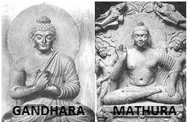
- Mathura tradition, Buddha images have longer ear lobes, thicker lips, wider eyes and prominent nose. In Gandhara images, eyes are longer; ear lobes shorter and noses sharper and better defined.

  - Mathura Buddha is also often shown accompanied by two Bodhisattvas – Padmapani
holding lotus and Vajrapani holding thunderbolt
  - Mathura Schools typically used red stone for making the sculptures, while Gandhara sculptures use grey sandstone, stucco (lime plaster).
  - Most scholars are believed that Gandhara images of Buddha are earlier to those of Mathura.
  - Halo of Mathura Buddha is more elaborately carved.
  - Earlier, Mathura Buddha was more fleshy, but later grew slender, probably as a result of confluence of two schools.
  - The Mathura school contributed clothes covering the left shoulder with thin muslin, the wheel on the palm, the lotus seat, etc.

AMRAVATI or SATVAHANA STYLE, 200 Century BCE to 200 Century AD

- The third type of sculpture art – apart from Gandhara and Mathura – that flourished around the Kushana time was Amaravati School of art in the Andhra Pradesh under patronage of Satvahanas or Andhra dynasty and later under Vakatakas.
- This was focused on Buddhist art and architecture and later also on Brahmin art. Stupas and sculptures were central to this art. Amravati Stupa is one of its magnificent examples was also known as Mahachaitya Stupa.
- Marble was used in this art and the themes were Buddha’s life and Jatakas tales in which Buddha is depicted in human as well as animal form, unlike
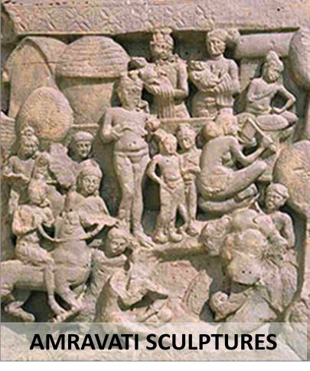
Kushan art in which figures of Buddha are mainly sculpted. Central characters are human beings, animals and kings, princes and palaces figure prominently.
- Later, Lord Buddha is also depicted in a human form with superhuman qualities. In one of the panels, he is shown as subduing an elephant.
- Nagarjunkonda is another place that is famous for Buddhist architecture which was an offshoot of Amravati school.
- Unlike Kushan art, it was indigenous in nature with no Greeko-Roman influence. Further, unlike Mathura art, it was mainly Buddhist art.
- Sculptures are not individual, but in narrative form in form of panels depicting events from life of Buddha and Jataka tales

GUPTA ARCHITECTURE, 300-550 Century AD

- Gupta period marked the real beginning of temple architecture in India and is known as the golden period of Indian art. Hindu subjects became focus of the art for the first time. The Gupta period marks the beginning of the construction of free-standing Hindu temples. For the first time they initiated permanent materials like brick and stone, instead of perishable materials like bamboo, wood etc in temple buildings.
- Gupta temples were durable as they were made out of durable material.
- Brics temples were started to be made during the Gupta period – Bhitragaon near Kanpur, Bhitari near Gazipur, Deogarh near Jhasi are some examples. The Bhitargaon Temple is a terraced brick building fronted with a terracotta panel. Built in the 6th century during the Gupta Empire, it is the oldest remaining terracotta Hindu shrine with a roof and a high Sikhara.
- Temple style during Gupta period evolved in various phases. Earliest temples used to have flat roofs. Later, square temples emerged – such as Vishnu and Varaha temples at Eran in Vidisha. Example of square temples with pradakshina path include Shiva temple at Bhumara, Madhya Pradesh. They also had a covered ambulatory path and main building was on a raised platform. In third phase most of the earlier features were retained and new features were added – now low curvilinear shikharas were introduced and apart from main shrine, subsidiary shrines were also built and main temple was build on a crucified platform – this style is generally termed as ‘Panchayatan’ style. Examples include Dashavtara temple at Deogarh near Jhansi and Durga temple near Aihole in Karnataka. Later, circular temples with shallow rectangular projections were also made – for eample – Maniyar Math at Rajgir.
- Gupta style of temple architecture is also said to have given birth to many sub-styles like – Odisha School (Konark, Lingraja, Jagannath Puri etc), Khajuraho School, Solanki School of Rajasthan and Gujarat etc.
- In UP, Dashavatara temple from 6th century is there in Deogarh belonging to late Gupta period
and due to presence of a curvilinear tall rekha-deol (or rekha-prasada) type shikhara, it is one of the earliest classical examples of Nagara style. This temple is in the panchayatana style of architecture where the main shrine is built on a rectangular plinth
with four smaller subsidiary shrines at the four corners (making it a
total number of five shrines, hence the name, panchayatana). There are three main reliefs of Vishnu on the temple walls – Sheshashayana (form of Vishnu where he is shown reclining on the sheshanaga) on the south, Nara-Narayan (shows the discussion between the human soul and the eternal divine) on the east and Gajendramoksha (is the story of achieving moksha, with an asura shown as an elephant) on the west.
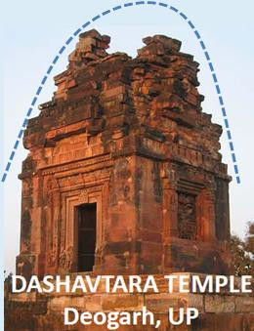
- In many forests of central India also, examples of Gupta are have been found, especially in the Bundelkhand region. These include the one at Bhitargaon in Kanpur district.
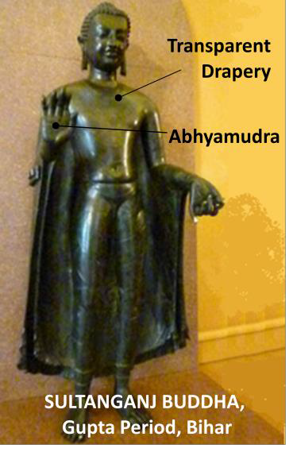
- Guptas were tolerant and encouraged other religions also. While early Gupta period Hindu architecture was largely promoted, later Bhuddhist and Jaina architecture was also promoted. In fact, Buddhist art reached its climax during Gupta period.
- Gupta period is also marked by development of sculpture art.
Buddhist, Hindu and Jain sculptures were profusely made. A new school called Sarnath School emerged. Cream colored sandstone was used in it. At Sarnath, Buddha is shown standing, seating as well as in other positions as well. Buddha here is shown in calm position smiling and eyes partly closed unlike Gandhar Buddha which is mainly only in seated position and is in somber mood. From Besnagar a relief of Goddess Ganga is found, from Gwalior flying Apsaras are found. From Khoh, Ekmukhi shivlinga has been discovered. Even metal sculptures were developed during this period, for example – Sultanganj Buddha. Majority of metal sculptures of Buddha in North are shown in Abhyamudra.
  - Cave architecture and paintings also reached their zenith – Ajanta caves, Ellora caves, Bagh caves near Bagh river in Madhya Pradesh, Junagarh Caves, Nashik Caves are examples. Junagrah caves have a uniqueness that they have a citadel called ‘uparakot’ apart from a lower prayer hall. Nashik Caves are also unique as they are primarily Hinyana Buddhist caves from around 1st century AD and Buddha is shown in form of symbols, there are 23 such caves and are termed as ‘Pandav Leni’. There are caves in Mandapeshwar caves also which are the only Brhamnical caves converted to Christian caves and these probably belong to rather post-Gupta period.
  - The artistic achievement of the age is also exhibited in the delicate workmanship and the variety of designs shown in different kinds of Gupta coins. The general scheme that was followed was to exhibit the portrait of the king on one side of the coin or an appropriate deity.

CHALUKYA ARCHITECTURE, or KARNATAKA ARCHITECTURE 550-1100 Century AD

They followed the Vakatakas who themselves folled Satvahanas. Chalukyas included three individual yet related dynasties. The first one was the Badami dynasty who ruled from Vatapi. Then came the Eastern Chalukyas who ruled over Deccan. The Western Chalukyas ruled from Kalyani. Finally, decline of Western Chalyukyas led to rise of Hyosalas in 12th century. The basic plan of the Western Chalukya style originated from the older Dravida style, many of its features were unique and peculiar to it. The Western Chalukya temples were smaller than those of the early Chalukyas.

Chalukya Art is often taken synonymous with Vesara style; however they had architecture in distinctively Dravidian style as well. It is also known as Karnataka style. It is distinctly different from contemporary western Deccan or Vakataka styles seen at places such as Paunar and Ramtek.

The hybridisation and incorporation of several styles was the hallmark of Chalukyan buildings.
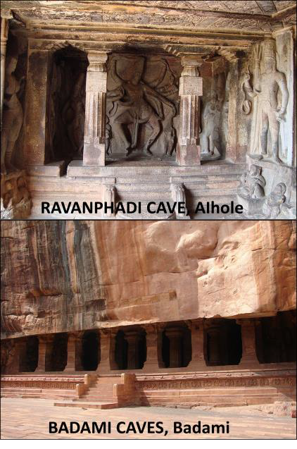
Since this style is a hybrid, it retained two major components of the Dravid style – Vimana and Mandapa. Unlike Dravida style, the ambulatory path is not covered in this style.

BADAMI CHALUKYA ARCHITECTURE

Earliest Chalukyas settled around Badami/Vatapi in Karnataka in around 550 CE in 6th century. Chalukya style originated in Aihole and was perfected in Badami and Pattadakal. Temples at Pattadakal are both Hindu and Jain temples. The Chalukya artists experimented with different styles, blended the Indo-Aryan Nagara and Dravidian styles, and evolved Chalukya style. Their style includes two types of monuments –

    - The rock cut halls (caves) – earlier style – They were executed by the early Chalukyas of Badami. Early experiments in rock cut halls were attempted in Aihole where they built three cave temples, one each in Vedic, Buddhist and Jaina styles. Aihole is also a palce of inscription which mention exploits of King Pulkeshin II. In Ravan Phadi cave at Aihole, there are exquisite sculptures, among which, Natraja is most famous one. Later they refined their style and cut out four marvelous cave temples at Badami. Badami cave temples are composed of four caves, all carved out of the soft Badami sandstone on a hill cliff in the late 6th to 7th centuries. The temple caves represent different religious sects. Among them, two are dedicated to god Vishnu, one to god Shiva and the fourth is a Jain temple. Each cave has a sanctum sanctorum, a mandapa, a verandah and pillars. The architecture includes structures built in Nagara Style and Dravidian style. The cave temples also bear exquisite carvings, sculptures and beautiful murals.
    - Structural temples – Earliest examples of the finest structural temples of Badami Chalukyas are located in Pattadakal. Of the ten temples in Pattadakal, six are in Dravidian style and four in Rekhanagara style. The Virupaksha temple in many ways holds resemblance to the Kailasanatha temple in Kanchipuram which came into existence a few years earlier. Papanath temple is another famous temple at Pattadakal.
Badami Chalukya temples are highly ornate and exquisitely carved. Chalukya temples are known for their extensive variations and experimental styles. Their major features and variations are –

      - Virupaksha Temple and other temples at Pattadkal are made in Dravida style with elements of Kanchipuram and Mahabalipuram temple style, it has a square pyramidical vimana. This most elaborates of all Chalukyan temples at Pattadakal was made during the reign of Vikramaditya II around 740 CE.
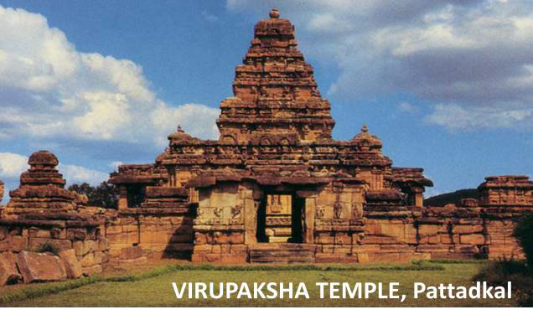
      - Eastern Chalukya temples like Mahakuta Temple near Badami and Swarga Brahma Temple near Alampur show influence of Odisha and Rajasthan style i.e. Nagara style.
      - Durga Temple near Aihole show influence of Buddhist style and reminds one of Chaitya halls and a shikhara like that of Nagara temples.
      - Lad Khan Temple at Aihole is inspired by wooden roof temples of hills, but made of stone instead of wood.

EASTERN CHALUKYA ARCHITECTURE
Eastern Chalukyas, or Chalukyas of Vengi, were a South Indian dynasty whose kingdom was located in the present day Andhra Pradesh. They ruled from 7th century to 12th century. Their rule is said as the golden period of Andhra. The Eastern Chalukyas, following the Pallava and Chalukya traditions, developed their own independent style of architecture, which is visible in the Pancharama shrines (especially the Draksharama temple) and Biccavolu temples. The Golingeswara temple at Biccavolu contains some richly carved out sculptures of deities like Arthnariswara, Siva, Vishnu, Agni, Chamundi and Surya.

WESTERN CHALUKYA ARCHITECTURE

Western Chalukyas or Chalukyas of Kalyani or the last Chalukyas were last in terms of evolution Chalukya dynasty. In 11th and 12th century and they flourished in area around Tungbhadra river in Karnataka.

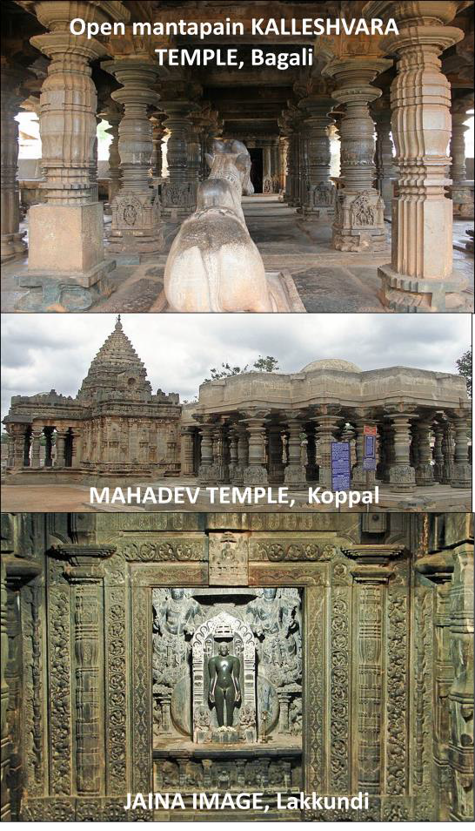
Most notable of the many buildings dating from this period are the Mahadeva Temple at Itagi in the Koppal district, the Kasivisvesvara Temple at Lakkundi in the Gadag district, the Mallikarjuna Temple at Kuruvatti in the Bellary
district and the Kallesvara Temple at Bagali in the Davangere district. The centre of these architectural developments was the region encompassing the present-day Dharwad district.

In contrast to the buildings of the early Badami Chalukyas, whose monuments were centered around the areas of Pattadakal, Aihole, and Badami, these Western Chalukya temples are widely dispersed, reflecting a system of local government and decentralisation.

The surviving Western Chalukya monuments are temples built in the Shaiva, Vaishnava, and Jain religious traditions.

Sometimes called the Gadag style of architecture, Western Chalukya architecture is considered a precursor to the Hoysala architecture of southern Karnataka.

Chalukyan temples fall into two categories — the first being temples with a common mantapa (a
colonnaded hall) and two shrines (known as dvikuta), and the second being temples with one mantapa and a single shrine (ekakuta).

Often temples are so ornate with the sculptures that architecture is shadowed by it.
Ground plan used in these temple varies and uses hexagonal, octagonal and star shaped base.

The Western Chalukyan architects retained features from both northern and southern styles. However, in the overall arrangement of the main temple and of the subsidiary shrines, they inclined towards the northern style and tended to build one main shrine with four minor shrines, making the structure a panchayatna or five-shrined complex. Chalukyan temples were, almost always, built facing the east.

Legacy of Chalukya architecture was later carried on by Hyolsalas.

RASHTRAKUTA, 700-950 Century AD

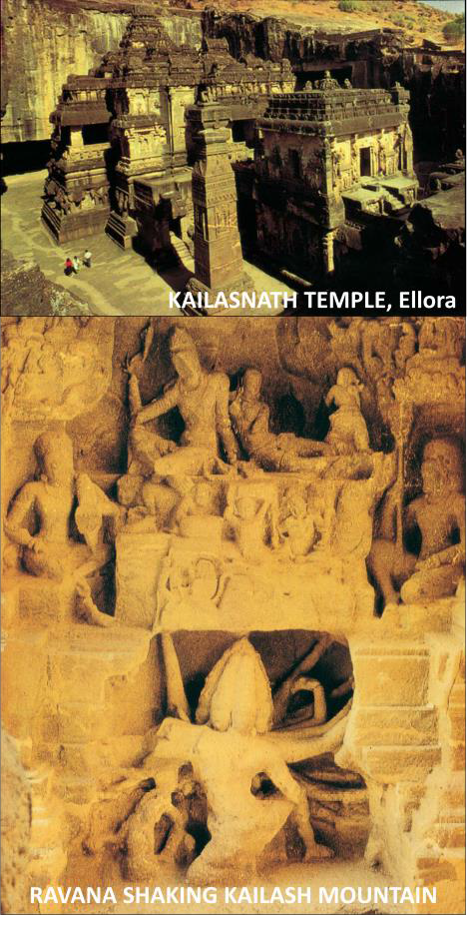
By about 750 CE, the early western Chalukya control of the Deccan was taken by the Rashtrakutas. Their greatest achievement is the Kailashnath temple at Ellora. They also built some temples at Elephanta. They gave patronage to both Jaina and Hindu art.

The Rashtrakutas built well-known Jain temples at locations such as Lokapura in Bagalkot district and their loyal feudatory, the Western Ganga Dynasty, built Jain monuments at Shravanabelagola and Kambadahalli.

Their architectural activities can be categorized into three groups –

- Ellora and Elelphanta – Many Jainist caves were also made apart from Hindu caves at Ellora. Kailasnath temple at Ellora is said to be a culmination of at least a millennium-long tradition in rock-cut architecture in India and the huge temple is cut out from a single rock. It is a complete dravida building with a Nandi shrine – since the temple is dedicated to Shiva – a gopuram-like gateway, absence of tall shikharas, surrounding cloisters, subsidiary shrines,
staircases and an imposing tower or vimana rising to thirty metres. The sculpture of the Rashtrakuta phase at Ellora is dynamic, the figures often larger than life-size, infused with unparalleled grandeur and the most overwhelming energy. Ravana shaking Mount Kailasha sculpture is a masterpiece of this temple and is an epitome of Indian sculpture art.
- Around Badami, Aihole and Pattadakal – In Karnataka their most famous temples are the Kashivishvanatha temple and the Jain Narayana temple at Pattadakal.
- At Sirval near Gulbarga – Many of these temples were build using a star base.

PALLAVA ART and ARCHITECTURE, 2nd – 9th Century AD

The Pallavas were one of the ancient South Indian dynasties that were active in the Andhra region from the second century CE onwards and moved south to settle in Tamil Nadu. They were influenced by Amravati architecture. Pallavas were the first recognizable South Indian dynasty which indulged in the pursuit of architectural innovations. The first seeds of Dravidian temple architecture were possibly sown during this period which later influenced Chalukyas and other Dravidian dynasties like Cholas also.

Although they were mostly Shaivite, several Vaishnava shrines also survived from their reign and they were also not untouched by the Buddhist tradition that was prevalent in Deccan.

The Pallavas were instrumental in the transition from rock-cut architecture to stone temples in South. Their early buildings, it is generally assumed, were rockcut, while the later ones being structural. Three phases of Pallava architecture can be divided as –
  - The earliest examples of Pallava constructions are rock-cut temples dating from 610– 690 CE called ‘mandapas’ and later structural temples between 690–900 CE. The early buildings are generally attributed to the reign of Mahendravarman I (also known as Mamlla and that why
Mahabalipuram is renamed as Mamllapuram), a contemporary of the Chalukyan king Pulakesin II of Karnataka. Famous caves are
– Durga Cave with figure of Mahishasurmardini, Panchpandava Cave showing Krishna lifting Govradhana. They were made under reign of Mahendravarman.

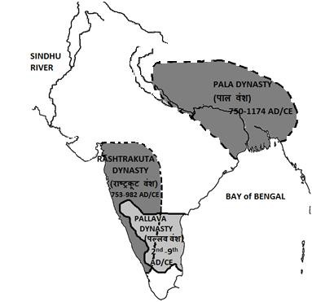
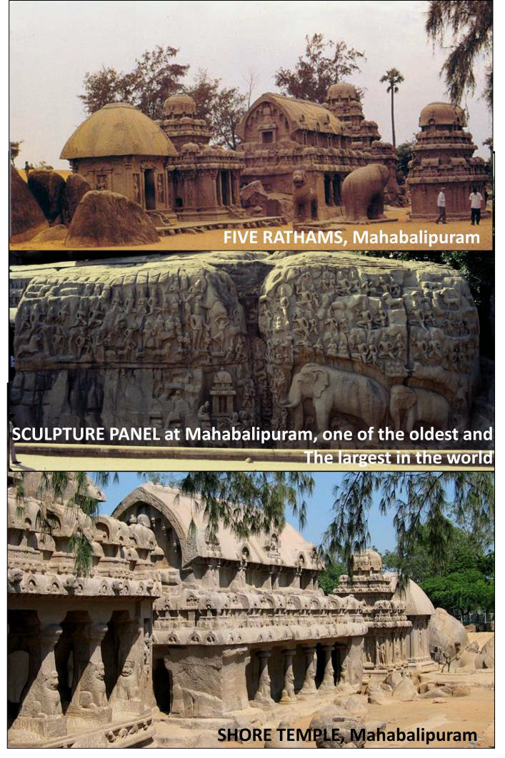
  - Famous shore temples in Mahabalipuram are another example of their architecture which were built around in 8th century. Five monolithic temples are called ‘ratham’ (instead of Mandapam) are now under UNESCO World Heritage List. Biggest is called Dharamraj Ratham and smallest one is called Draupadi Ratham. They were made under reign of Narsimha Varman II. They have signs of early gopurams as well. A significant part of the temples have been eroded by moisture laden winds over the years. A sculpture panel which is 30 meters long is one of the largest and the oldest in the world which is interpreted differently by different people – arrival of Ganga from celestial space; penance of Arjuna inspired from Keeratarjunaya – a work of Bharavi who was an important Pallava poet.
  - The Pallavas also built structural temples like the Kailashanath and Vaikunthperumal temples at Kanchipuram.

  - The Kailashanath temple is a huge structure with thousands of images and is said to be the ‘largest single work of art ever undertaken in India’.
Early temples were mostly dedicated to Shiva. They laid an important cornerstone in Dravidian style of architecture which was followed by Chola during which it reached to its zenith. It can be said that the project Dravidian architecture was initiated by Pallavas, but was closed by Cholas.

EASTERN ARCHITECTURE

Temple architecture in East has three broad distinct styles in – Assam, Bengal and Odisha or Kalinga.

PALA ART, 8th – 11th Century AD

Pala school of Bengal was one influenced by Vajryayan Buddhism in Bengal and Bihar region and architecture and art of Gupta and local traditions as well. Later effect of Gupta style was minimized and it developed its own distinctive style.

Their architecture was both Hindu and Buddhist. Architecture had fine finish and figures were much decorated and well polished. The gigantic structures of Vikramshila Vihara, Odantapuri Vihara and Jagaddala Vihara were masterpieces of the Palas. The Pala King Dharamapala had established the Somapura Mahavihara, which is largest Buddhist Vihara in the Indian subcontinent (now in Bangladesh). They also established Vikramshilla university for study on Vajrayana Buddhism.

Pala also contributed to the Mahabodhi complex in Bodhgaya and enhanced the original shrine which was built by Chandragupta Maurya.
Hindu temples made during this time were known to be in Vanga (stood for ‘Banga’) Style. Siddheshwara Mahadev temple in Burdhwan district is one of the famous examples of early Pala style and was similar to Odisha style and has a quite tall shikhara crowned by a large amalaka (disk shape). Many of the temples from the 9th to the 12th century were located at Telkupi in Purulia District as well.

Sculptures tradition was influenced by Gupta tradition from Sarnath etc and they were predominantly stone made, but metal sculptures have also been found. But stone sculptures are polished so well that even they appear metal sculptures. The main feature of Pala sculptures is their free flowing movement. Almost all the figures are of similar sizes and were carved out of grayish or white spotted sandstone. Although Buddhist sculptures dominated, sculptures from secular themes and Hindu deities were also made. Image of Hari-Hara from Burdwan is an example.

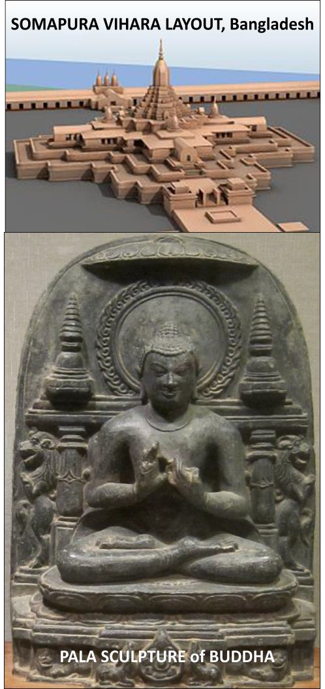
Apart from stone sculptures, their terracotta sculptures were also unique and they were used for decoration of walls. Besides the religious themes several images representing daily life are also to be found on these terracotta plates or plaques.

They also promoted paintings which in a way heralded miniature paintings in East India. Colors were symbolic and with subdued lines. However, this was not true miniature and was largely a compact form of murals. They were generally made on palm or paper manuscripts. The 10th century illustrated Buddhist text, Prajnaparamita, is the earliest known example of painting where a canvas of micro, or miniature size made its debut. They are said to have pioneered miniature school in India which illustrated Vajrayana Buddhism.

ODISHA or KALINGA TEMPLES ARCHITECTURE, 8th – 13th Century AD

Odisha was a center of religious activity since long and many Ashokan edicts were built there. Jaina caves of 2nd century BCE are also found here. Shatrughaneshwara temples of 6th century CE are also found belonging to Pashupat Shavivite sect.

In Odisha, temples are built in a sub-style of Nagara in which Shikhara (called deul in Odisha) is almost vertical before it curves near the top. Shikhara is preceded by a mandapa (which is called Jagmohan or ‘dance pavilion’ in Odisha). Plan of temple is usually square and there is a boundary wall as well. Temple gets curved gradually as we go up and is finally crowned by a circular part called ‘Mastak’. Temples are decorated from outside, but are simple from inside.

The main architectural features of Odisha temples are classified in three orders, i.e., rekha deul, pidha deul and khakhara deul. Most of the
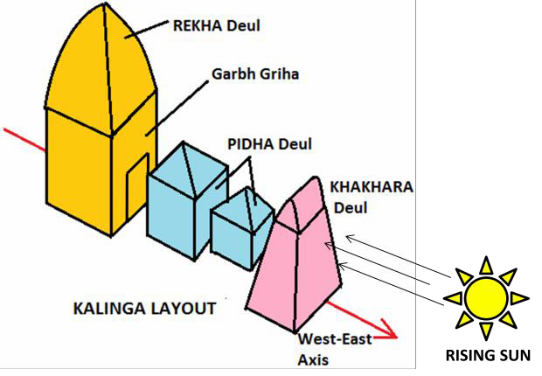
main temple sites are located in ancient Kalinga – modern Puri District, including Bhubaneswar or ancient Tribhuvanesvara, Puri and Konark.

The Rajarani temple is an example and was built around 1000 CE in Bhubneshwar. This temple is unique in Indian architecture, because it is believed that this temple led to development of the architecture of other
temples of central India, particularly, Khajuraho. It is also known as ‘love temple’ on account of the erotic carvings of maidens and mithunas in the temple.

Lingaraja Temple of Bhubneshwara is one of the prominent temples. It is made in Nagara style and has four halls – for offerings, dance, assembly and sanctuary. The present temple was probably built by the rulers of the Somavamshi dynasty as a Shaiva temple but with the arrival of the Vaishnavite Ganga dynasty, the temple was remodelled and elements of Vaishnavism were inculcated in it. Thus, the temple deity came to be known of Harihara (Hari=Vishnu, Hara=Shiv), a mixed form of Shiva and Vishnu. The consort of Hari Hara is Bhubneshari.
Sun Temple of Konark near Puri is also known as Black Pagoda (as the gate is made of black sandstone and first rays of sun enter through these gates) is one of the greatest Hindu temples and was built in 13th century. It is set on a higher base. It is said to have the highest shikhara, which crumbled under its own weight in 19th century. It resembles the celestial chariot of sun and has rath with wheels which is pulled by horses. It has 12 pairs of wheel (which used to move) drawn by 8 mythological horses of sun god.It was erected by King Narsinmha Dev of Eastern Ganga Dynasty. Scene of loving couples – mithuns – is one of the distinctive features of temple.
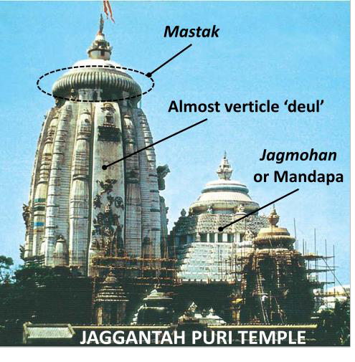
Jagganath Puri Temple is another fine example of Kalinga Art.

Features of Kalinga temple architecture –

      - They are primarily from Nagara style.
        - Later temples of Odisha don’t have pillars and the roof is partially supported by Iron girders.
        - Usually outer part is highly adorned and inner part is left unadorned.
        - Shikharas are called ‘Deul’ which is highly vertical before it sharply curved inside and mandapas are called ‘Jagmohan’ and temples have an outer boundry wall as well.
        - In Odisha are three types of Deula viz. Rekha Deula, Pidha/Bhadra Deula and Khakra Deula (It is a rectangular building with a truncated pyramid-shaped roof, like the gopuras.). The Rekha Deula means a shrine with different parts in a line (vimana, hall, entrance etc).
        - Ground plan of main temple is square.
        - In Odishan style, sanctum, vestibule and assembly halls are usually separate unlike typical Nagara style temples in which they are part of a single structure as in Khajuraho temples.

AHOM STYLE, 12th – 14th Century AD

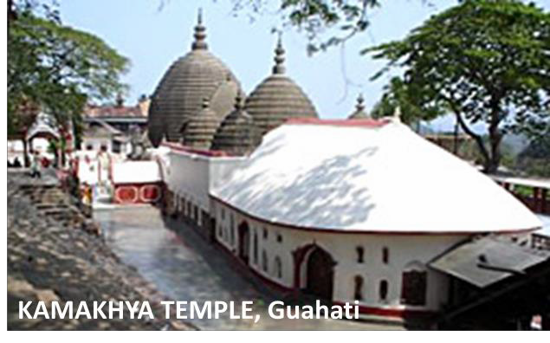
In Assam, by the twelfth to fourteenth centuries, a distinct regional style developed. The style that came with the migration of the Tais from Upper Burma mixed with the dominant Pala style of Bengal and led to the creation of what was later known as the Ahom style (due to patronage by Ahom kings) in and around Guwahati. Kamakhya temple, a Shakti Peeth, is dedicated to Goddess Kamakhya and was built in the seventeenth century.

CHOLA ART, 9th – 13th Century AD
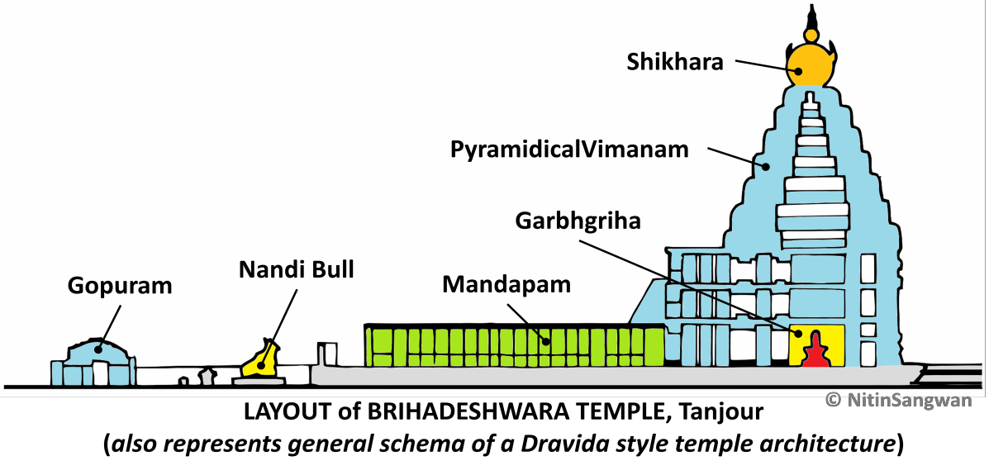

Their architecture was influenced by their predecessors Pallavas. Karikala was the most important ruler of this kingdom. He defeated the combined forces of the Cheras and the Pandays. Cholas emerged as one of the most powerful dynasty in South that ever ruled. Their unique achievements also lie in their conquests across the seas, maintenance of powerful navies. Rajendra Chola is said to have conquered some Indonesian islands as well. They also developed democratic institutions for governance at the village level. The village panchayat called sabha or ur had extensive powers, including financial powers, during their times. It was in fact the most remarkable administrative achievement of the Cholas and it is mentioned in Uttaramerur inscription.

Nataraja Image shows Siva in his cosmic dance. In this dance, he creates and destroys the world. There is an oval ring around the original figure of Shiva Nataraja. It represents the cosmic fire he uses to destroy the universe as part of the cycle of destruction and creation. Shiva’s third eye represents his cosmic knowledge. The Hindu deity is depicted with multiple arms to illustrate divine power. Shiva Nataraja’s four arms each take a different position or hold symbolic objects, showing his strength and constellation of skills. On Shiva’s right ear is an earring depicting a makara, a mythical water creature. His left ear is adorned with a circular earring worn by women. The pair represents Shiva’s male and female aspects (Ardhnarishwar) – illustrating the cosmic balance of male and female energies. The open palm of Shiva’s right hand forms the abhayamudra, or hand gesture, signifying that the worshipper need have no fear. In one hands, he has Damaru, that Shiva beats a rhythm that brings the universe into creation. Nataraja has been shown balancing himself on his right leg and suppressing the apasmara, the demon of ignorance or forgetfulness, with the foot of the same leg. At the same time he raises his left leg in bhujangatrasita stance, which represents tirobhava that is kicking away the veil of maya or illusion from the devotee’s mind. His left front arm crosses his chest, the hand pointing in ‘elephant trunk’ position (gaja hasta) to his upraised left foot, which signifies liberation.

The Cholas continued the temple building traditions of the Pallava dynasty and elevated the Dravidian temple design to greater heights. Common feature of architecture are – Mandapam, Vimana, Gopura etc. They excelled in all the three areas of art – temple architecture, paintings and sculpture.
Over a hundred important temples of the Chola period are still in good shape and most famous of them are Brihadeshwara temple at Tanjore and temples at Gangaikondacholapuram. They were bigger in scale than anything built by their predecessors, the Pallavas, Chalukyas or Pandyas.

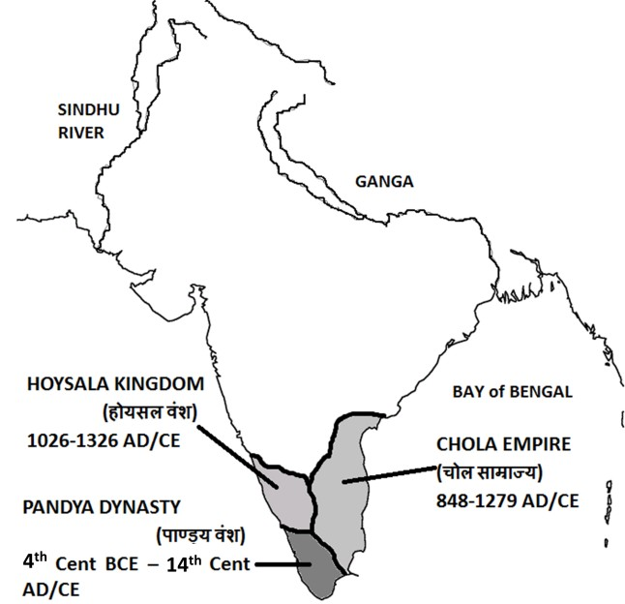
Early temples were not as grand as those of later temples. The Vijayalacholeswaram near Pudukkottai in Tamil Nadu is an example of early architecture. Early temples had a marked Pallava influence.

It was during the middle phase of their rule that the most progress was made under legendry Rajaraj Chola and his son Rajendra Chola. Chola and also Dravida architecture culminated with Brhdeshwara temple and Gangaikondacholapuram temples.

The magnificent Shiva temple of Thanjavur or Brihdeshwara or Rajarajeshwara Temple, completed around 1009, is a fitting memorial to the material achievements of the time of Rajaraja. It is the largest and tallest of all Indian temples and its Vimanam is of 70 meters height. In this temple, gopurams are still smaller than Vimanas, which was later reversed in other dynasties. The temple is built entirely of granite, interestingly, in a place where there is no source of granite. It is the world's first complete granite temple. Monolithic Nandi bull in its court is second largest in India after Lepakshi temple Nandi bull. One of the peculiar features of the temple is that shadow of cupola on its top never falls on ground. An immense Gopuram marks the entrance of the temple. In fact, it is in this temple that one notices for the first time two large gopuras (gateway towers) with an elaborate sculptural work which was conceived along with the temple. Pillared halls and sculptures depicting Bharata’s Natyashastra are also unique features of this temple. Fine paintings and murals are also there in temples which depict mythological narratives.

Gangaikondacholapuram temple is also similar in architecture as Brihadeshwara temple of Tanjore. But instead of two gopurams, it has only once. The most important difference between the two lies in the introduction of curves in the place of the strong straight lines of the Thanjavur vimana. The pyramidal body is slightly concave in its outline at its angles. In this temple also, there is a Nandi bull in temple compound.

The Airavateswara temple at Darasuram near Thanjavur built during the reign of Rajaraja Chola II is an example of later Chola art. Many temples were built in this period as well. This temple

has artistic stone pillars and decorations on its walls. The front mandapam of this temple is in the form of a huge chariot drawn by horses.

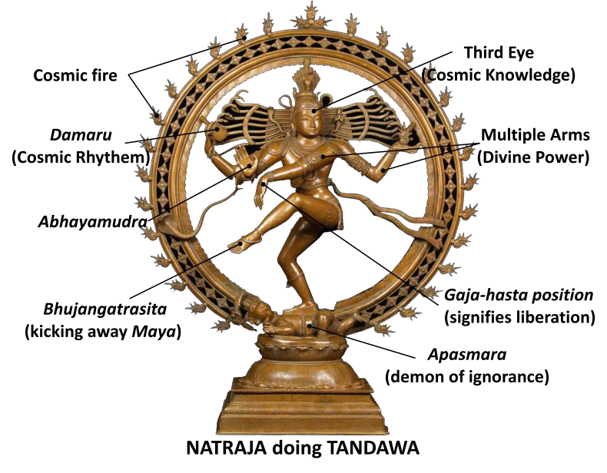
Chola period bronzes are exquisite forms of art and were created using the lost wax technique. The most famous of all the bronze icons is that of Nataraja. Although bronze casting has a long history in south India, a much larger and a much greater number of bronze sculptures in all sizes ranging from massive to miniature were cast during the Chola period than before, further attesting to the importance of bronze sculpture
during this period. The forms of Chola bronzes are very plastic. They are devoid of intricate ornaments and designs in comparison with the subsequent bronzes of the Vijayanagar and Nayaka period.

PANDYAS, 4th Century BCE – 16th Century AD

Pandya dynasty was the longest ruling dynasty in Indian history. It is said that the Pandyan Empire was founded by a woman king and she
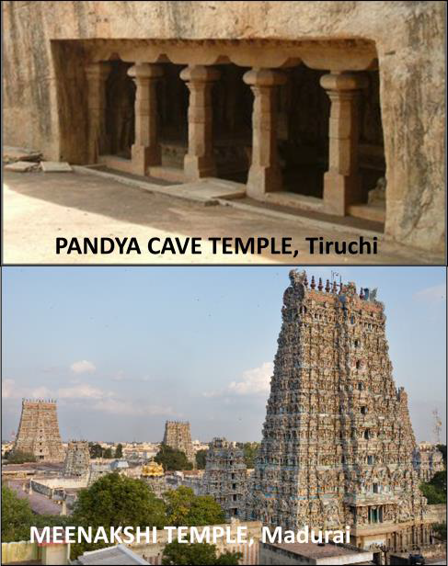
maintained a huge army. Earlier they ruled from a
coastal twon, but they later shifted their capital to Madurai.

As a result of their long rule, they built both the rock- cut and structural temples. The early rock-cut temples have monolithic vimanas. Such rock cut temples are found in Tirumeyyam in Pudukkottai district, Anaimalai, Sittanavasal, Karaikudi, Kalugumalai, Malaiyadikurichi and Trichy. These temples were mostly constructed for Lord Siva and Vishnu and in fact some of the Jaina cave shrines were also converted to Shaiv or Vaishnav caves.
They are mostly located on ancient trade routes. Today they are less explored than Pallava cave temples. The early Pandya cave temples are mostly simple with one cella and a front mandapa. Unlike the Pallava caves, almost all the Pandya caves have the images of Ganapati in one of the niches. These images are luxuriantly carved.
During the Pandya Dynasty rule, several structural stone temples were also built which had all the features of bigger Dravida temples like vimana, mandapa and sikhara. In the latter period of the Pandya rule development of elegant vimanas with finely sculptured idols and the gopurams or portals of the temples originated. Meenakshi Temple in Madurai and Nellaiappar Temple in Tirunelveli were built during the reign of the Pandyas. Meekashi temple is the epitome of Pandya architecture. It is dedicated to Parvati, known as Meenakshi, and her consort, Shiva or Sundareswarar. It houses 14 gopurams which were built by different rulers and in fact, the most impressive of the gopurams were built by the Nayakas in 16th-17th century only. Later gopuras were highly sculpted from outside. It is one of the few temples in Tamil Nadu to have four entrances facing four directions. Ancient Tamil classics mention that the temple was the center of the city and the streets happened to be radiating out like lotus and its petals.

Temples at Chidambaram, Kumbakonam, Srirangam etc are other good examples of the development of Pandya architecture.

A characteristic symbol of their architecture was that they built high outerwalls and gopuram and shrine itself was comparatively smaller.

HYOSALA ARCHITECTURE, 11th – 14th Century AD
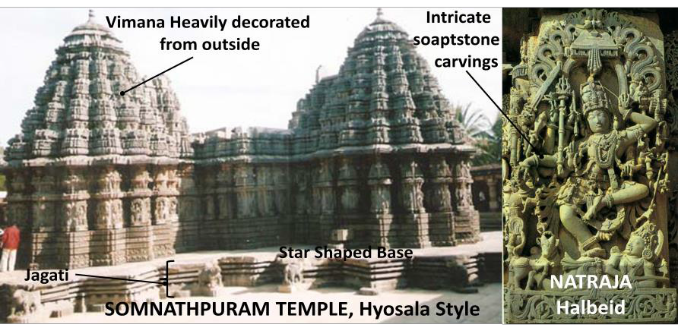
With the waning of Chola and Pandya power, the Hoysalas of Karnataka grew to prominence in South India and became

the most important patrons centred at Mysore region in Karnataka. It has considerably retained many features of Chalukya style and is another important school of Vesara school.Temples at Belur, Halebid and Somnathpuram are epitome of their art, though around more than 100 temples still remain.
Temple building activities of Hyosalas are rooted in socio- cultural settings. The transformation of the Karnata temple building tradition reflected religious trends popularized by the Vaishnava and Virashaiva philosophers as well as the growing military prowess of the Hoysala kings who desired to surpass their Western Chalukya overlords in artistic achievement.

Features of architecture –

- Their architectural style, an offshoot of the Western Chalukya style, shows distinct Dravidian influences. Hyosla architecture has minimum northern influence and dravida influence is marked one.The most characteristic feature of these temples is that they grow extremely complex with so many projecting angles emerging from the previously straightforward square temple that the plan of these temples starts looking like a star, and is thus known as a ‘stellate’ plan.
- The vimana of the temples is generally plain and square, whereas outside it is profusely decorated. Kalasha on the top of the temple is in shape of a water pot.
- There are generally two Matapas – one open and other closed. The open mantapa is supported by many lathe turned (circular or bell-shaped) pillars which were sometimes further carved with deep fluting and moulded with decorative motifs like called salabhanjika or madanika.
- The star shaped base with the main structure standing on an almost one meter raised platform called ‘Jagati’. The jagati, apart from giving a raised look to the temple, serves as a pradakshinapatha or ‘circumambulation path’ for circumambulation around the temple, as the garbagriha (inner sanctum) provides no such feature unlike Dravida style temples which have a covered circumambulatory path.
- Unlike a single inner chamber, there are multiple shrines around a central pillared hall.
So, the walls of the temple followed in zig-zag pattern due to a star shaped base.
- In many cases, there are multiple temples within same complex. Depending on the number of shrines (and hence on the number of towers), the temples are classified as ekakuta (one), dvikuta (two), trikuta (three), chatushkuta (four) and panchakuta (five). Most Hoysala temples are ekakuta, dvikuta or trikuta. In temples with multiple shrines, all essential parts are duplicated for symmetry and balance.
- Structure of the temples is relatively dwarf compared to other two styles viz Dravida and Nagara.
- The entrance of the temple is flanked by a pair of large Vaishnavite dwarpals and is elaboratively decorated.
- A feature of Hoysala temple architecture is its attention to exquisite detail and skilled craftsmanship. The tower over the temple shrine (vimana) is delicately finished with intricate carvings, showing attention to the ornate and elaborately detailed rather than to a tower form and height.
- Since they were made out of softer Soapstone, the artists were able to make intricate carvings. Salabhanjika, a common form of Hoysala sculpture, is an old Indian tradition going back to Buddhist sculpture. Sala is the sala tree and bhanjika is the chaste maiden.
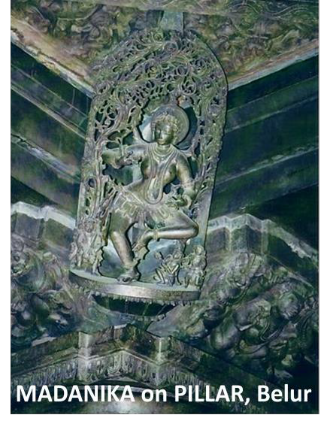
- While medieval Indian artisans preferred to remain anonymous, Hoysala artisans signed their works
Three major temples of Hyosala Style are –

  - Belur – Chennakesava Temple
  - Halebid (capital of Hyosalas) – Dedicated to Natraja/Shiva. The Hoysaleshvara temple (Lord of the Hoysalas) at Halebid in Karnataka was built in dark schist stone by the Hoysala king in 1150.

  - The Halebid temple is a double building with a large hall for the mandapa to facilitate music and dance. A Nandi pavilion precedes each building. There are hundreds of elephants at the bottom platform of the temple, easch of which is in different pose.
    - Somnathpuram – Kesava Temple
Sculpture art of Hyosala is also of finest quality and they have made sculptures of not only deities, but also of many mundane subjects. Due to use of soft soapstone, they are highly intricate in their carvings and projections. Movements in the sculptures are highly fluid. Their workmanship shows an attention paid to precise detail. Every aspect down to a fingernail or toenail is perfected. Salabhanjika, a common form of Hoysala sculpture, is an old Indian tradition going back to Buddhist sculpture. Sala is the sala tree and bhanjika is the chaste maiden. Madanika were also sculpted and they are seemingly engaged in artistic activities such as music and dance.

CHANDELA ART or KHAJURAHO STYLE, 10th – 11th Century AD

Chandela School is primarily known for Khajuraho temples which are finest example of Nagara style. There were originally 85 temples at Khajuraho, of which 25 remain today.

The Chandela architecture is divided into three groups – west, east and south. The first king who started construction in Khajuraho was Harsha who built the 64 Yogini Temple in south dedicated to Yoginis – perhaps Tantric deities.

The most notable prince of this dynasty was King Dhanga whose time is known for building the most beautiful Khaujraho Temples of Parsvanath and Vishwavanath. His grandson Vidyadhara built the Kandariya Mahadev Temple. Sculptures at Kalinjar fort are also examples of Chandela art.

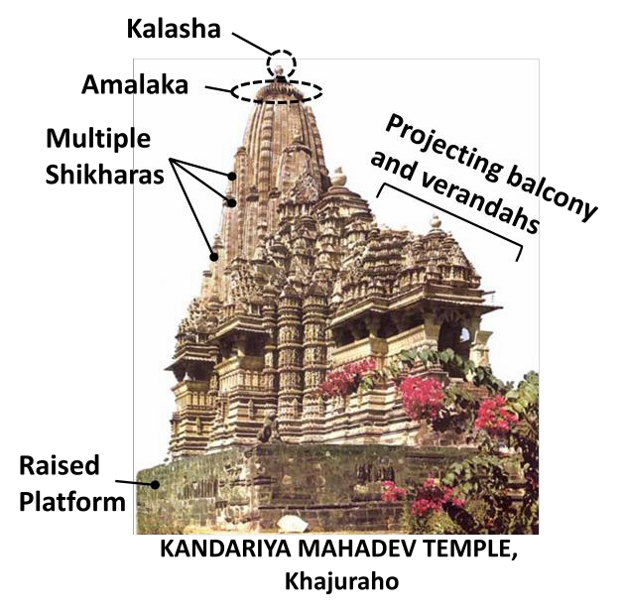
The group of temples at Khajuraho is a strikingly homogenous group. All the temples there were built within a relatively short period.

Kandariya Mahadev temple built around 1000 AD is one of the finest examples of Chandela art. The Kandariya Mahadeva temple is adorned on all sides with celestial nymphs, mithunas and many deities. The Kandariya Mahadev Temple is built on Panchayatana style (a temple is a Panchayatana one when the main shrine is surrounded by four subsidiary shrines at four different corners).
In fact, this feature is repeated in many other temples of Chandela style, e.g. in Lakshmanatemple – grandest of all Khajuraho temples – dedicated to Vishnu which was built in 950 CE. In its layout plan, it is similar to the Kalinga or Oriya/Odisha architecture style.
Main features of these temples are –

- Main elements included – Garbha Griha, Assembly Hall, Portico or verandah with pillars
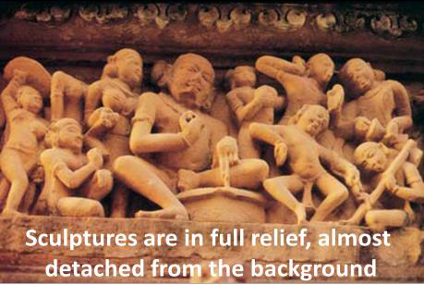
- They patronized both Hindu as well as Jaina architecture. There is a Chusath Yogini temple as well which has female deities called ‘yoginis’ and is supposed to be dedicated to Tantric tradition.
- These temples are marked by multiple Shikharas with one main Shikhara.
- Platform is relatively raised one.
- Panchayatana is also quite common feature of these temples.
- Shikharas have a crowning disc (called amalak) which is unique feature of these temples.
- These temples have no boundary walls like Odisha style.
- These temples have sculptures both outside and inside, in contrast to some other temples like Odisha temples which have sculptures primarily on outsides.
- These temples also have sculptures denoting erotic figures probably taken from Kamasutra and they are generally on outside the temple only.
- Khajuraho’s sculptures are highly stylized with typical features – they are in almost full relief, cut away from the surrounding stone, with sharp noses, prominent chins, long slanting eyes and eyebrows.

SOLANKI ART, 10th – 11th Century AD

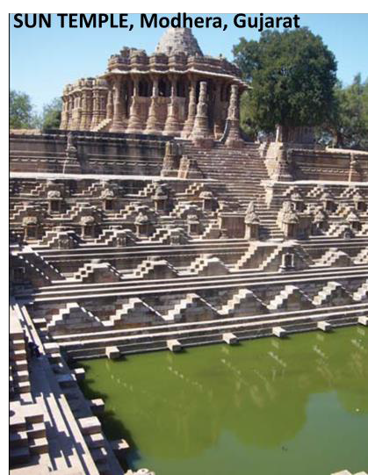
The Solankis were a branch of the later Chalukyas. They built both Hindu and Jain temples. Among Jaina temples, Dilwara temples of Mount Abu are the most famous one which are made of white marble. Among the Hindu temples, the Sun temple at Modhera dates back to early eleventh century and was built by Raja Bhimdev I of the Solanki Dynasty in 1026. There is a massive rectangular stepped tank called the surya kund in front of it. Proximity of sacred architecture to a water body such as a tank, a river or a pond has been noticed right from the earliest times. The influence of the woodcarving tradition of Gujarat is evident in the lavish carving and sculpture work. However, the sanctum sanctorumis left plain without any decoration and it has a unique feature as at time of equinox, sun raus fall directly in the central shrine.

VIJAYANAGA ART and ARCHITECTURE, 14th – 17th Century AD

VIjaynagara was the last Hindu Kingdom of India and hence, it also represents the last major achievements of Hindu architecture in India. Architecturally, Vijayanagara demonstrated the confluence of old Dravidian style – a vibrant combination of the Chalukyan, Hoysalan, Pandyan and Cholan styles – with some Islamic influence from neighboring Sultanates.

Temple architecture reached to new heights under the patronage of Krishnadevaraya who is considered the most important Vijaynagara king who gave Vijaynagara style a distinctive identity. Its capital was Vijaynagara or present day Hampi and the monuments in and around Hampi are listed as UNESCO World Heritage Sites.

Vijaynagara architecture is characterized by pillared mandapam/halls, impressive gopurams/Rayagopurams etc. In Hampi walls, no mortar or cementing agent was used in their construction.

Vitthalswami temple of 16th century at Hampi is one of the classic examples of Vijayanagara style which took many decades to built.

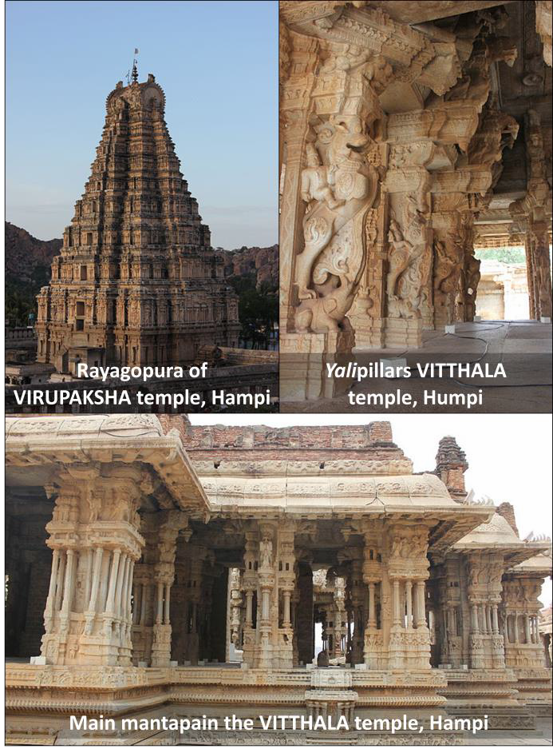
Virbhadra Temple at Lepakshi in Andhra is another temple from Vijaynagara style dedicated to lord Shiva. It has in its premises largest monolithic bull of the world. In this Shiva temple, Shiva is surrounded by musical figures and
hence the hall is called Hall of Dance.
Figures in this temple are of low relief which almost give a two dimensional look. Inside the boundary there are two structures – Kalyan Mandapam or main hall for primary deity and smaller Amman Shrine for consort deity. This is a unique feature of some of the Vijaynagara temples as most of the other temples have a single shrine/mandapam.

Features of Vijaynagara architecture include –

- Vijayanagara architecture can be broadly classified into religious, courtly and civic architecture.
- Its stylistic hallmark is the ornate pillared] Kalyanamantapa (marriage hall), Vasanthamantapa (open pillared halls) and the Rayagopuram (tower).
  - Early temples were in Vesara style of Deccan, but later Dravida influence was more pronounced for ritual purposes. The Prasanna Virupaksha temple (underground temple) of Bukka and the Hazare Rama temple of Deva Raya are examples of early Vesara architecture.
  - In order to cover the unevenness of the stone used in sculptures, artists employed plaster to give the rough surface a smooth finish and then painted it with lively colours.
  - Vijayanagara temples are usually surrounded by a strong enclosure.
  - Monolithic Structures – One important element of the Vijayanagara style is the carving of large monoliths such as the Nandi bull in Lepakshi. Another element of the huge Ganesha at Hampi, the Gommateshvara (Bahubali) monoliths in Karkala and Venur, and Nandi Bulll is the largest monolithic bull in India.
  - Massive Walls And Small Shrines – Another feature of the temple architecture in this age was the construction of massive walls around the shrine as a safeguard against intruders. Small shrines consist simply of a garbhagriha (sanctum) and a porch.
  - Granite Material – Artisans used the locally available hard granite instead of softer socapstone that was used by Chalukyas and Hyosalas because of its durability since the kingdom was under constant threat of invasion. Due to use of this material, artistic quality was not very high and relief was relatively lower in sculptures.
  - Gopurams – Like common features of the Dravida architecture, temples had gopurams,
but they were enlarged Gopurams. The term Raya is added to indicate a gopura built by Vijayanagar Rayas and were called RayaGopuram.
  - Pillared Structures – The pillars are the most prominent feature of these temples.
Temple pillars often have engravings of charging horses or Yali (supernatural horse) – horses standing on hind legs with their fore legs lifted and riders on their backs. The bottom supports of these pillars have engravings of Gods and Goddesses.
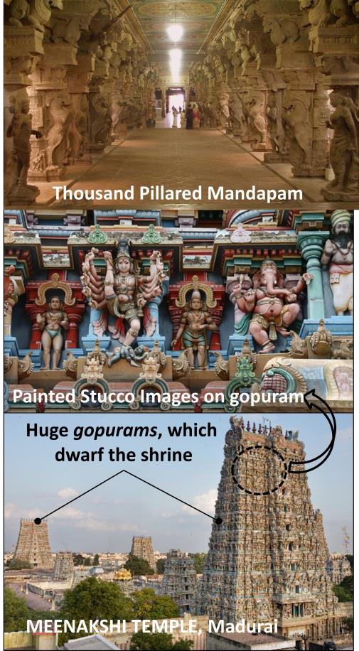
  - Vijaynagara rulers also introduced secular architecture as in case of Lotus Mahal.
Viajaynagara art also includes wall-paintings such as
Dasavathara (ten Avatars of Vishnu) in the Virupaksha (a form of Shiva) temple at Hampi, the Shivapurana paintings (tales of Shiva) at the Virabhadra temple at Lepakshi.

NAYAKA or MADURAI STYLE, 17th Century AD

Nayakas succeeded Vijayanagara Empire.

The major architectures achievements are the shrine at Tiruvannamalai and the Great Temple at Madurai. Other significant architectural wonders included that of the Temple at Rameswaram (famous for its long

corridors) and the Subramanya Temple at Thanjavur District.

Nayak architectural style was characterized by elaborate hundred-and thousand-pillared mandapas, the high gopurams with painted stucco statues – of both gods and demons – on the surface, and long corridors. The immense courtyards surrounding the central shrine of these temples were designed to accommodate the crowds who would gather to see the processions, when the Gods, would be taken from their shrines and displayed to the masses.

Their most famous architectural achievement was in form of Meenakshi Temple of Madurai or Sundereswara Temple built by Thirumalai Nayak, dedicated to Parvati and Lord Shiva. It was actually not built by the Nayakas, they only refurbished the temple by building new larger gopurams and other changes in temple.

  - It has two shrines one dedicated to Shiva/Sundereswara and other dedicated to his wife parvati/Meenakshi.
  - A large water tank in the temple is one of the distinct features of the temple.
  - Parakramas or roofed ambulatory paths is another distinguishing features of Meenakshi Temple apart from other Dravidian features.
  - A thousand pillared Mandapam is another unique feature of this temple.
  - This temple is also known for its highly impressive gopuram, which is perhaps more impressive than the temple itself and it totally dwarfs the central shrines.
For all the innovation of its massive but unsystematic plan – including the large gopurams and
huge courtyards, the architecture of Madurai, under the Nayak dynasty represented only an exaggeration of already established forms in every detail of its structure, rather than a new development as it is best exemplified by the Meenakshi temple which was a Pandya temple, later modified by Nayakas.

Tanjore painting, a major form of classical South Indian painting, originated under the Nayaks of Tanjore around 1600 AD. Renowned for their surface richness, vivid colors, and compact composition, these paintings serve primarily as devotional icons. Hindu gods, goddesses, and saints are the most frequent subjects. Tanjore paintings are usually done on solid wooden planks and were given an embossed look (which gives a three dimensional feel), and the painting was covered with gold foil and finished with dyes to color the figures. In Tanjore paintings, the figures are static and located in the center of the composition inside decorated arches or curtains. Eyes are broad and the outer lines are either brown or red, except for the god Krishna who's eyes are depicted in blue.

PART B

BRITISH ARCHITECTURE
Renowned architects of the likes of Lutyens, Edward Frere etc. laid layout plans for some modern Indian cities and designed exquisite buildings during this period. Notable architectures of that period are – The Madras Government House, Bombay Town Meeting Hall, Victoria Memorial, Viceroy Palace (which is now Rashtrapati Bhawan) etc.

Both European and Indian elements were used and there was no uniform style in British architecture. Herbert Baker and Edward Lutyens were the prime architects of New Delhi. In Lutyen’s Delhi, a fusion of Mughal, Buddhist and Hindu architecture was used. Rashtrapati Bhavan is example of such fusion. It is built of sandstone and has design features like canopies from Rajput tradition. Its dome was copied from the Buddhist stupa at Sanchi, and the red sandstone and carved screens or jalis were borrowed from Mughal architecture.

In Delhi and other places, the British made many big big public buildings. The large structure of the India Gate, the Viceroy House which is now the Rashtrapati Bhavan, Parliament House and the North and South Blocks in Delhi, Victoria Memorial in Calcutta, Gateway of India in Mumbai etc were all made to impress the Indian subjects of the British rule. They were meant to show the supremacy, the majestic power as well as the regality of the British.

New Delhi was constructed as a 10-square-mile city on Raisina Hill, south of the existing city. Two architects, Edward Lutyens and Herbert Baker, were called on to design New Delhi and its buildings. The government complex in New Delhi consisted of a two-mile avenue, Kingsway (now Rajpath), that led to the Viceroy’s Palace (now Rashtrapati Bhavan), with the Secretariat buildings on either sides of the avenue. The features of these government buildings were borrowed from different periods of India’s imperial history, but the overall look was Classical Greece (fifth century BCE). For instance, the central dome of the Viceroy’s Palace was copied from the Buddhist stupa at Sanchi, and the red sandstone and carved screens or jalis were borrowed from Mughal architecture. But the new buildings had to assert British importance: that is why the architect made sure that the Viceroy’s Palace was higher than Shah Jahan’s Jama Masjid.

New Delhi took nearly 20 years to build. The idea was to build a city that was a stark contrast to Shahjahanabad. There were to be no crowded mohallas, no mazes of narrow bylanes. In New Delhi, there were to be broad, straight streets lined with sprawling mansions set in the middle of large compounds. The architects wanted New Delhi to represent a sense of law and order, in contrast to the chaos of Old Delhi. The new city also had to be a clean and healthy space. The British saw overcrowded spaces as unhygienic and unhealthy, the source of disease. This meant that New Delhi had to have better water supply, sewage disposal and drainage facilities than the Old City. It had to be green, with trees and parks ensuring fresh air and adequate supply of oxygen.

For public buildings three broad architectural styles were used. Two of these were direct imports from fashions prevalent in England.

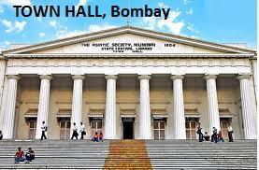
- Neo-Classical/Greco-Roman – The first was called neo-classical or the new classical. Its characteristics included construction of geometrical
structures fronted with lofty pillars. It was derived from a
style that was originally typical of buildings in ancient Rome. The Town Hall in Bombay was built in this style in 1833. Some Greek and Roman influence can be observed in the colonnades or pillared buildings. Parliament House and
Connaught Place in Delhi are other good examples. Another group of commercial buildings, built during the cotton boom of the 1860s, was the Elphinstone Circle.
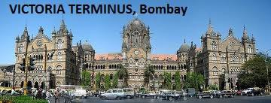
- Neo-Gothic or Victorian Architecture – Another style that was extensively used was the neo-Gothic (Goths were barbaric tribals in
Europe, later a style of architecture was named after them which developed in France in 12th century for making of churches. Gothic, was distinguished by high pointed arches, the use of stained glass,
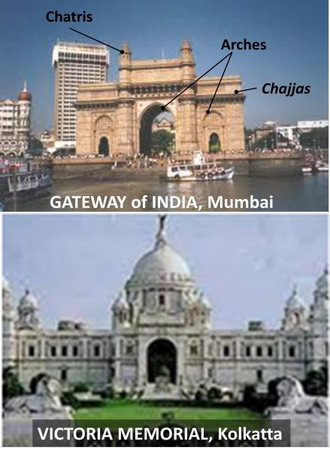
often painted with scenes drawn from the Bible, and flying buttresses), characterised by high-pitched roofs, pointed arches and detailed decoration. An impressive group of buildings facing the seafront including the Secretariat, University of Bombay, Writer’s Building in Calcutta and High Court were all built in this style. The most spectacular example of the neo-Gothic style is the Victoria Terminus (now called Chatrapati Shivaji Terminus), the station and headquarters of the Indian Railways. It looks more like a cathedral than a railway station. It contains carved stone friezes, stained glass windows and flying walls. However, in a bid to fuse oriental elements, Victorian architecture in India lost its orginal vitality and was not as impressive as original Gothic architecture.
- Indo-Sarcenic or Mughal-Gothic – A new hybrid style called Indo-Saracenic was also developed during this period. ‘Indo’ was shorthand for Hindu and ‘Saracen’ was a term Europeans used to designate Muslim.
The inspiration for this style was medieval buildings in India with their domes, chhatris, jalis, arches. By integrating Indian and European styles in public architecture the British wanted to prove that they were legitimate rulers of India. Modern architectural science and material like iron, steel and concrete was used to give strength to the structures. Construction was grand in size.
Walls were thinner, archs were pointed and windows were large. The Gateway of India, built in the traditional Gujarati style to welcome King George V is the most famous example of this style. The industrialist Jamsetji Tata built the Taj Mahal Hotel in a similar style. Similarly, for the Victoria Memorial, Kolkatta designed by Willian Emerson an attempt was made to revive the grandeur of the Taj, but failed to yield similar effect. The Victoria Memorial was made up of white makrana Marble from Rajasthan. Emerson was asked to design the building in the Italian Renaissance style, but he was against the use European style and instead used ‘Indo-Saracenic style’, blending Mughal elements in the architecture. However, it also carried the elements of Victorian architecture which is evident in the sculptures, drains etc.
- Baroque – Many a buildings like General Post Office in Kolkatta, 'Baroque' is evident in scale and movement.

OTHER REGIONAL ARCHITECTURAL STYLES and MONUMENTS

WOODEN SCULPTURES

The southern state of Karnataka is famous for its rosewood and sandalwood sculptures. The most popular subject is the elephant. Figures of Hindu gods and goddesses, Christ, Buddha, and of birds and other animals are also crafted from wood by talented artisans. The cities of Mysore and Bangalore are famous for their rosewood sculptures.

In Kerala, sheesham (rosewood) statues are sculpted in Trivandrum and Trichur. Ernakulam and Cochin are important centers of wood sculpture crafting.

HILL ARCHITECTURE

Hill sections in North India – Himachal and Kashmir – initially developed under strong influence of Gandhara style in 5th century CE and later mixed with Gupta and post-Gupta traditions as well as Brahmin pundits and Buddhist monks frequently travelled to these areas. As a result both Buddhist and Hindu traditions began to intermingle and spread in the hills. The hills also had their own tradition of wooden buildings with pitched roofs.

The Karkota period of Kashmir is the most significant in terms of architecture. One of the most important temples is Pandrethan, built during the eighth and ninth centuries. The architecture of this temple is in keeping with the age-old Kashmiri tradition of wooden buildings. Due to the snowy conditions in Kashmir, the roof is peaked and slants slowly outward.

SOMNATH TEMPLE

It is in Gujarat and is the first among the twelve Jyotirlinga shrines of the god Shiva. Jyotirlingas are the places where Shiva appeared as a column of light. The temple has a long history and it is the Hindu temple which was destroyed many a times by invaders and was again re-built. It was built for the first time in around 6th century. It had been destroyed by Arab Muslims, Mahmud of Ghazni, Allauddin Khilji, Aurangzeb and so on. It was also famous for its riches and was plundered many a time. At different times, the temple was rebuilt by rulers like Parmaras, Solankis etc. Its current shape was built by government of Independent India in 1951. The present temple is built in the Chalukya style of temple architecture.

18th-19th CENTURY BENGAL ARCHITECTURE

The temples began to copy the double-roofed (dochala) or four-roofed (chauchala) structure of the thatched huts. This led to the evolution of the typical Bengali style in temple architecture. In the comparatively more complex four-roofed structure, four triangular roofs placed on the four walls move up to converge on a curved line or a point. Temples were usually built on a square platform. The interior was relatively plain, but the outer walls of many temples were decorated with paintings, ornamental tiles or terracotta tablets. In some temples, particularly in Vishnupur in the Bankura district of West Bengal, such decorations reached a high degree of excellence.

MUSICAL STONE PILLARS in INDIAN TEMPLE

Indian temples are very famous for their musical stone pillars. These beautiful pillars emit musical notes when tapped, which makes these temple pillars unique and exceptional. These gracefully carved and highly decorated stone pillars are considered to be audio marvels. They are found in the courtyards within the temple campus and there is generally a single pillar is separated into columns or smaller, slender pillars.

These musical pillars are four types: Sruthisthamba (used during Puja along with ‘shangu and Yeakalum’), Ganasthamb, Layasthamba and Pradharasana sthamba. These pillars are mainly found in South Indian temples. Historians believe that the original pillars were prepared during the Vijayanagar era and Hampi, the ancient capital of the Vijayanagar dynasty, was the place where earliest musical stone pillars were made. The Sthapathis or sculptors of this era were exemplary craftsmen. They were well versed in the science of building acoustics. They thoroughly search for stones with different resonance and worked with these stones in order to create fascinating musical stone pillars. They experimented with these rare stones and therefore they had to carve upon them with great agility and skill to produce such unique marvels. Apart from their music producing quality, these stone pillars are also praised for their beautiful carvings and sculptures.

PROMOTION and PRESERVATION of ARCHITECTURE

WORLD HERITAGE SITES

In 1972, UNESCO adopted a resolution for the creation a Convention on protection of the world natural and cultural heritages. Criteria for selection of of sites is that ‘they should be of outstanding universal value’ and ‘satisfy at least one of ten criterion laid by the UNESCO’.

There are 4 criteria for natural heritage sites and 6 for cultural sites.

Criteria for cultural heritage include – it should be a masterpiece of human creative values; unique or exceptional testimony of an existing or extinct civilization; is an example of an architecture, building etc which illustrates a significant stage in human history; is n example of living tradition of universal significance and so on.

Criteria for natural heritage include – natural phenomenon of exceptional natural beauty and aesthetic importance; represents major stages of Earth’s history; important habitats for in-situ conservation of biological diversity, including those containing threatened species of outstanding universal values.

Such sites are also protected by all governments irrespective of war and conflict.

