**INDIAN HISTORY**

**CULTURE**

**(1) Prehistoric Era Art – Rock Paintings**

Indian Culture is a vast subject in which there are many sub-areas like art, architecture, sculpture, philosophy, science etc. Not all books on Indian culture and heritage in the market are reader-friendly. Then how can an aspirant study culture topics? We suggest aspirants to start from the book published by NCERT on Indian Culture and then move on to other online and offline sources. The book is titled ‘An Introduction to Indian Art’

– Part 1. Though many aspirants might not be aware, this textbook provides valuable knowledge for a beginner. Clear IAS is starting a compilation of the important aspects of Indian culture based on the book ‘An Introduction to Indian Art’ – Part 1 so that aspirants can save time.

Take the Clear IAS Exam UPSC prelims [mock test on Indian culture.](http://www.cleariasexam.com/culture-upsc-prelims-all-india-mock-test-301p/) You not only will learn the important facts related to Indian culture, but will also start to love the subject!

**What’s inside: An Introduction to Indian Art’ – Part 1**

This NCERT textbook for Class XI extensively covers the tradition of cave paintings in the pre-historic era and their continuation in mural paintings of Buddhist era and later on in various parts of the country, Buddhist, Jain and Hindu sculptural and architectural developments. During the Indo-Islamic period and before the Mughal rule, another era dawned upon India, which saw massive constructions in the form of forts and palaces. Different aspects of all these styles have been discussed to introduce students with the fabric of India’s culture. **The approach is mostly chronological**, and it extends from the pre-historic period till the Mughals. **Prehistoric Rock Paintings in India**

***What is prehistoric?***

The distant past when there was no paper or language or the written word, and hence no books or written document, is called as the Prehistoric period.

It was difficult to understand how Prehistoric people lived until scholars began excavations in Prehistoric sites.

Piecing together of information deduced from old tools, habitat, bones of both animals and human beings and drawings on the cave walls scholars have constructed fairly accurate knowledge about what happened and how people lived in prehistoric times.

Paintings and drawings were the oldest art forms practised by human beings to express themselves using the cave wall as their canvas.

**Prehistoric Period: Paleolithic Age, Mesolithic Age and Chalcolithic Age**

The drawings and paintings can be catagorised into seven historical periods. Period I, Upper Palaeolithic; Period II, Mesolithic; and Period III, Chalcolithic. After Period III there are four successive periods. But we will confine ourselves here only to the first three phases. **Prehistoric Era art** denotes the art (mainly rock paintings) during Paleolithic Age, Mesolithic Age and Chalcolithic Age.

1. **Paleolithic Age Art**

* The prehistoric period in the early development of human beings is commonly known as the ‘Old Stone Age’ or ‘Palaeolithic Age’.
* Palaeolithic period can be divided into three phases:
  1. Lower Palaeolithic (2.5 million years-100,000 years ago)
  2. Middle Palaeolithic (300,000-30,000 years ago)
  3. Upper Palaeolithic (40,000-10,000 years ago)
* We did not get any evidence of paintings from lower or middle palaeolithic age yet.
* In the Upper Palaeolithic period, we see a proliferation of artistic activities.
* Subjects of early works confined to simple human figures, human activities, geometric designs and symbols.
* First discovery of rock paintings in the world was made in India (1867-68) by an Archaeologist,**Archibold Carlleyle**, twelve years before the discovery of Altamira in Spain (site of oldest rock paintings in the world).
* In India, remnants of rock paintings have been found on the walls of caves situated in several districts of Madhya Pradesh, Uttar Pradesh, Andhra Pradesh, Telangana, Karnataka, Bihar and Uttarakhand.
* Some of the examples of sites early rock paintings are **Lakhudiyar in Uttarakhand, Kupgallu in Telangana, Piklihal and Tekkalkotta in Karnataka, Bhimbetka and Jogimara in Madhya Pradesh etc**.
* Paintings found here can be divided into three categories: **Man, Animal and Geometric symbols**.
* Some of the characteristics of these early paintings are:

1. Human beings are represented in a stick-like form.
2. A long-snouted animal, a fox, a multi-legged lizard are main animal motifs in the early paintings (later many animals were drawn).
3. Wavy lines, rectangular filled geometric designs and a group of dots also can be seen.
4. Superimposition of paintings – earliest is Black, then red and later White.

* In the late historic, early historic and Neolithic period the subjects of paintings developed and figures like Bulls, Elephants, Sambhars, Gazelles, Sheep, Horses, styled human beings, tridents and rarely vegetal motifs began to see.
* The richest paintings are reported from Vindhya range of Madhya Pradesh and their Kaimurean extension into U.P.
* These hills are fully Palaeolithic and Mesolithic remains.
* There are two major sites of excellent prehistoric paintings in India:

1. **Bhimbetka Caves, Foothills of Vindhya, Madhya Pradesh.**
2. **Jogimara caves, Amarnath, Madhya Pradesh.**

**Bhimbetka Caves**

|  |  |  |  |  |  |
| --- | --- | --- | --- | --- | --- |
| • | Continuous occupation of the caves from 100,000 B.C– 1000 A.D |  | | | |
| • | Thus, it is considered as an evidence of **long cultural continuity**. |  |  |  |  |
| • | It was discovered in 1957-58. |  |  |  |  |
| • | Consists of nearly 400 painted rock shelters in five clusters. |  |  |  |  |
| • | One of the oldest paintings in India and | the | world | (Upper | palaeolithic). |

The features of paintings of three different phases are as follows (even though Bhimbetka contains many

paintings of periods later, different from what is explained explained below, as we are dealing with prehistoric period only, we are concluding by these three):

**Upper Palaeolithic Period:**

* Paintings are linear representations, in green and dark red, of huge animal figures, such as Bisons, Tigers, Elephants, Rhinos and Boars beside stick-like human figures.
* Mostly they are filled with geometric patterns.
* Green paintings are of dances and red ones of hunters.

1. **Mesolithic period Art:**

* The largest number of paintings belongs to this period.
* Themes multiply but the paintings are small in size.
* Hunting scenes predominate
* Hunters in groups armed with barbed spears, pointed sticks, arrows and bows.
* Trap and snares used to catch animals can be seen in some paintings.
* Mesolithic people loved to point animals.
* In some pictures, animals are chasing men and in others they are being chased by hunter men.
* Animals painted in naturalistic style and humans were depicted in a stylistic manner.
* Women are painted both in nude and clothed.
* Young and old equally find places in paintings.
* Community dances provide a common theme.
* Sort of family life can be seen in some paintings (woman, man and children).

1. **Chalcolithic period Art:**

* Copper age art.
* The paintings of this period reveal the association, contact and mutual exchange of requirements of the cave dwellers of this area with settled agricultural communities of the Malwa Plateau.
* Pottery and metal tools can be seen in paintings.
* **Similarities with rock paintings:** Common motifs (designs/patterns like cross hatched squares, lattices etc)
* **Difference with rock paintings:** Vividness and vitality of older periods disappear from these paintings.

Some of the general features of Prehistoric paintings (based on the study of Bhimbetka paintings)

* Used colours, including various shades of white, yellow, orange, red ochre, purple, brown, green and black.
* But white and red were their favourite.
* The paints used by these people were made by grinding various coloured rocks.
* They got red from haematite (Geru in India).
* Green prepared from a green coloured rock called Chalcedony.
* White was probably from Limestone.
* Some sticky substances such as animal fat or gum or resin from trees may be used while mixing rock powder with water.
* Brushes were made of plant fibre.
* It is believed that these colours remained thousands of years because of the chemical reaction of the oxide present on the surface of rocks.
* Paintings were found both from occupied and unoccupied caves.
* It means that these paintings were sometimes used also as some sort of signals, warnings etc.
* Many rock art sites of new painting are painted on top of an older painting.
* In Bhimbetka, we can see nearly 20 layers of paintings, one on top of another.
* It shows the gradual development of the human being from period to period.
* The symbolism is inspiration from nature along with slight spirituality.
* Expression of ideas through very few drawings (representation of men by the stick like drawings).
* Use of many geometrical patterns.
* Scenes were mainly hunting and economic and social life of people.
* The figure of flora, fauna, human, mythical creatures, carts, chariots etc can be seen.
* More importance for red and white colours.

**(2) Arts of Indus Valley Civilization**

**Arts of Indus Valley Civilization**

* The arts of Indus Valley civilization, one of the earliest civilizations of the world, emerged during the second half of the third millennium (Bronze Age).
* The forms of art found from various sites of civilization include sculptures, seals, pottery, **gold**ornaments, terracotta figures, etc.
* Their delineation of human and animal figures was highly realistic in nature.
* Modeling of figures was done in an extreamely careful manner.
* **Two major sites** of Indus valley civilization, along the river Indus are: North – cities of**Harappa;** South –

**Mohenjo-Daro.**

* The site showcase one of the earliest examples of civic planning.
* Houses, markets, storage facilities, offices, etc. arranged in a **grid-like pattern**.
* In this pattern, roads were cut across one another in 90-degree angle and the city was divided into blocks.
* There was also a highly developed drainage system.
* While Harappa and Mohenjo-Daro are situated in Pakistan, the important sites excavated in India are:
  + Lothal, Surkotada, Dholavira – Gujarat
  + Rakhigarh and Banwali – Haryana
  + Ropar – Punjab
  + Kalibangan and Balatha – Rajasthan

#### Materials used: Stone, Bronze, Terracotta, Clay etc.

The arts of Indus valley which are excavated yet are:

#### Stone Statues:

* Stone statues found in Indus valley sites are excellent examples of handling the 3D volume.
* Two major stone statues are:

1. **Bearded Man (Priest Man, Priest-King)**

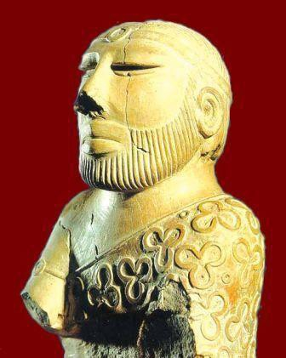

* Found in Mohenjo-Daro.
* Bearded man’s figure made of **Steatite.**
* The figure interpreted as a priest and is draped in a shawl coming under the right arm and covering the left shoulder.
* The shawl is decorated with trefoil pattern.
* The eyes are elongated and half closed as in a meditative concentration.
* Nose is well formed and medium size.
* Short cut moustache and a short beard and whiskers.
* Hair is parted in the middle and a plain woven fillet is passed round the head.
* An armlet on the right hand and holes around neck suggest necklace.
* A slight touch of the Greek style of statues can be seen overall.

2. **Male Torso**

* Found in Harappa (only major art element found in Harappa).
* Made of **Red Sandstone.**
* There are socket holes in the neck and shoulders for the attachment of head and arms.
* Legs are broken.
* The shoulders are well baked and the abdomen slightly prominent.
* One of the well carved and finished work.

#### Bronze Casting:

* Bronze casting was practiced in wide scale in almost all major sites of the civilization.
* The technique used for Bronze Casting was **Lost Wax Technique.**

[Initially, the figure needed is made of wax and covered it with clay. After allowed to dry the clay, the whole thing is heated so that the wax inside the clay will be melted. The molten wax was then drained out through a tiny hole made in the clay part. The hollow mold of clay thus created was filled with molten metal. Once it cooled, the clay cover was completely removed].

* Human as well as animal figures are present in the Bronze casting.
* Amongst animal figures the buffalo with its uplifted head, back and sweeping horns and the goat are artistic merits.
* Copper dog and bird of Lothal and the Bronze figure of a bull from Kalibangan shows that Bronze casting was popular at all centers of Indus valley civilization.
* Metal casting continued even after the Indus valley civilization through late Harappan, Chalcolithic people, etc.
* Examples of Bronze casting are:

###### Dancing Girl

* Found from Mohenjo-Daro.
* Made up of Bronze.
* One of the best-known artifacts from Indus valley.
* Approximately 4-inch high figure of a dancing girl.
* This exquisite casting depicts a girl whose long hair is tied in the bun and bangles cover her left arm.
* Cowry shell necklace is seen around her neck.
* Her right hand is on her hip and her left hand is clasped in a traditional Indian dance gesture.
* She has large eyes and flat nose.

###### Bull from Mohenjo-Daro

* Bronze figure of the bull found in Mohenjo-Daro.
* The massiveness of the bull and the fury of the charge are eloquently expressed.
* The animal is shown standing with his head turned to the right.
* There is a cord around the neck.

#### Terracotta:

* Terracotta figures are more realistic in Gujarat sites and Kalibangan.
* In terracotta, we find a few figurines of bearded males with coiled hairs, their posture rigidly upright, legs slightly apart, and the arms parallel to the sides of the body. The repetition of this figure in exactly the same position would suggest that he was a deity.
* A terracotta mask of a horned deity has also been found.
* Toy carts with wheels, whistles, rattles, bird and animals, gamesmen, and discs were also rendered in terracotta.
* The most important terracotta figures are those represent Mother Goddess.

###### 1. Mother Goddess

* Mainly found in Mohenjo-Daro.
* These figures are usually crude standing figures.
* Adorned with necklaces hanging over the prominent breast and wearing a loin cloth and a grid.
* The fan-shaped headdress with a cup like projection on each side is a distinct decorative feature of the mother goddess.
* The pellet eyes and beaked nose of the figure are very crude (constructed in a rudimentary way).
* Mouth is indicated by a narrow opening.

**Seals:**

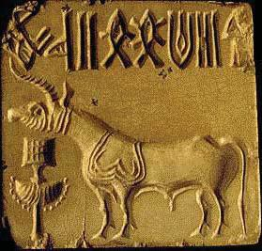

* Thousands of seals were discovered from the sites, usually made of steatite, and occasionally of agate, chert, copper, faience and terracotta, with beautiful figures of animals such as unicorn bull, rhinoceros, tiger, elephant, bison, goat, buffalo, etc.
* The purpose was mainly commercial.
* They were also used as amulets, carried on the persons of their owners, perhaps as modern identity cards.
* Standard Harappan seal was 2 x 2 square inches.
* Every seal is engraved in a pictographic script which is yet to be deciphered.
* Some seals were also been found in Gold and Ivory.

###### 1. Seals of Pashupati Mahadeva

* Found in Mohenjo-Daro.
* The seal depicts a human figure seated cross legged.
* An elephant and a tiger are depicted to the right side of the figure, while on the left a rhinoceros and a buffalo are seen.
* Two antelopes (deer) are shown below the seat (nearby his feet).
* The figure has a three horned head.

#### Pottery:

* Indus valley pottery consists of very fine wheel made wares, very few being handmade.
* Plain pottery is more common than painted ware.
* Plain pottery is generally red clay, with or without a fine red or grey slip.
* The black painted ware has a fine coating of red slip on which geometric and animal designs are executed in glossy black paint.

###### 1. Painted Earthen Jar

* Found in Mohenjo-Daro.
* Made on a potters’ wheel with clay.
* The shape was manipulated by pressure of the crafty fingers of the potter.
* After baking a clay model, it was painted with black colour.
* High polishing was done as a finishing touch.
* Motifs are vegetal and geometric forms.
* Designs are simple.

**Beads, Ornaments and Cosmetics:**

* The Harappan men and women decorated themselves with a large variety of ornaments produced from every conceivable materials ranging from precious metals and gemstones to bone and baked clay.
* White necklaces, fillets, armlets and finger rings were commonly worn by both sexes.
* Jewellery found at Mohenjo-Daro and Lothal include necklaces of gold and semiprecious metal stones, copper bracelets and beads, gold earrings and head ornaments.
* A cemetery has been found at Farmona in Harappa where dead bodies were buried with ornaments.
* Well developed bead industries were present at Chauhudaro and Lothal.
* Some beads were made of two or more stones cemented together.
* Also made models of animals, especially monkeys and squirrels, used as pin head and beads.
* Spinning of cotton and wool was very common (both rich and poor practiced spinning).
* Men and women wore two separate pieces of attire similar to dhoti and shawl.
* Shawl covered the left shoulder passing below right arm.
* They were conscious of fashion.
* Different hair styles were in vogue and beard was popular.
* Cinnabar was used as a cosmetic and face-paint, lipstick and collyrium (eyeliner) were also known to them.

1. **Arts of the Mauryan Period (Indian Culture Series – NCERT)**

#### Arts of the Mauryan Period

* Sixth century B.C. marks the beginning of new religious and social movements in the Gangetic valley in the form of Buddhism and Jainism (Sramana/**Shraman Tradition**).
* Magadha emerged as a powerful kingdom and consolidated its control over the other religions.
* By the third century, a large part of India was under Maurya control.
* Ashoka emerged as the most powerful king of the Maurya dynasty.
* Religious practices had many dimensions during this period.
* Worship of Yakshas and Mother Goddess was prevalent during that time.
* Yaksha worship was very popular before and after the advent of Buddhism and it was assimilated in Buddhism and Jainism.
* Construction of stupas and viharas (dwelling place of monks) became part of the Buddhist tradition.
* However, in this period, apart from stupas and viharas, stone pillars, rock cut caves and monumental figure sculptures were carved in several places.

**Pillars**

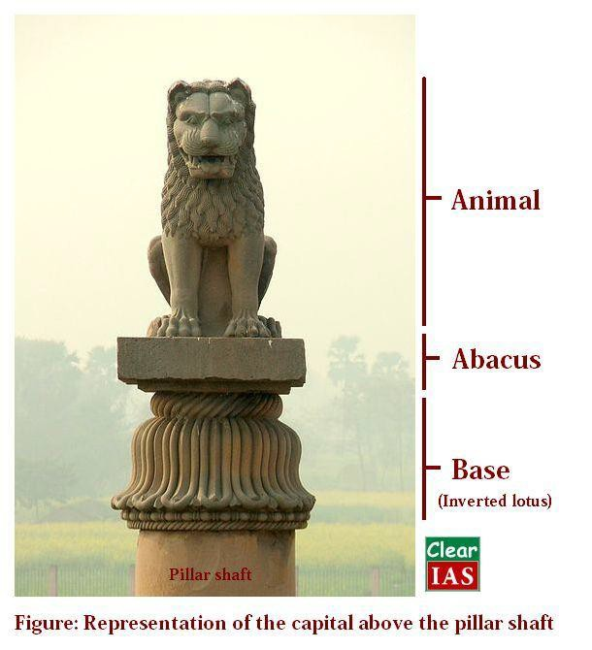

* Even though constructing pillars are very old, Mauryan pillars are different from the pillars in the other parts of the world (like Achaemenian pillars) as they are **rock cut** pillars thus displaying the carver’s skills.
* Stone pillars were erected all over the Mauryan Empire.
* The uppermost elements of a pillar or column is known a capital.
* The top portion of the pillar was carved with figures like a bull, lion, elephant, etc.
* All the **capital** figures (usually animals) are vigorous and carved standing on a square or circular abacus.
* **Abacuses** are decorated with stylized lotuses.
* Mauryan pillar capital found at Sarnath popularly known as the Lion Capital is the finest example of Mauryan sculpture tradition.

Lion Capital, Sarnath

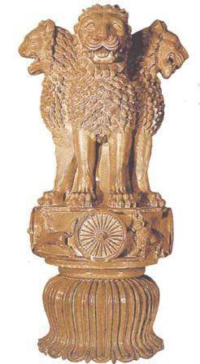

* The Lion Capital discovered more than a hundred years ago at Sarnath, near Varanasi, is generally referred as Sarnath Lion Capital.
* It is one of the finest examples of sculpture from Mauryan period and was built **by Ashoka in commemoration of** ‘**Dhammachakrapravartana’ or the first sermon of Buddha.**
* Originally it consists of five components:
  1. The pillar shaft.
  2. The lotus bell or base.
  3. A drum on the bell base with four animals proceeding clockwise (abacus).
  4. Figure of four majestic addorsed (back to back)
  5. The crowning element, confidence. Dharamchakra/Dharmachakra.
* Dharamchakra (the fifth component said above), a large wheel was also a part of this pillar. However, this wheel is lying in broken condition and is displayed in the site museum of **Sarnath**.
* The capital has four Asiatic lions seated back to back and their facial muscularity is very strong.
* They symbolize power, courage, pride andThe surface of the sculpture is heavily polished, which is typical of the Mauryan period.
* **Abacus (drum on the bell base)** has the depiction of a chakra (wheel) in all four directions and a bull, a horse, an elephant and a lion between every chakra.
* Each chakra has **24 spokes** in it.
* This 24 spoke chakra is adopted to the National Flag of India.
* The circular abacus is supported by an inverted lotus capital.
* **The capital without the shaft, the lotus bell and crowning wheel has been adopted as the National Emblem of Independent India.**
* In the emblem adopted by **Madhav Sawhey,** only three Lions are visible, the fourth being hidden from

view. The abacus is also set in such a way that only one chakra can be seen in the middle, with the bull on the right and horse on the left.

* A lion capital has also been found at **Sanchi**, but is in a dilapidated condition.
* A pillar found at Vaishali is facing towards the north, which is the direction of Buddha’s last voyage.

#### Yakshas and Yakshinis

* Large statues of Yakshas and Yakshinis are found at many places like Patna, Vidisha and Mathura.
* They are mostly in the standing position.
* Their polished surface is distinguished element.
* Depiction of faces is in full round with pronounced cheeks and physiognomic detail.
* They show sensitivity towards depicting the human physique.
* Finest example is Yakshi figure from Didarganj, Patna.

##### **Didarganj Yakshi**

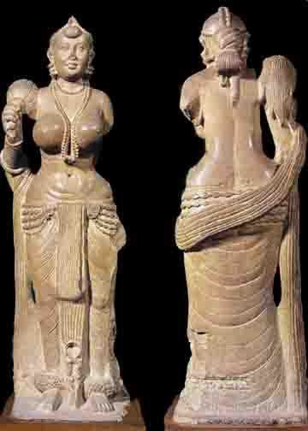

* The life-size standing image of a Yakshi holding a chauri (flywhisk) from Didarganj near Patna is another good example of the sculpture tradition of Mauryan period.
* It is a tall well proportioned, free standing sculpture in round made in sandstone with a polished surface.
* The chauri is held in the right hand, whereas the left hand is broken.
* The image shows sophistication in the treatment of form and medium.
* The sculpture’s sensitivity towards the round muscular body is clearly visible.
* The face is round, fleshy cheeks, while the neck is relatively small in proportion; the eyes, nose and lips are sharp.
* Folds of muscles are properly rendered.
* The necklace beads are in full round, hanging the belly.
* The tightening of garments around the belly rendered with great care.
* Every fold of the garments on the legs is shown by protruding lines clinging to the legs, which also creates a somewhat transparent effect.
* Thick bell ornaments adorn the feet.
* Heaviness in the torso is depicted by heavy breasts.
* The hair is tied in a knot at the back and the back is clear.
* Flywhisk in the right hand is shown with incised lines continued on the back of the image.

#### Rock cut Architectures:

* Ashoka also patronized many rock cut architectures during his period
* The majority of these belongs to Buddhism.
* The rock-cut cave carved at Barabar hills is a good example of Mauryan rock cut architectures.

Lomus Rishi Cave, Barabar Hills

* Rock-cut cave carved at Barabar Hills near Gaya in Bihar is known as Lomus Rishi Cave.
* It is patronized by Ashoka for Ajeevika sect.
* The facade of the cave is decorated with the semicircular Chaitya (worship place) arch as the entrance.
* An elephant frieze carved in high relief on the chaitya.
* The interior hall of this cave is rectangular with a circular chamber at the back.
* Entrance is located on the side wall of the hall.

Stupas and Chaityas:

* Stupa, chaitya and vihara are part of Buddhist and Jain monastic complex, but the largest number belongs to the Buddhist religion.
* One of the best examples of the structure of a stupa is in the third century B.C. at Bairat, Rajasthan.
* The Great Stupa at Sanchi was built with bricks during the time of Ashoka and later it was stone and many new additions were made.
* Subsequently, many such stupas were constructed which shows the popularity of Buddhism.
* From second century B.C. onwards, we get many inscriptional evidences mentioning donors and, at times, their profession.
* The pattern of patronage has been a very collective one and there are very few examples of royal patronage.
* Patrons range from lay devotees to gahapatis (householders, ordinary farmers, etc.) and kings.
* Donations by the guild are also mentioned at several places.
* There are very few inscriptions mentioning the names of artisans such as Kanha at Pitalkhora and his disciple Balaka at Kondane caves.
* Artisans’ categories like stone carvers, goldsmith, carpenters, etc. are also mentioned in the inscriptions.
* Traders recorded their donation along with their place of origin.
* In the subsequent century (mainly 2nd century B.C), stupas were elaborately built with certain additions like the enclosing of the circumbulatory path with railings and sculptural decorations.
* Stupa consisted of a cylindrical drum and a **circular anda** with a harmika and chhatra on the top which remains consistent throughout with minor variations and changes in shape and size.
* Gateways were also added in the later periods.

**Depiction of Buddha in Chaityas**

* During the early period, Buddha is depicted symbolically through footprints, stupas, lotus throne, chakra, etc.
* Gradually narrative became a part.
* Thus, the events from life of Buddha, the Jataka stories, etc. were depicted on the railings and torans of the stupas.
* The main events associated with the Buddha’s life which were frequently depicted were events related to birth, renunciation, enlightment, dhammachakrapravartana (first sermon), and mahaparinirvana (death).
* Among Jataka stories that are frequently depicted are Chhadanta Jataka, Ruru Jataka, Sibi Jataka, Vidur Jataka, Vessantara Jataka and Shama Jataka.

### Post Mauryan Trends in Indian Art and Architecture (Indian Culture Series – NCERT)

#### Indian Architecture after the Mauryan Period

* From the second century BCE onwards, various rulers established their control over the vast Mauryan Empire: the Shungas, Kanvas, Kushanas and Guptas in the north and parts of central India; the Satavahanas, Ikshavakus, Abhiras, Vatakas in southern and western India.
* The period also marked the rise of the main Brahmanical sects such as the Vaishnavas and Shaivas.

#### Places where important sculptures are seen

Some of the finest sculptures of this period are found at Vidisha, Barhut (M.P), Bodhgaya (Bihar), Jaggaypetta (Andhra Pradesh), Mathura (UP), Khandagiri-Udayagiri (Odisha), Bhaja near Pune (Maharashtra).

Barhut

* Barhut sculptures are tall like the images of Yaksha and Yakshini in the Mauryan period.
* Modelling of the sculpture volume is in low relief maintaining linearity.
* Relief panels are depicted by narratives and clarity in the narratives are enhanced by selecting main events.
* Narrative panels are shown with fewer characters, but as the time progress, apart from the main character in the story, others have also started appearing in the picture space.
* Availability of space is utilized to the maximum by the sculptors.
* Narrative reliefs at Barhut show how artisans used the pictorial language very effectively to communicate stories.
* One such narrative shows **Queen Mahamaya/Mayadevi’s (mother of Siddhartha Gautama) dream**.

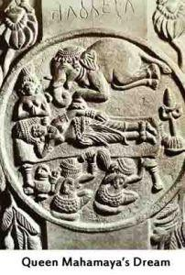

* The queen is reclining on the bed, whereas an elephant is shown on the top heading towards the womb of the queen Mayadevi.
* On the other hand, the **depiction of a Jataka story is very simple** – narrated by clubbing the events according to the geographical location of the story like the depiction of Ruru Jataka where the Bodhisattva deer rescuing a man on his back.
* Such Jataka stories became part of stupa decoration.
* With the rise in the construction of stupas in various parts of the country, regional stylistic variations also began to emerge.

#### Sanchi

* The next phase of cultural development at Sanchi stupa-1, Mathura and Vengi in Andhra Pradesh is noteworthy in the stylistic progression.
* Stupa-1 at Sanchi has upper as well as lower **pradakshinaptha or circumambulatory path.**
* It has four beautifully decorated **Torans (Gateways)** depicting various events from the life of Buddha and Jataka stories.
* Figure compositions are high in relief, filling up the entire space.
* The depiction of posture gets naturalistic and there is no stiffness in the body.
* The narration gets elaborated and carving techniques appear more advanced than Barhut.
* Symbols continued to be representing Buddhas or past Buddhas (according to the textual tradition there are 24 Buddhas, but only first one, Dipankar, and the last six are pictorially represented).
* Even though narrative gets more elaborated, the depiction of the dream episodes remains very simple (the dream of queen Mayadevi).

**Stupa-1, Sanchi (Madhya Pradesh):**

* Sanchi near Bhopal, Madhya Pradesh, is a **World Heritage Site.**
* Along with other relatively small stupas, there are **three main stupas**.
* Stupa-1 is presumed to have the relics of the Buddha.
* Stupa-2, the relics of ten less famous **Arhats** belonging to three different generations (In Theravada Buddhism, an Arhat is a perfected person who has attained Nirvana. In other Buddhist traditions, the term is used for people far advanced along the path of Enlightenment, but who may not reach full Buddhishood).
* Stupa-3 has the relics of **Sariputta and Mahamoggallana/Mahamougalayana** (disciples of Gautama Buddha).
* **Stupa-1 is the finest example of stupa architecture** and is known for the carvings on its gateways (torans).
* Originally it was a small brick structure which expanded over a period and was covered with stone,**vedika (fence)** and the torans.
* There is also the **upper pradakshinapatha which is unique to this site** (i.e., totally two pradakshinapathas).
* The four gateways are decorated profusely with sculptures.

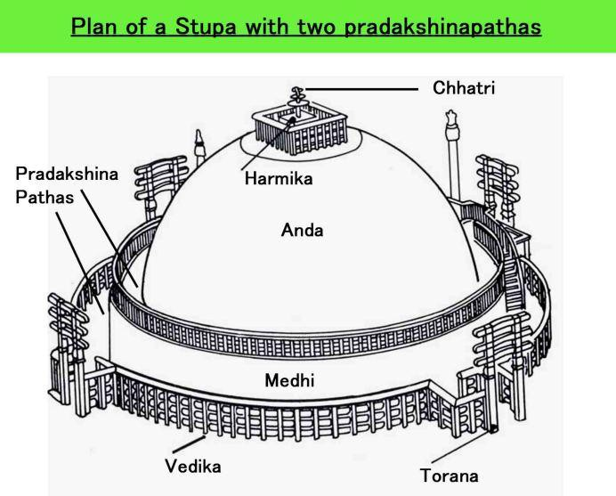

* **Buddha is shown symbolically as an empty throne, feet, chhatra, stupas etc**.
* Torans are constructed in all four directions.
* Their stylistic differences indicate their possible chronology from the first century BCE onwards.
* Though **stupa-1 is the oldest stupa,** the carvings of images at the vedika of stupa-2 are **earlier**than those on stupa-1.
* Jataka stories also became an important part of the narratives.
* The figures in Sanchi despite being small in dimension are very naturalistic.
* There are guardian images on sculptors and salabhanjika sculptures are remarkable in their volume (salabhanjika are sculpture of ladies holding the branch of a tree/plate etc).
* Each torana consists of two vertical pillars and three horizontal bars on the top.
* Each horizontal bar is decorated with different sculptural themes on both sides.
* Supporting the extension of the lowermost horizontal bar from below are the images of salabhanjikas.

#### Mathura, Sarnath, Amaravati and Gandhara Schools

* In the first century CE onwards, Gandhara (now in Pakistan), Mathura in UP and Vengi in Andhra Pradesh emerged as important centres of art.
* **Buddha in the symbolic form got a human form in Mathura and Gandhara.**
* The sculptural tradition in Gandhara had the confluence of Bactria, Parthia (both were Indo-Greeks) and the local Gandhara tradition.
* The local sculptural tradition of Mathura became so strong that the tradition spread to other parts of northern India. The best example is the stupa sculpture found at Sanghol in the Punjab.
* **The Buddha image at Mathura is modelled on the lines of earlier Yaksha images, whereas in Gandhara it has Hellenistic features**. [Hellenistic art is the art of the Classical period dating from the death of Alexander the Great in 323 BCE to the emergence of ancient Rome].
* Images of Vaishnava and Shaiva faiths are also found at Mathura, but Buddhist images are found in large numbers.
* The images of Vishnu and Shiva are represented with their Ayudhas (weapons).
* Characteristics of the different architectural schools are explained below with a suitable example from each.

**Seated Buddha, Katra mount, Mathura:**

* A large number of images dating back to the Kushan period are from Mathura.
* The image of Buddha from Karta Mount belongs to the second century CE.

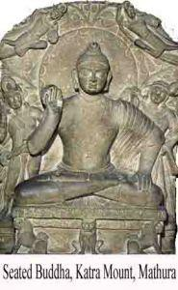

* It represents the Buddha with two Boddhisattva attendants.
* The Buddha is seated in Padmasana and the right hand is in the Abhayamudra.
* The face of the Buddha is round with fleshy cheeks.
* The **Ushanisha (hair knot)** is shown with a vertical raised projection.
* Mathura sculptures from this period are made with light volume having a fleshy body.
* The **sanghati (garment)** covers only one shoulder.
* The **attendant figures are** identified as the images of **Padmapani and Vajrapani** Bodhisattvas as one hold lotus and the other a Vajra (Thunderbolt).
* The halo around the head of Buddha is very large and is decorated with simple geometric motifs.
* There are two flying figures placed diagonally above the halo.

#### Seated Buddha at Sarnath, UP:

* The image of Buddha from Sarnath **made of chunar sandstone** belongs to the late fifth century CE.
* The Buddha is shown seated on a throne in Padmasana.

• It represents **Dhammachakrapravartana (first sermon)** as can be seen from the figures on the throne.

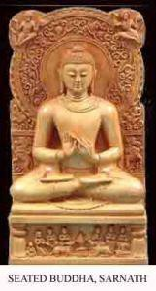

* The panel below the throne depicts a Chakra (wheel) in the centre and a deer on either side with his disciples.
* Thus, it is the representation of the historic event of Dhammachakrapravartana or the preaching of dhamma.
* It is the finest example of Sarnath School of sculpture.
* The face is round, the eyes are half closed, the lower lip is protruding, and the roundness of cheeks has reduced as compared to the earlier images from the Kushana period at Mathura.
* The **hands are shown in Dhammachakrapravartana Mudra.**
* The Ushanisha has circular curled hairs.
* The aim of the sculptures in ancient India had always been to represent the Buddha as a great human being who achieved **Nibbana (cessation of anger and hate)**.

#### Buddha Head, Taxila, Gandhara:

* The Buddha head from Taxila in the Gandhara region, now in Pakistan, dates back to the second century CE and belongs to the Kushanas period.
* It shows the hybridized pictorial convention that developed during the Gandhara period.
* It has **Greeko-Roman elements**.
* The Buddha Head has typical Hellenistic elements.
* The curly hair of Buddha is thick having a covered layer of shape and linear strokes over the head.
* The forehead plane is large having protruding eyeballs, eyes are half closed and the **face and cheeks are NOT round like the images of other parts of India.**
* There is a certain amount of heaviness in the figures of Gandhara region.

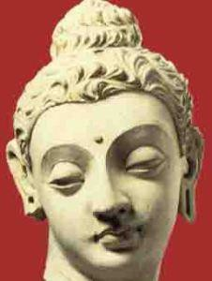

* The ears are elongated, especially the ear lobes.
* The treatment of the form bears linearity and the outlines are sharp.
* The surface is smooth and the image is very expressive.
* The expression of calmness is the centre point of attraction.
* Modelling of face enhances the naturalism and three-dimensionality.
* Assimilating various traits of Acamenian, Parthian and Bactrian tradition into the local tradition is a hallmark of Gandhara style.
* The source of development of Buddha images as well as other has its genesis in its peculiar geopolitical conditions.
* It may also be observed that the north-western part of India, which is now in Pakistan, always had continuous habitation from proto-historic times. It continued in the historic period as well.

#### Amaravati stupa, Andhra Pradesh:

* Vengi in Andhra Pradesh has many stupas like Jagayyapetta, Amaravati, Bahattiprolu, Nagarjunakonda, etc.
* Amaravati has a Mahachaitya and had many sculptures.
* Like Sanchi stupa, Amaravati stupa also has pradakshinapatha enclosed within a vedika on which many narrative sculptures are depicted.
* The **domical stupa structure is covered with relief stupa sculpture slab which is a unique feature**.
* The torana of the Amaravati stupa has disappeared over a period of time.
* Like Sanchi, the early phase is devoid of Buddha images but during the later phase (2nd and 3rd CE); the Buddha images are carved on the drum slabs and at many other places.
* The sculptural form in this area is characterized by intense emotions.
* Bodies are shown with three bends **(Tribanga)**, and the sculpture composition is more complex than Sanchi.
* The Dream of Queen Mayadevi has also been depicted here.
* Independent Buddha images are also found at Amaravati, Nagarjunakonda and Guntapalle.
* Guntapalle is a rock cut cave near Eluru, Andhra Pradesh.
* In Karnataka, **Sannati** is the largest stupa excavated yet.
* Along with the images of Buddha, other Buddhist images of Bodisattvas like Avalokiteswara, Padmapani, Vajrapani, Amitabha, and Maitreya Buddha started getting sculpted.

|  |  |  |
| --- | --- | --- |
| **Gandhara** | **Mathura** | **Amaravati** |
| * Hellenistic art, Greeko- Roman elements along with traditional elements. * Buddha is muscular. * Rich carving and great symbolism. * Highly polished and rich carvings. * Curly hair and elongated ears. * Flowing type dress. * Initially made of **stone** and later **stucco** used. | * Indigenous in the beginning but later influenced by Gandhara. * Less symbolism. * Not much refined compared to Gandhara. * Hair not always curly. * Mostly made of **red sand stone.** | * Completely indigenous. * Most of the works are on marbles. * Buddha mostly represented by symbols. * Beauty is less when compared to Gandhara and Mathura. |

**Cave tradition in western India**

* In the western India, many Buddhist caves dating back to the second century BCE onwards have been excavated.
* Mainly three architectural types were executed:

1. **Apsidal vault-roof chaitya hall** (found at Ajanta, Pitalkhora, Bhaja)
2. **Apsidal vault-roof pillar-less hall** (found at Thana-Nadsur)
3. **Flat roofed quadrangular hall with a circular chamber at the back** (found at Kondivite)

* In all the chaitya caves, a stupa at the back is common.
* In the first century BCE, some modifications were made to the standard plan of the apsidal vault-roof variety where the hall becomes rectangular with a stone screen wall as facade.
* **The biggest rock cur chaitya hall was excavated in Karla, Maharashtra.**
* Viharas are excavated in all the caves.
* The plan of vihara consists of a veranda, a hall and cells around the walls of the hall.
* Many of the early vihara caves are carved with interior decorative motifs like chaitya arches and the vedika designs over the cell doors of the cave.
* A stupa was added in the back of the vihara in the later period and it became Chaitya- Vihara.
* Junnar (Maharashtra) has the largest cave excavations – more than 200 caves around the hills of the town – whereas Kanheri in Mumbai has a hundred and eight excavated caves.
* **Vihara cave excavated at Junnar is popularly known as Ganeshi** because of an image of Ganesh belonging to a later period was installed in it.
* Earlier it was believed that because of the absence of the Buddha images, the caves were considered belonging to the **orthodox faith of Buddhism, Theravadins.**
* But with the discovery of Konkan Maurya inscription mentioning the Saka era 322 (400CE), it is now satisfactorily proved that the caves activity in western Deccan was an ongoing process and many caves had been carved with Buddha image where the image does not exist anymore.
* It may also be noted that many caves are converted into modern Hindu shrines and have become popular worship sites.

#### Ajanta:

* The famous cave site in western India is Ajanta.
* It is located in Aurangabad district of Maharashtra.
* It has **29 caves, including 4 chaitya caves.**
* It has the large Chaitya-Vihara and is **decorated with sculpture and paintings (murals).**
* **Ajanta is the only surviving example of the painting of the first century BCE and the fifth century BCE.**
* Some of the vihara caves here are unfinished.
* The important patrons of Ajanta were Varahadeva, the Prime Minister of Vakataka king Harisena; Upendragupta, the local king of the region and feudatory of Harisena; Buddhabadra and Mathurasena.
* Major paintings are in cave Nos. 1, 2, 16 and 17.
* The paintings have a lot of typological variations.
* Figures in the paintings are heavy like the sculptures of western India.
* Cave excavation and painting were a simultaneous process and dating of the paintings follows the date of the cave excavation.
* Almost in all the finished excavations, pictures have been painted, but very few have survived.
* Various skin colours in the paintings represent multi-coloured society.
* The themes of the paintings are events from the life of Buddha, the Jatakas and Avadanas.
* Events happened in the jungle and events happened in the palace are separated by their locations.
* Images of Padmapani and Vajrapani are very common in Ajanta.

**Padmapani Bodhisattva**

* It is a painting which dates back to the late first century CE.
* The Bodhisattva is holding a padma (Lotus) has large shoulders and has three bents in the
* body creating a movement in the picture space.

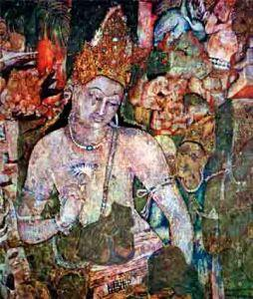

* The modelling is soft and the outlines are merged with the body volume, creating the effects of three- dimensionality.
* Light red, brown, green and blue colours are used in the picture.
* On the other side of the image, Vajrapani Bodhisattva has been painted.
* He holds a vajra in his right hand and wears a crown.
* Bodhisattvas are painted as shrine guardians
* Similar pictures can be seen in other caves too. However pictures in cave no.1 are among the best survived paintings of Ajanta.

**Mara Vijaya, Ajanta cave no. 26**

* The theme of Mara Vijaya has been painted in the caves of Ajanta, but only cave no.26 has a sculptural representation, sculpted on the right wall.
* The panel shows the image of the Buddha in the centre, surrounded by Mara’s army.
* The event is the part of enlightenment and **Mara represents desire.**
* It is the personification of mind which the Buddha went through at the time of enlightenment.
* The Buddha is shown with his right hand indicating towards the earth as a witness to his generosity.
* The image of Mara is shown contemplating how to disturb Siddhartha, the name of Buddha before enlightenment.

#### Ellora:

* Another important cave site located in Aurangabad is Ellora.
* It is located 100kms away from Ajanta.
* There are **32 Buddhist, Brahamanical and Jain caves.**
* It is unique art historic site in the country as it has monasteries associated with the three religions dating from fifth century CE onwards to eleventh century CE.
* It is also unique in terms of stylistic eclecticism, i.e., the confluence of many styles at one place.
* There are 12 Buddhist caves having many images belonging to Vajrayana Buddhism.
* Buddhist caves are big in size and are of a single, double and triple storey.
* The triple storey of Ellora is a unique one.
* Pillar designs grow from Buddhist caves and when they reach Jain caves (9th century CE), they become very ornate and the decorative forms gain heavy protrusion.
* Most of the caves of Brahamanical faith are dedicated to Shaivism.
* The different avatars of Vishnu are also depicted here.
* **Cave no.16 is known as Kailas Leni/ kailasa temple.**
* It is a rock cut temple which is carved out of a single rock.
* It was built in the 8th century CE.
* The grand sculpture of Ravana attempting to lift Mount Kailash, with his full might is a landmark in Indian art.

**Elephanta caves and other sites:**

* Elephanta caves located on Elephanta Island near Mumbai were originally a Buddhist site which was later dominated by the shaivite faith.
* It is contemporary with Ellora.
* The other noteworthy cave site is **Bagh located near Indore, MP.**
* The Bagh cave also contains paintings and a painting which represents a group of dancers resembles the Garba Dance of North India (originated in Gujarat).
* The tradition of rock-cut cave continued in the Deccan and they are found not only in Maharashtra but also in Karnataka, mainly at Badami and Aihole, executed under the patronage of the Chalukyas; in Andhra Pradesh in the area of Vijayawada; and in Tamil Nadu, mainly at Mahabalipuram, under the patronage of the Pallavas.
* When the early history of the country depends on collective public patronage, the post sixth century CE depends more on political patronage.
* The sculpture of **Maheshmurti** (Shiva at centre and heads of Bhairava and Uma on either side) is located here.

#### Cave tradition in Eastern India

* Like in western India, Buddhist caves have been excavated in eastern India, mainly in the coastal regions of Andhra Pradesh and Odisha.
* One of the main sites in Andhra Pradesh is Guntapalle in Eluru district.
* Guntapalle is among unique sites where the structural stupas, viharas and the caves are excavated at one place.
* Apart from Guntapalle, the other important site is Rampaerrampallam.
* In Ankapalli, near Vishakapattanam, a huge rock-cut stupa was carved out of the hillock during 4th- 5th century CE.
* It is a unique site as it has the biggest rock cut stupas in the country.
* Another important cave site is the Udayagiri-Khandagiri caves located in Odisha.
* These caves are scattered and have inscriptions of Kaharvela Kings.
* According to the inscription, the caves were meant for Jain monks.
* There are numerous single cell excavations here.
* The upper part of the cell is decorated with a series of Chaitya arches and narratives that still continue in the folklores of the region.

#### Early Temples

* While construction of stupas continued, Brahmanical temples and images of gods also started getting constructed.
* Myths mentioned in the Puranas became part of narrative representation.
* Each temple had a principal image of god.
* **The shrines of the temple were three kinds**:

1. **Sandhara type**: with pradakshinapatha.
2. **Nirandara type**: without pradakshinapatha.
3. **Sarvatobhadra type**: which can accessed from all sides.

* Some of the important temple sites of this period are Deogarh (UP), Eran, Nacha-kuthara and Udayagiri near Vidisha in MP, etc.
* These temples are simple structures consisting of a veranda, a hall and a shrine at the rear.

### Later Mural Traditions (Indian Culture Series – NCERT)

In this article titled ‘Later Mural Traditions’, we discuss about the mural traditions developed in India after the initial mural traditions of Ajanta, Ellora, and other such sites. This article is a part of the Indian Culture series based on the NCERT text book ‘An Introduction to Indian Art’ – Part 1. We have already discussed in detail about the [Prehistoric Era Art and the early Rock Paintings](http://www.clearias.com/prehistoric-rock-paintings/) in our previous posts. The article ‘Later Mural Traditions’ is a continuation of the previous posts like [Arts of the Mauryan Period](http://www.clearias.com/arts-mauryan-period/) and [Post Mauryan Trends in](http://www.clearias.com/post-mauryan-art-architecture/) [Indian Art and Architecture.](http://www.clearias.com/post-mauryan-art-architecture/)

#### Later Mural Traditions

* Even after Ajanta, very few sites with paintings have survived which provide valuable evidences to reconstruct the tradition of painting.
* The sculptures too were plastered and painted and the tradition of cave excavation continued further in many places where sculpting and painting were done simultaneously.

#### Badami:

* One of the examples of later Mural tradition is Badami, Karnataka.
* It was the **capital of the western Chalukyan dynasty,** which ruled the region from 543 to 598 CE.
* With the decline of the Vakataka rule, the Chalukyas established their power in the Deccan.
* The **Chalukya king, Mangalesha, patronized** the excavations of Badami caves. He was the younger son of the Chalukya king, Pulikeshi I, and the brother of Kirtivarman-I.

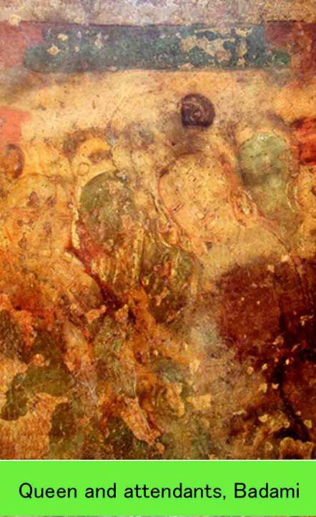

* The **cave No. 4 is popularly known as Vishnu cave** and in the inscriptions patron (Mangalesha) records his Vaishnava affiliation.
* One of the paintings shows Kirtivarman, the son of Pulikeshi I and the elder brother Mangalesha, seated inside the palace with his wife and feudatories watching a dance scene.
* Stylistically the painting represents an extension of the tradition of mural paintings from Ajanta to Badami in south India.
* The sinuously drawn lines, fluid forms and compact composition exemplify the proficiency and maturity the artist had achieved in the 6th century CE.
* The gracefully drawn faces remind us of the style of modelling in Ajanta.
* Their eye sockets are large, eyes are half closed, and the lips are protruding.

**Murals under Pallava, Pandava and Chola kings:**

* The tradition of painting extended further down south in Tamil Nadu in the preceding centuries with regional variations during the regime of Pallava, Pandya and Chola dynasties.
* The Pallava kings, who succeeded the Chalukyas in parts of the south India, were also patrons of the arts.
* Mahendravarman (Pallava) who ruled the 7th century CE was responsible for building temples atPanamalai, Mandagapattu, and Kanchipuram.
* **The inscriptions at Mandagapattu mentions Mahendravarman I with numerous titles such as Vichitrachitta (curious minded), Chitrakarapuli (tiger among artists), Chaityakari (temple builder), which shows his interests in art activities.**
* Paintings in Kanchipuram temple were patronized by the Pallava king, Rajasimha.
* Increased ornamentation was a notable feature of these paintings when compared with the paintings of the earlier period.
* When the Pandyas rose to power, they too patronized art.
* Tirumalaipuram caves and Jaina caves at Sittanvasal are some of the surviving examples.
* The tradition of building temples and embellishing them with carvings and paintings continued during the reign of the Chola kings who ruled over the region from 9th to the 13th

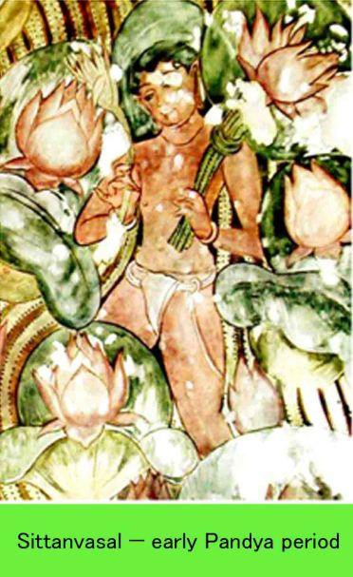

* But it was in the 11th century, when the Cholas reached their zenith of power, the masterpieces of Chola art and architecture began to appear.
* **The temples of Brihadeswara at Tanjore, Gangaikonda Cholapuram and Darasuram were built during the reign of Rajaraja Chola and Rajendra Chola.**
* The important paintings of Chola period can be seen at Nartamalai and Brihadeswara temples.
* In Brihadeswara temple, the paintings were executed on the walls of the narrow passage surrounding the shrine.
* Two layers of paints were found when they were discovered.
* The upper/outer layer was painted during the Nayaka period, in the 16th century.
* The Chola paintings at Brihadeswara are showing the aspects related to the Lord Shiva, Shiva in Kailash, Shiva as Tripuranartaka, Shiva as Nataraja, a portrait of **Rajaraja and his mentor Kuruvar**, dancing figures, etc.

#### Vijayanagara Mural:

With the decline of the Chola dynasty in the 13th century, the Vijayanagara dynasty captured and brought under its control the reign from Hampi to Trichy with **Hampi serving as its capital.**

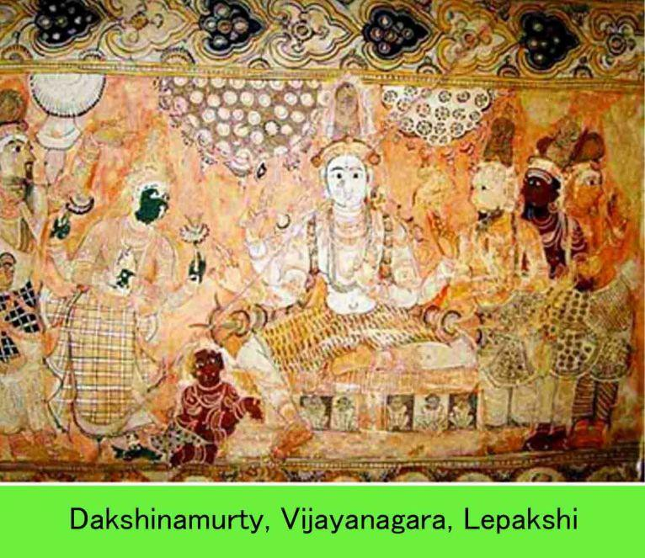

* The paintings at **Tiruparakunram, near Trichy**, done in the 14th century represent the early phase of the Vijayanagara style.
* In **Hampi** (Karnataka), the Virupaksha temple has paintings on the ceiling of its mandapa narrating vents from dynastic history and episodes from the Ramayana and Mahabharata.
* Among the important panels are the one which shows Vidyaranya, the spiritual teacher ofBukkaraya Harsha.
* In **Lepakshi,** near Hindupur, in present Andhra Pradesh, there are glorious examples of Vijayanagara paintings on the walls of the Shiva temple.
* The stylistic conventions of the proceeding centuries were adopted by artists in various centres in south India as can be seen in the paintings of the Nayaka period.
* **Nayaka paintings** in the 17th and 18th centuries are seen in Thiruparakuram, Sreerangam, and Tiruvarur (all in Tamil Nadu).
* In Tiruparakunram, paintings are found of two different periods – of the 14th and 17th Earlier paintings depict scenes from the life of Vardhamana Mahavira.
* The Nayaka paintings depict episodes from the Mahabharata and Ramayana and also scenes from Krishna Leela.
* In Tiruvarur, there is a panel narrating the story of Machukunda.
* In the Srikrishna temple at Ehengam in Arcot District there are 26 panels narrating the story of the Ramayana, which represents the late phase of the Nayaka paintings.
* From the examples, it suggests that **Nayaka paintings were more or less an extension** of Vijayanagara style with minor regional modifications and incorporations.
* The figures are **mostly set against a flat background** and the male figures are shown with slim waist but with less heavy abdomen as compared to those in Vijayanagara.

Kerala Mural:

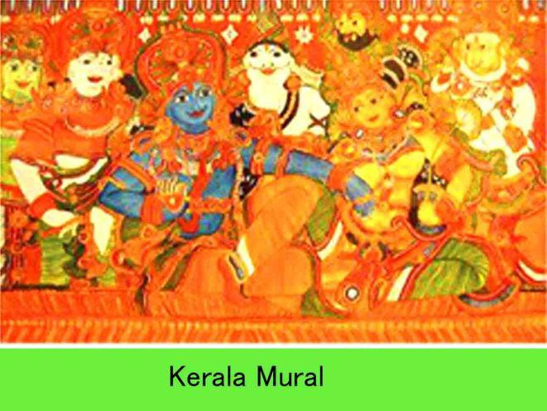

* Kerala painters (16th to 18th century) evolved a pictorial language and technology of their own while discriminately adopting certain stylistic elements from Nayaka and Vijayanagara schools.
* The painters evolved a language taking cues from contemporary traditions like Kathakali and Kalam Ezhuthtu using vibrant and luminous colours, representing human figures in three dimensions.
* Most of the paintings are seen on the shrine walls, cloister walls of temples and some inside the palaces.
* Thematically too, paintings from Kerala stand apart.
* Most of the narrations are based on those episodes from Hindu mythology which were popular in Kerala.
* The artist seems to have derived sources from oral traditions and local versions of the Ramayana and the Mahabharata for painting narrations.
* More than 60 sites have been found with mural paintings.
* **The important palaces where mural paintings can be found are** : Dutch Palace, Kochi, Krishna Puram palace, Kayamkulam and Padmanabhapuram palace.
* The mature phase of Kerala’s mural tradition can be seen at **Pundareekapuram Krishna Temple, Panayanarkavu, Thirukodithanam, Tripayar Sri Rama temple and Thrissur Vadakkunnatha temple.**

### Temple Architecture and Sculpture – Hindu, Buddhist and Jain (Indian Culture Series – NCERT)

In this mega-article, we shall discuss about the Indian temple architecture and sculpture in detail. This post is a part of the Indian Culture compilation based on the NCERT text book ‘An Introduction to Indian Art’ – Part 1. In the previous articles we have discussed about the [Later Mural Traditions,](http://www.clearias.com/later-mural-traditions/) [Post Mauryan Trends in Indian Art](http://www.clearias.com/post-mauryan-art-architecture/) [and Architecture,](http://www.clearias.com/post-mauryan-art-architecture/) [Arts of the Mauryan Period,](http://www.clearias.com/arts-mauryan-period/) [Arts of Indus Valley Civilization,](http://www.clearias.com/arts-indus-valley-civilization/) etc. In this post we deal

with major topics like Nagara Temple Architectural Style, Dravida Temple Architectural Style, Vesara Temple Architectural Style, etc. and the sculptures associated with them. We will also see Buddhist and Jain architecture.

#### Basic form of a Hindu temple

When you browse our earlier articles on Hindu Temple Architecture, you would realize one thing. It was a gradual evolution starting from the **rock cut- cave temples** to **monolithic rathas** which finally culminated in **structural temples**.The basic form of a Hindu structural temple consists of the following.

* 1. Garbhagriha:
* It literally means ‘womb-house’ and is a cave like sanctum.
* In the earliest temples, it was a small cubical structure with a single entrance.
* Later it grew into a larger complex.
* The Garbhagriha is made to house the main icon (main deity) which is itself the focus of much ritual attention.
  1. Mandapa:
* It is the entrance to the temple.
* It may be a portico or colonnaded (series of columns placed at regular intervals) hall that incorporate space for a large number of worshippers.
* Dances and such other entertainments are practiced here.
* Some temples have multiple mandapas in different sizes named as Ardhamandapa, Mandapa and Mahamandapa.

#### 3. Shikhara or Vimana:

* They are mountain like spire of a free standing temple.
* Shikhara is found in North Indian temples and Vimana is found in South Indian temples.
* Shikhara has a curving shape while vimana has a pyramidal like structure.

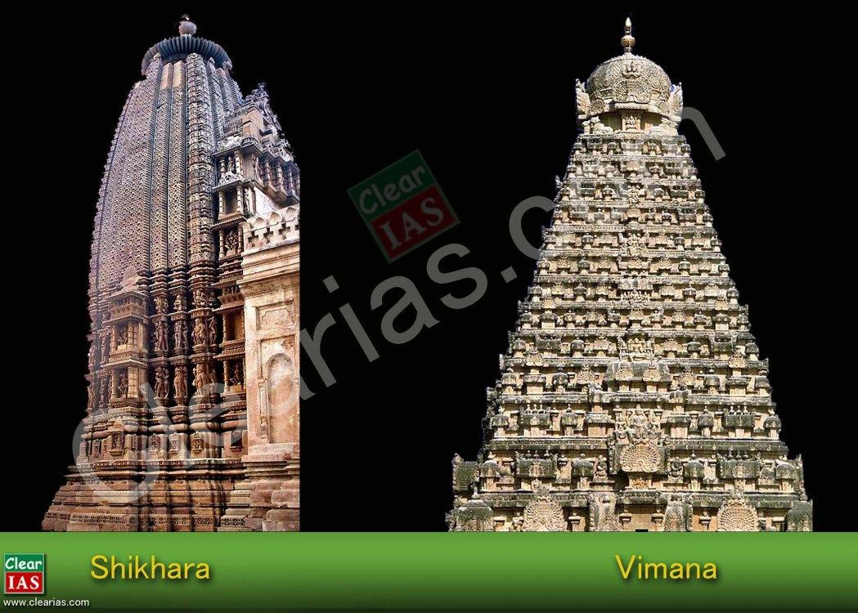

1. Amalaka:

* It is a stone disc like structure at the top of the temple and they are common in North Indian temples.

1. Kalasha:

* It is the topmost point of the temple and commonly seen in North Indian temples.

1. Antarala (vestibule):

* Antarala is a transition area between the Garbhagriha and the temple’s main hall (mandapa).

1. Jagati:

* It is a raised platform for sitting and praying and is common in North Indian temples.

1. **Vahan:**

* It is the mount or vehicle of the temple’s main deity along with a standard pillar or **Dhvaj** which is placed axially before the sanctum.

#### Classification of Indian Temples

Indian temples can be classified into two broad orders as

* **Nagara (in North India)**
* **Dravida (in South India)**
* At times, the **Vesara style** of temples as an independent style created through the mixing of Nagara and Dravida orders.

#### Sculptures, Iconography and Ornamentation

* **Iconography** is a branch of art history which studies **the images of deities**.
* It consists of identification of image based on certain symbols and mythology associated with them.
* Even though the fundamental myth and meaning of the deity may remain the same for centuries, its specific usage at a spot can be a response to its local or immediate social, political or geographical context.
* Every region and period produce its own distinct style of images with its regional variations in iconography.
* The temple is covered with elaborate sculptures and ornament that form a fundamental part of its conception.
* The placement of an image in a temple is carefully planned: for instance, **river goddesses (Ganga and Yamuna) are visually found at the entrances in a Nagara temple, Dwarapalas are usually found on the gateway or gopurams of Dravida temples**, similarly **mithunas (erotic images)**, navagrahas ( the 9 auspicious planets) and Yakshas are also placed at the entrances to guard them.
* Various forms or aspects of the main divinity are to be found on the outer walls of the sanctum.
* The ashtadikpalas (deities of direction) face eight key directions on the outer walls of the sanctum and/or on the outer walls of the temple.
* Subsidiary shrines around the main temple are dedicated to the family or incarnations of the main deity.
* The various elements of ornamentation are gavaksha, vyala/ yali, kalpa-lata, amalaka, kalasha, etc.

#### The Nagara or North Indian Temple Architecture

* Nagara is the style of temple architecture which became popular in Northern India.
* It is common here to build an entire temple on a stone platform with steps leading up to it.
* Unlike in south India, it doesn’t usually have elaborate boundary walls or gateways.
* Earliest temples had only one shikhara (tower), but in the later periods multiple shikharas came.
* The garbhagriha is always located directly under the tallest tower.

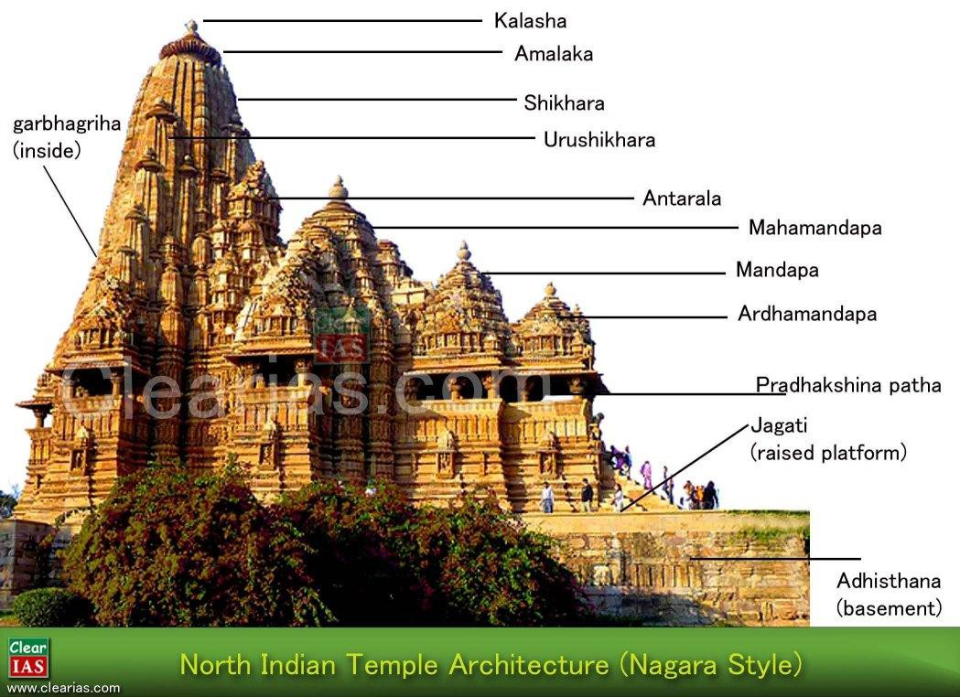

Nagara temples can be subdivided mainly into three – based on the shikhara type.

1. Latina/ Rekha-Prasada:

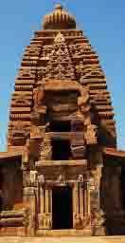

* It is the **simple and most common** type of shikhara.
* It is **square at the base and the walls curve or slope inwards to a point on top**.
* Latina types are mainly used for housing the garbhagriha.
* Later on, the Latina buildings grew complex, and instead of appearing like a single tower, the temple began to support many small towers, which were clustered together like rising mountain type with the tallest one being in the centre, and this was the one which was always above the garbhagriha.

1. Phamsana type shikhara:

* They are broader and shorter than Latina type.

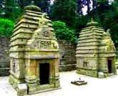

* Their **roof is composed of several slabs** that **gently rise** to a single point over the centre of the building, unlike the Latina ones which looks like sharply rising towers.
* Phamsana roofs do not curve inwards; instead they slope upward on a straight incline.
* In many north Indian temples, the phamsana type is used for mandapas while the main garbhagriha is housed in a Latina building.

1. Valabhi type shikhara:

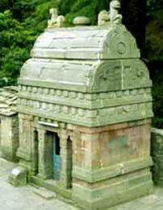

* These are **rectangular buildings with a roof that rises into a vaulted chamber**.
* The edge of the vaulted chamber is round, like the bamboo or wooden wagons that would have been drawn by bullocks in ancient times.
* The form of this temple is influenced by ancient building forms that were already in existence. We can also classify the Nagara Temples on the basis of region as follows:

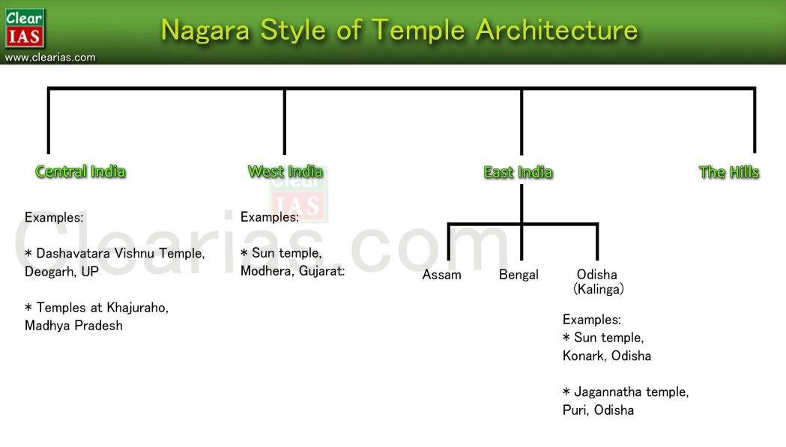

Central India

* In the later periods,the temples grew from simple four pillared structures to large complex.
* This means that similar developments were incorporated in the architecture of temples of both the religions.
* Two such temples that survive are; **temple at Udaygiri** which is on the outskirts of Vidisha (it is a part of a large Hindu temple complex) and a **temple at Sanchi**, which was a Buddhist site.
* The early temples were modest looking shrines each have four pillars that support a small mandapa before an equally small room that served as garbhagriha.
* Some of the oldest surviving structural temples of Gupta period are in Madhya Pradesh.
* The ancient temple sin UP, MP and Rajasthan share many traits and the most visible is that they are made of **Sandstone**.

1. ***Dashavatara Vishnu Temple, Deogarh, UP:***

* Even though the patrons and donors of the temple are unknown, it is believed that this temple was built in the early 6th century CE.
* This is a classical example of the late Gupta period.
* This temple is in the **Panchayatana** style of architecture. [Panchayatana is an architectural style where the main shrine is built on a rectangular plinth with four smaller subsidiary shrines at the four corners and making it a total of five shrines – i.e., Pancha]
* There are 3 main reliefs of Vishnu on the temple walls.
* In fact, it is not actually known to whom the four subsidiary shrines were originally dedicated.
* The temple depicts Vishnu in various forms due to which it was assumed that the four subsidiary shrines must also house Vishnu’s avatars and the temple was mistaken for a dashavatara temple.
* The grand doorway of the west facing temple (west facing is less common) has the sculptures of Ganga on the left and Yamuna on the right side.
* The shikhara is in latina/ prasada style which makes it clear that this is an early example of a classical nagara style of temple.
* **Sheshayana** – on the south (Vishnu reclining on the sheshanaga called Ananta)
* **Nara-narayana** – on the east (discussion between human soul and the eternal divine)
* **Gajendramoksha –** on the west (story of achieving moksha , symbolically communicated by Vishnu’s suppression o an asura who had taken the form of an elephant)
* The temple is west facing, which is less common, as most of the temples are east or north facing.

1. ***Temples at Khajuraho, Madhya Pradesh:***

* The temples at Khajuraho were made in the 10th century, about 400 years after the temple at Deogarh and the complex is a UNESCO World Heritage Site.
* The temples were patronized by Chandela kings.
* We can see how dramatically the shape and style of the nagara temple architecture had developed.
* The temples at Khajuraho are **all made of Sandstone.**
* The largest temple at Khajuraho is the Kandariya Mahadeva temple which is attributed to king Ganda.
* The Lakshmana temple dedicated to Vishnu was built in 954 by Chandela king, Dhanga.
* All the towers or shikhara of the temple rise high, upward in a curved pyramidal fashion, emphasizing the temple’s vertical thrust ending in a horizontal fluted disc called an Amalaka topped with a Kalasha or a vase.
* The crowning element Kalasha and Amalaka are to be found on all nagara temples of this period.
* The Khajuraho temples are also known for their extensive erotic sculptures (about 10% of total sculptures); the erotic expression gives equal importance in human experience as a spiritual pursuit, and it is seen as a part of the larger cosmic whole.
* Many Hindu temples, therefore feature Mithuns (embracing couples-erotic sculptures) sculptures, considered auspicious.
* Khajuraho sculptures are highly stylized with typical features.
* There are many temples at Khajuraho, most of them dedicated to Hindu gods.
* **There are some Jain temples as well as a Chausanth Yogini temple.**
* Chausanth Yogini is a temple of small square shrines dedicated to esoteric devis or goddesses associated with the rise of **Tantric worship after the 7th**
* [Khajuraho dance festival is organized by MP Kalaparishad and is a one week long (first week of February) festival of classical dances celebrated annually against the spectacular backdrop of Khajuraho]

West India

* There are too numerous temples in the northwestern parts of India, including Gujarat and Rajasthan, and stylistically extendable, at times, to western Madhya Pradesh.
* The stones to build temples ranges in colour and type.
* While **sandstone is the commonest,** a grey to black basalt can be seen in some of the 10th to 12thcentury temple sculptures.
* The most exuberant and famed is the manipulatable soft white marble which is also seen in some of the 10th to 12th century Jain temples in Mount Abu and the 15th century temple at Ranatpur.
* Among the most important art historical sites in the region is **Samlaji in Gujarat.**
* It shows how earlier artistic traditions of the region mixed with a post-Gupta style and gave rise to a distinct style of sculpture.
* A large number of sculptures made of grey schist have been found in this region.

1. ***Sun temple, Modhera, Gujarat:***

* The temple dates back to the early 11th century and was built by **Raja Bhimdev I** of the **Solanki dynasty.**
* The Solanks were a branch of later Chalukyas.
* There is a massive rectangular stepped tank called **Surya Kund** in front of it.
* The hundred square metre rectangular pond is perhaps the grandest temple tank in India.
* A hundred and eight miniature shrines are carved in between the steps inside the tank.

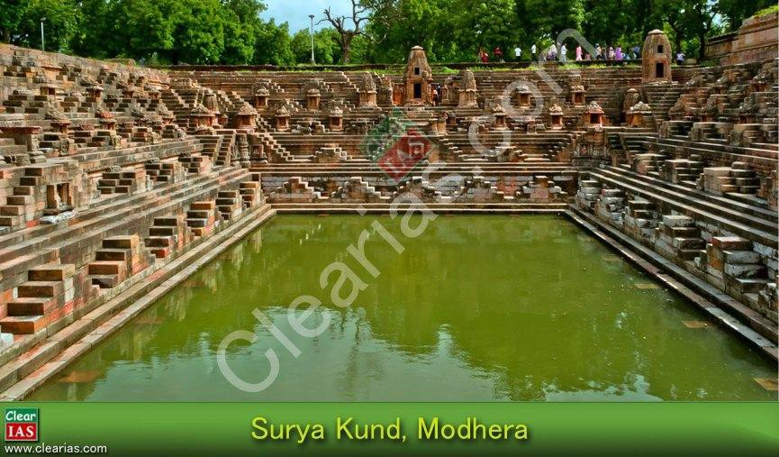

* A huge ornamental arch-torana leads one to the sabha mandapa (the assembly hall) which is open on all sides, as was the fashion of the times in western and central India temples.

East India

* East Indian temples include those found in the North-East, Bengal and Odisha and each of these three areas produce a distinct type of temple.
* The history of architecture in the northeast and Bengal is hard to study because a number of ancient buildings in those regions were renovated, and what survives now are later brick or concrete temples at those sites.
* It appears that terracotta was the main medium of construction.
* A large number of sculptures have been found in Assam and Bengal, which shows the development of important regional schools in those regions.

***Assam:***

* An old 6th century sculpted door frame from DaParvatia near Tezpur and another few stray sculptures from Rangagora Tea Estate near Tinsukia in Assam bear witness to the import of the Gupta idiom in that region.
* The post-Gupta style continued in the region well in the 10th
* However, by the 12th to 14th centuries, a distinct regional style developed in Assam.
* The style that came with the **migration of the Tais from upper Burma** mixed with the dominant Pala style of Bengal and led to the creation of what was later known as the **Ahom style in and around Guwahati**.
* Kamakhya temple, a Shakti peeth, is dedicated to goddess Kamakhya and was built in the 17thcentury.

***Bengal:***

* The style of sculptures during the period **between the 9th and 11th centuries in Bengal (including Bangladesh) and Bihar is known as the Pala style**, named after the ruling dynasty at that time.
* That **style in the mid 11th and mid 13th centuries is named after the Sena kings.**
* While the Palas are celebrated as patrons of Buddhist monastic sites, the temple of the region are known to express the **Vanga style.**
* The **Siddheswara Mahadeva temple in Burdwan, W.B**, built in the 9th century, shows a tall curving shikhara crowned by a large amalaka**, is an example of early Pala style.**
* Many of the temples from 9th to 12th centuries were located at **Telkupi** in Puruta district, W.B.
* They were submerged when dams were constructed in the region.
* The architecture of these temples heavily influenced the earliest Bengal Sultanate buildings at Gaur and Pandya.
* Many local vernacular building traditions of Bengal also influenced the style of the temple in that region.
* The most prominent of these was the shape of the **sloping or curving side of the bamboo roof of a Bengali hut.**
* This feature was eventually even adopted in Mughal buildings, and is known as across India as the**Bangla**

**Roof** (word Bungalow derived from this).

***Odisha (Kalingia Architecture):***

The main architectural features of Odisha temples are classified in three orders:

* 1. **Rekhapida/ Rekha deula/ rathaka deula:**

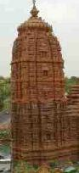

Rekha means line and it is a tall straight building with a shape of sugar loaf. It covers the garbhagriha.

* 1. **Pidhadeula:**

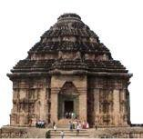

It is a square building with a pyramid shaped roof and is mainly found for **housing the outer dancing and offering** halls.

* 1. **Khakradeula:**

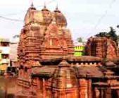

It is a rectangular building with truncated pyramid shaped roof. Temples of the**female deities** are usually in this form (garbhagriha usually) and will have a resemblance with Dravidian temples of south.

* Most of the ancient temples are located in ancient Kalinga – modern Puri district, including Bhuvaneswar or ancient Tribhuvaneswar, Puri, and Konark.
* The temples of Odisha constitute a distinct sub style within nagara order.
* In general, **here the Shikhara called Deul in Odisha is vertical almost until the top** when it suddenly curves sharply inwards.
* **Mandapas in Odisha are called Jagamohanas**.
* The ground plan of the main temple is almost always square, which, in the upper reaches of its superstructure becomes circular in the crowning
* The exterior of the temple is lavishly curved while their interiors are generally quite bare.
* **Odisha temples usually have outer walls.**

**1. Sun temple, Konark, Odisha:**

* It is built around 1240 on the shores of the Bay of Bengal.
* The temple is set on a high base, its walls covered in extensive, detailed ornamental carving.
* These include **12 pairs of enormous wheels** sculpted with spokes and hubs, representing the chariot wheels of the sun God who, in mythology, rides a chariot driven by 8 horses, sculpted here at the entrance staircase.
* The whole temple thus comes to resemble a colossal processional chariot.
* On the southern wall is a massive sculpture of Surya carved out of green stones.
* It is said that there were 3 such images, carved out of a different stone placed on the three temple walls, each facing different directions.
* The fourth wall had the doorway into the temple from where the actual rays of the sun would enter the garbhagriha.

**2. Jagannatha temple, Puri, Odisha:**

* It is also located on the eastern coast, at Puri, Odisha.
* The temple **is a part of Char Dham** (Badrinath, Dwaraka, Puri, Rameswaram) pilgrimages that a Hindu is expected to make in one’s lifetime.
* When most of the deities in the temples of India are made of stone or metal, the **idol of Jagannatha is made of wood** which is ceremoniously replaced in every twelve or nineteen years by using sacred trees.
* The temple is believed to be constructed in the 12th century by King Anatavarman Chodaganga Deva of the Eastern Ganga Dynasty.
* The temple is famous for its **annual Ratha Yatra or Chariot festival**.

The Hills

* A unique form of architecture developed in the hills of Kumaon, Garhwal, Himachal and Kashmir.
* Kashmir’s proximity to Gandhara site (such as Taxila, Peshawar and north-west frontier) left the region a strong Gandhara influence by the 5th century CE.
* This began to mix with the Gupta and post Gupta traditions that brought to it from Sarnath, Mathura, and even centres in Gujarat and Bengal.
* Both Buddhist and Hindu traditions began to intermingle and spread in the hills.
* The hills also had their own tradition of wooden building with pitched roofs and as a result, while the main garbhagriha and shikhara are made in latina/rekha-prasada type, the mandapa is of an older form of wooden architecture.
* Sometimes, the temple itself takes on a pagoda shape.
* The Karkota period of Kashmir is the most significant in terms of architecture.
* The most important temples of these regions are Pandrethan, Laksna-devi Mandir, Jageswar near Almora, Chambavat near Pithoragarh, etc.

#### The Dravida or South Indian Temple Architecture

* Unlike the nagara temple, the dravida temple is enclosed within a compound wall.
* The front wall has an entrance gateway in its centre, which is known as **Gopura/ Gopuram**.
* The shape of the main temple tower is known as Vimana (shikhara in nagara style).
* The vimana is like a stepped pyramid that rise up geometrically rather than the curving shikhara of north India.
* In south India, the word Shikhara is used only for the crowning element at the top of the temple which is usually shaped like a small stupika or an octagonal cupola (this is equivalent to the amalaka or kalasha of north Indian temples).

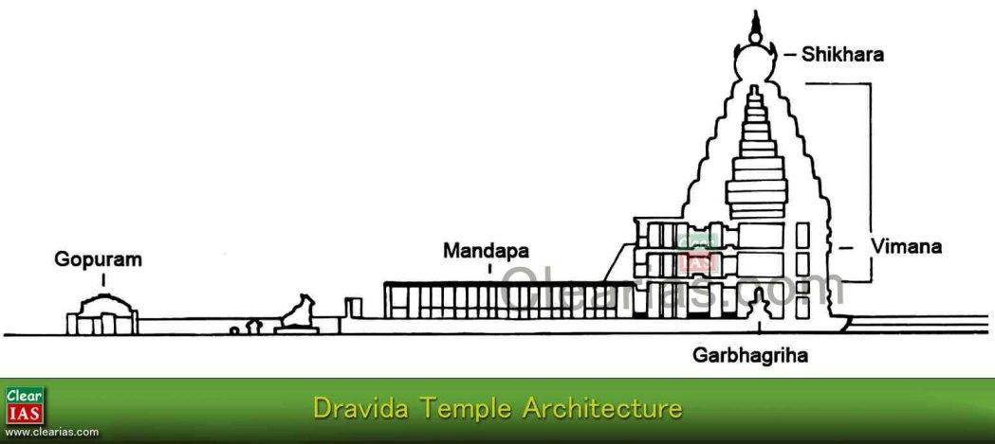

* In north Indian temples we can see images such as Mithunas (erotic) and the river goddesses, Ganga and Yamuna guarding the temple. But in the Dravida style of temple architecture, instead of these sculptures, we can see the sculptures of fierce dvarapalas or door keepers guarding the temple.
* A large water reservoir or a temple tank enclosed in the complex is general in south Indian temples.
* Subsidiary shrines are either incorporated within the main temple tower, or located as a distinct, separate small shrine besides the main temple.
* The north Indian idea of multiple shikharas rising together as a cluster was not popular in dravida style.
* At some of the most sacred temples in south India, the main temple in which the garbhagriha is situated has, in fact, one of the smallest towers.
* This is because it is usually the oldest part of the temple.
* When the population and the size of the town associated with the temple increased, it would have become necessary to make a new boundary wall around the temple (and also associated structures).
* An example for this is the Srirangam temple at Thiruchirapally, which has as many as seven concentric rectangular enclosure walls, each with gopurams.
* The outermost is the oldest while the tower right in the centre housing the garbhagriha is the oldest.
* Just as the nagara architecture has subdivisions, dravida temples also have subdivisions. These are basically of five different shapes:

1. Kuta or caturasra – square
2. Shala or ayatasra – rectangular
3. Gaja-prishta or vrittayata (elephant backed) –elliptic
4. Vritta – circular
5. Ashtasra – octagonal

***Pallavas:***

* The [Pallavas](http://www.clearias.com/hindu-temple-architecture-pallava/) were one of the ancient south Indian dynasties that were active in Andhra region from the 2nd century onwards and moved south to settle in Tamil Nadu.
* Their history is better documented in the inscriptions in stone and several monuments.
* Although they were mostly Shaivites, several Vaishnava shrines also survived from the reign, and there is no doubt that they were influenced by the long Buddhist history of the Deccan.
* The early buildings of Pallavas were rock-cut; while the later ones were structural (structural buildings were well known to them when rock cut ones being excavated).
* The **early buildings are generally attributed to Mahendravarman I**, contemporary of Chalukya king, Pulikeshi II of Karnataka.
* **Narasimhavarman I, who was also known as Mamalla,** acceded the throne around 640 CE.
* He expanded the empire and also inaugurated most of the building work at Mahabalipuram which is known after him as Mamallapuram.

***The shore temple at Mahabalipuram, Tamil Nadu***

* It is a structural temple and was built during the reign of **Narasimhavarman II, also known as Rajasimha.**
* The temple is facing to east towards the sea and has three shrines – east and west to Shiva and the middle for Vishnu (Anantashayana).
* This is unusual because temples generally have a single main shrine and not three areas of worship. This shows that it was probably not originally conceived like this and different shrine may be added at different times.
* In the compound, there is an evidence of a water tank, an early example of a gopuram, and several other images.
* Sculpture of the bull, Nandi, Shiva’s mount, lines the temple walls.
* The temple has suffered severe disfiguration due to erosion by salt water laden air over the centuries. The Pallava temple architecture can be classified into four groups according to the rulers and the features of temples they constructed.
  1. **Mahendravarman Group:**
* Early temples of the Pallavas belong to King Mahendravarman I (7th century).
* They were **rock cut temples** (may be influenced from rock cut architecture).
* g. Manndagapattu, Mahendravadi, Tircuchirapally, etc.

1. **Narasimha/Mamalla Group:**

* It is the second stage of Pallava architecture which started when Narasimhavarman I (Mamalla) came to throne.
* The architecture is represented by **Monolithic rocks.**
* The monolithic rathas and mandapas of Mamallapuram are examples.
* The five rathas are popularly known as Panchapandava rathas.

1. **Rajasimha Group:**

* The group was under Narasimhavarman II who was also known as Rajasimha.
* He introduced the structural temples and Gopura style in Pallava architecture.
* The Kailasnath temple at Kanchi and the Shore temple at Mahabalipuram are examples.

1. **Nandivaram Group:**

* Architecture mainly under the Pallava king, Nandivaram Pallava.
* They also represented structural temples.
* The temples were generally small compared to the other groups.
* The Vaikundaperumal temple, Tirunelveli and Mukteswara temple are examples.

**Cholas**

* The best example of [Chola temple architecture](http://www.clearias.com/hindu-temple-architecture-cholas/) is the **Brihadeswara temple at Tanjore.**
* The temple is **also known as Rajarajeswara temple.**
* It was completed around 1009 by **Rajaraja Chola**, and is the **largest and tallest of all Indian temples.**
* The temples pyramidal multi-storeyed Vimana rises a massive seventy metres, topped by a monolithic shikhara, and the kalasha on top by itself is about three metres and eight centimetres in height.
* The main deity of the temple is Shiva, who is shown as a huge lingam set in a two storeyed sanctum.
* **Painted Murals** and sculptures decorate the walls surrounding the sanctum.

**The Vesara or the Deccan Temple Architecture**

* The buildings in the Deccan region are hybridized style, which contain both elements from nagara

and dravida architectural styles and is known in some ancient texts as the Vesara style (not all temples of Deccan are vesara type).

* The vesara style became popular after the mid 7th century.

**Chalukyas**

* 1. **Ravan Phadi cave, Aihole, Karnataka:**
* The Ravan Phadi cave at Aihole is an example of the early [Chalukya style](http://www.clearias.com/hindu-temple-architecture-chalukyas/) which is known for its distinct sculptural style.
* One of the most important sculptures at the site is of Nataraja, surrounded by a large depiction ofsaptamatrikas: three to Shiva’s left and four to his right.
  1. **Lad Khan Temple at Aihole, Karnataka:**
* The temple is dedicated to Shiva and is one of the oldest Hindu temples.
* Built in the 5th century by the Kings of the Chalukya Dynasty.
* It seems to be inspired by the wooden – roofed temples of the hills except that it is constructed out of stone.
* The temple is named after a person named Lad Khan, who turned this temple into his residence for a short period.
  1. **Durga Temple at Aihole, Karnataka:**
* The temple is built in between 7th and 8th century.
* Architecture of the temple is predominantly Dravida with Nagara style also in certain areas.
* The temple is considered as a unique and magnificent temple of the Chalukya period.
* The Lad Khan Temple of Aihole is located to its South.
  1. **Temples at Pattadakkal, Karnataka:**
* There **are ten temples at Pattadakkal including a Jain temple and is a UNESCO world Heritage Site.**
* A fusion of various architectural styles can be seen here.
* Out of ten temples, four are in dravida style, four are in nagara style and one is Jain temple, while the **Papanatha Temple** is built in a fusion of both nagara and Dravida styles.
* The Jain temple (Jain Narayana temple) was built by Rashtrakutas in the 9th
* The Virupaksha temple at Pattadakkal is also known as Sri-Lokeswar-Maha-Sila-Prasad, was built by Loka Mahadevi, the Queen of the Chalukya king Vikramaditya II (733-44).
* It was probably built around 740 CE to commemorate her husband’s victory over the Pallavas of Kanchipuram.
* It closely resembles the Kailasnath temple at Kanchipuram on plan and elevation.
* It represents a fully developed and perfect stage of the dravida architecture.

**Rashtrakutas**

* By about 750 CE, the early western Chalukya control of the Deccan was taken by the Rashtrakutas.
* Their greatest achievement in architecture is the **Kailasnath Temple at Ellora.**
* The Jain temple at Pattadakkal was also built by Rashtrakutas.

Hoyasalas

* With the waning Chola and Pandya power, the [Hoyasalas](http://www.clearias.com/hindu-temple-architecture-hoysala/) of Karnataka grew into prominence in south India and became the most important patrons centred at Mysore.
* The three main temples of Hoyasala are the temples at Belur, Halebid and Somanathpuram.
* The most characteristic feature of these temples is that they grow extremely complex with so many projecting angles emerging from the previously straight forward square temple so that **the plan of these temples starts looking like a star**.
* **As the plan looks like a star, it is known as stellate plan.**
* They are usually made out of **soapstone**. **Temples at Halebid, Karnataka:**
* The temple is also known as Hoyasaleswara temple.
* Built in dark schist stone by the Hoyasala king Vishnuvardhan in 1150.
* Dedicated to Shiva as Nataraja and contains a large hall for the mandapa to facilitate music and dance.
* In the bottom frieze of the temple featuring a continuous procession of hundreds of elephants with their mahouts, no two elephant are in the same position.

Vijayanagara

* The Vijayanagara Empire, which was founded in the 14th century, attracted a number of international travellers such as the Italian, Nicoclo di Conti, the Portuguese Domingo Paes, Fernao Nuniz and Duarte Barbosa and the Afghan Abd, al- Razzaq, who have left vivid accounts of the city.
* Architecturally, Vijayanagara synthesizes the centuries old dravida temple architecture with Islamic styles demonstrated by the neighbouring Sultanates.
* Their sculptures too, which were consciously seeking to recreate Chola ideals, occasionally shows the presence of foreigners.

#### Buddhist and Jain Architectural Developments

The period of 5th to 14th centuries were not only the period of the development of Hindu temples, but also were equally vibrant period for the Buddhist and Jain architectures.

Buddhist Architecture

* When the Gupta empire crumbled in the 6th century CE, the eastern region of Bihar and Bengal , historically known as Magadha, appears to have remained unified whilst numerous small Rajput principalities sprang up to the west.
* In the 8th century, the Palas came to power in the region.
* The 2nd Pala ruler, Dharmapala, became immensely powerful and established an empire by defeating the powerful Rajput Pratiharas.
* Dharmapala consolidated an empire whose wealth lay in a consolidation of agriculture along the fertile Ganges plain and international trade.

***Bodhgaya, Bihar:***

* Bodhgaya became a pilgrimage site since Siddhartha achieved enlightenment here and became Gautama Buddha.
* The Mahabodhi Temple at Bodhgaya is an important reminder of the brickwork of that time.
* The first shrine here, located at the base of the Bodhi Tree, is said to have been constructed by the King Ashoka.
* The vedika (fence) around it is said to be Post-Mauryan, of about 100 BCE.
* Many sculptures in the temple are dated to the 8th century Pala period.
* The actual Mahabodhi temple as it stands now is largely a colonial period reconstruction of the old 7th
* The design of the temple is unusual and is neither dravida nor nagara style.

***Nalanda, Bihar:***

* The monastic University of Nalanda is a **Mahavihara** as it is a complex of several monasteries of various sizes.
* Only a small portion of this ancient learning centre has been excavated till date, as most of it lies buried under contemporary civilization, making further excavations almost impossible.
* Most of the information about Nalanda is based on the records of Xuan Zang/Hsuan Tsang (Chinese traveller).
* It states that the foundation of the monastery was laid by **Kumaragupta I** in the 5th century CE.
* All three Buddhist doctrines – Theravada, Mahayana and Vajrayana – were taught here.
* Monks came to here from the different regions of the world such as China, Sri Lanka, Thailand, Burma, etc.
* Monks and pilgrims who came here take back small sculptures and illustrated manuscripts to their homeland, which resulted in a decisive impact on the arts of the Buddhist countries in Asia.
* The sculptural art of Nalanda was developed out of a heavy dependence on the Buddhist Gupta art of Sarnath.
* The Sculptures were mainly made in stucco, stone and bronze.
* By the 9th century, Nalanda school of sculpture was formed which was characterized by distinctive facial features, body forms and treatment of clothing and jewellery.
* The Nalanda sculptures initially depict Buddhist deities of the Mahayana tradition, such as standing Buddhas, bodhisattvas, etc.
* During the 11th and 12th centuries, Nalanda emerged as an important tantric centre and the sculptures during that period dominated by deities of Vajrayana tradition, such as Vajrasharada (a form of Saraswati), Khasarpana, Avalokiteswara, etc.
* Various brahmanical images have also been found at Nalanda.

#### Jain Architecture

* Jains were also prolific temple builders like Hindus and their sacred shrines and pilgrimage spots can be found across the country.
* **The oldest Jain pilgrimage sites are to be found in Bihar**.
* In the Deccan, some of the most architecturally important Jain sites can be found at Ellora and Aihole.
* **Karnataka has** a rich heritage of Jain shrines and the **Sravana Belagola**, the famous statue of the**Gomateswara, the granite statue of Lord Bahubali which stands eighteen metre, is the world’s tallest monolithic free**

**standing structure.**

* It was commissioned by Camundaraya, the General-in-Chief and Prime Minister of the Ganga Kings of Mysore.
* Gujarat and Rajasthan have been strongholds of Jainism since early times.
* The **Jain temples at Mount Abu (Dilwara Temples) were constructed by Vimal Shah.**
* One can see a complex of temples carved of **white marble**
* The temples are famous for its unique patterns on very ceilings, and graceful bracket figs along the domed ceiling.

1. **Indian Bronze Sculpture (Indian Culture Series – NCERT)**

In this article we discuss about the Indian Bronze Sculptures. The post deals with bronze casting technique, bronze sculptures in North and South India, and some of the important examples of bronze sculptures like Nataraja. As you rightly guessed, this article too is a part of the Indian Culture series based on the NCERT textbook ‘An Introduction to Indian Art’. In the previous posts we have discussed in detail about the Temple Architecture, Post Mauryan Trends in Indian Art and Architecture, etc. This is a continuation of those posts and the second last entry in the series.

### Bronze sculptures of India

* + We know that Indian sculptures were masters in terracotta sculpturing and carving in stones. They were masters in the bronze medium too.
  + Bronze is Copper + Tin.
  + The **‘Cire-Perdu’ or ‘Lost Wax’ technique** for casting was learnt as long ago as the [Indus Valley](http://www.clearias.com/arts-indus-valley-civilization/) [Civilization.](http://www.clearias.com/arts-indus-valley-civilization/)
  + The ‘Dancing Girl’ in tribhanga posture found from Mohenjo-Daro is the earliest bronze sculpture datable to 2500 BCE.
  + Sculptors discovered the process of making alloys of metals by mixing copper, zinc and tin which called Bronze.
  + Bronze sculptures and statuettes of Buddhist, Hindu and Jain icons have been discovered from many regions of India dating from the 2nd century AD until the 16th century AD.
  + Most of these were required for ritual worship and are characterized by exquisite beauty and aesthetic appeal.
  + The metal casting process was also used for making articles for various purposes of daily use, such as utensils for cooking, eating, drinking, etc.
  + The present day tribal communities also utilizes the ‘lost wax’ process for their artistic expression.

**North India**

* + Dancing girl – Mohanjadaro.
  + Chariot – Daimabad (Maharashtra) datable to 1500 BCE.
  + Interesting **images of Jain Thirthankaras** have been discovered from Chausa, Bihar, belonging to the **Kushana period during the 2nd century CE**.
  + These shows how the Indian sculptors had mastered the modelling of masculine human physique and simplified muscles.
  + Remarkable is the depiction of **Adinath or Vrishabhanath**, who is identified with long **hair locks**dropping to his shoulders. **Otherwise the thirthankaras are noted by their short curly hair.**
  + Many standing Buddha images with right hand in Abhaya Mudra were cast in the North India, particularly in UP and Bihar, during the Gupta and the Post-Gupta periods.
  + The Sanghati or **the Monks Robe** is wrapped to cover the shoulders, which turn over the arm, while the other end of the drapery is wrapped over the left arm.
  + The cloths of Buddha figures were thin.
  + The figure appears youthful and proportionate in comparison with the Kushana style.
  + In the typical bronze from Dhanesar Khera, UP, the folds of the drapery are treated as in the Mathura style, i.e., in a series of dropping down curves.
  + Sarnath style bronze have fold less drapery and an outstanding example is that of the Buddha image at Sultanganj, Bihar, which is a quiet monumental bronze figure.
  + Vakataka bronze images of Buddha from Phophnar, Maharashtra are contemporary with the Gupta period bronzes. They show the influence of the Amaravati style of Andhra Pradesh in the 3rdcentury and at the same time, there is a significant change in the draping style of monk’s robe.
  + Buddha’s right hand in Abhaya Mudra is free so that the contemporary drapery clings to the right side of the body contour. The result is a continuous flowing line on this side of the figure.
  + The additional importance of the **Gupta and Vakataka** bronze is that **they were portable** and monks carried them from place to place for the purpose of individual worship or to be installed in Buddhist Viharas.
  + In the manner, the refined classical style spread to different parts of India and to Asian countries overseas.
  + Himachal Pradesh and Kashmir regions also produced bronze images of Buddhist deities as well as Hindu gods and goddesses.
  + Most of these were created during the 8th, 9th and 10th centuries and have a very distinct style in comparison with bronze from other parts of India.
  + A noteworthy development is the **growth of different types of iconography of Vishnu images**.
  + Four headed Vishnu, also known as **Chaturanana or Vaikuntha Vishnu**, was worshipped in these regions.
  + In **Buddhist** centres like Nalanda, a school of bronze casting emerged around the 9th century, during the rule of the **Pala dynasty** in Bihar and Bengal regions.
  + In the gap of a few centuries the sculptors at Kurkihar near Nalanda were able to revive the classical style of the Gupta period.
  + A remarkable bronze is of a **four armed Avalokiteswara**, which is a good example of male figure in graceful tribhanga posture.
  + **Worship of female goddesses** was adopted which is a part of the growth of the **Vajrayana phase in Buddhism**. Images of **Tara** became popular. Seated on the throne, she is accompanied by a growing curvilinear lotus stalk and her right hand is in Abhaya Mudra.

**South India**

* + The bronze casting technique and making of bronze images of traditional icons reached a high stage of development in south India during the medieval period.
  + Among the **Pallava period** bronze of the 8th century, the best one is the **icon of Shiva** seated in Ardhaparyanka asana (one leg kept dangling). The right hand is in the **Achamana Mudra gesture,**suggesting that he is about to drink poison.
  + Although bronze images were modeled and cast during the Pallava period in the 8th and 9th centuries, some of the most beautiful and exquisite statues were produced during the **Chola period** in Tamil Nadu from 10th to 12th century AD.
  + The technique of art fashioning bronze images is still skilfully practiced in South India, particularly in **Kumbakonam**.
  + The distinguished patron during the 10th century was the widowed Chola Queen, Sembiyan **Maha Devi.**
  + Chola bronze images are the most sought after collectors’ items by art lovers all over the world.
  + The well known dancing figure of **Shiva as Nataraja** was evolved and fully developed during the**Chola period** and since then many variations of this complex bronze image have been modeled.

##### A wide range of Shiva iconography was evolved in the Tanjore region of Tamil Nadu.

* + The 9th century **Kalyanasundara Murti** is highly remarkable for the manner in which panigrahana (ceremony of marriage) is represented by two separate statuettes.
  + Shiva with his extended right hand accepts Parvati’s (the bride’s) right hand, who is depicted with a bashful expression and taking a step forward.
  + The **union of Shiva and Parvati** is very ingeniously represented in the **Ardhanarisvra** in a single image.

Beautiful independent figurines of Parvati have also been modelled, standing in the graceful tribhanga posture.

* + During the 16th century known as the Vijayanagara period in Andhra Pradesh, the sculptors experimented with portrait sculpture in order to preserve knowledge of the royal patrons for prosperity. At Tirupati, the life-size standing portrait statue was cast in bronze, depicting Krishnadevaraya with his two queens, Tirumalamba and Chinnadevi.
  + The sculpture has combined the likeness of the facial features with certain elements of idealization.
  + The idealization is further observed in the manner the physical body is modeled to appear imposing as well as graceful.
  + The standing King and Queens are depicted in a praying posture, that is, both hands in the Namaskara mudra.

Nataraja

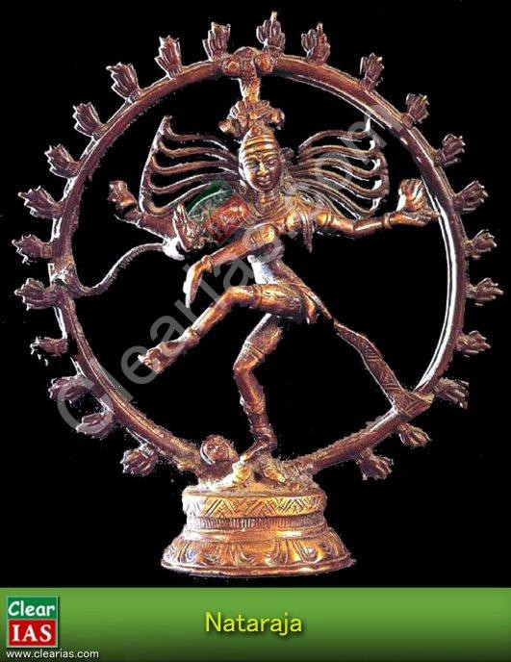

* + - Shiva is associated with the end of the cosmic world with which his dancing position is associated.
    - In this Chola period bronze sculpture, he has been shown **balancing himself on his right** leg and**suppressing the apasmara, the demon of ignorance or forgetfulness**, with the foot of the same leg.
    - At the same time, he raises his **left hand in Bhujangatrasita stance, which represents tirobhava that is kicking away the veil of maya or illusion** from the devotee’s mind.
    - His four arms are outstretched and the main right hand is posed in Abhayahasta or the gesture suggesting.
    - The upper right hand holds the damura, his favourite musical instrument to keep on the beat tala.
    - The upper left hand carries a flame while the main left hand is held in the Dolahasta and connects with the Abhayahasta of the right hand.
  + His hair locks fly on both the sides touching the circular jvala mala or the garland of flames which surrounds the entire dancing figure.

# Indo-Islamic Architecture (Indian Culture Series – NCERT)

In this article, we discuss the Indo-Islamic architecture, which is also known as Indo-Saracenic architecture. This is the last chapter (8th) of the NCERT text book ‘An Introduction to Indian Art’ – Part 1. This post finish our task of covering the highlights of the book in an exam-friendly manner, but we don’t stop creating ‘easy-to- read articles’ for our readers here. We will surely come up with more articles on Indian culture (topics like Painting, Dances etc) from other sources soon.

Here we discuss about various examples of Indo-Islamic architecture, their styles, certain decoration techniques, etc. In previous posts, we have already discussed about the ancient art and architecture. Use the search bar in this website for [arts of the Mauryan Period,](http://www.clearias.com/arts-mauryan-period/) [Arts of Indus Valley Civilization,](http://www.clearias.com/arts-indus-valley-civilization/) and medieval period [temple art](http://www.clearias.com/temple-architecture-sculpture/) [and architecture.](http://www.clearias.com/temple-architecture-sculpture/)

**How did Indo-Islamic Architecture evolve?**

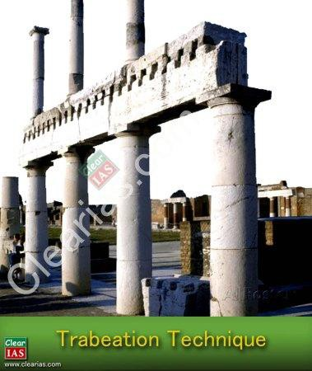

* In the 7th and 8th centuries CE, Islam spread towards Spain and India.
* Islam came to India particularly with merchants, traders, holy men and conquerors over a passage of 600 years.
* Although by the 8th century Muslims had begun to construct in Sindh, Gujarat, etc., it was only in the

13thcentury that large-scale building activity was begun by the Turkish state, established after the Turkish conquest of the North India.

* A noteworthy aspect of these migrations and conquests was that Muslims absorbed many features of local culture and tradition and combined them with their own architectural features.
* Thus, in the field of architecture, a mix of many structural techniques, stylized shapes, and surface decorations came about through constant interventions of acceptance, rejections or modifications of architectural elements.
* These architectural entities or categories showcasing multiple styles are known as **Indo-Saracenic or Indo- Islamic Architecture.**
* By the 12th century, India was already familiar with monumental construction in grandiose settings.
* Certain techniques and embellishments were prevalent and popular, such as trabeation (the use of beam rather than arches or vaulting), brackets, and multiple pillars to support a flat roof or a small shallow dome.
* The arches in early constructions were shaped in wood and stone, and were unable to bear the weight of the domes/top structures.
* Such arches needed to be constructed with voussoirs (series of interlocking blocks) and fitted with keystones.

**Categories of Styles**

The study of Indo-Islamic architecture is conventionally categorized as follows:

1. **The Imperial Style (Delhi sultanate)**
2. **The Provincial styles (Mandu, Gujarat, Bengal and Jaunpur)**
3. **The Mughal Style (Delhi, Agra and Lahore)**
4. **The Deccani style (Bijapur and Golconda)**

* Amongst provincial styles, the architecture of Bengal and Jaunpur is regarded as distinct.
* Gujarat was said to have a markedly regional character for patrons borrowed elements from the regional temple traditions such as torans, lintels in mihrabs, carving of bell and chain motifs, and carved panels depicting trees, for tombs, mosques and dargahs.
* The 15th century white marble dargah of Sheikh Ahmad Khattu of Sarkhej is a good example of provincial

style and it heavily influenced the forms and decoration of Mughal tombs.

**Decorative Forms**

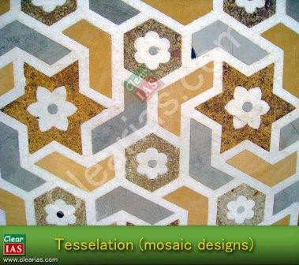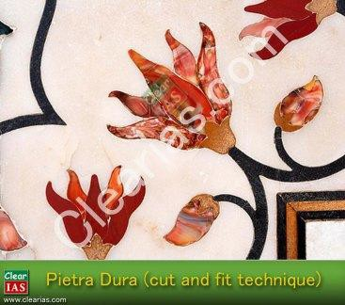

* These forms include designing on plasters through incisions or stucco.
* The designs were either left plain or covered with colours.
* Motifs were also painted on or carved in stones.
* These motifs include varieties of flowers, both from sub-continent and places outside, particularly Iran.
* The lotus bridge fringe was used to great advantage in the inner curves of the arches.
* The walls were also decorated with Cypress, Chinar, and other trees as also with flower vases.
* Many complex designs of flower motifs decorating the ceiling were also to be found on textiles and carpets.
* In the 14th, 15th and 16th centuries, tiles were also used to surface the walls and the domes.
* Popular colours were blue, turquoise, green and yellow.
* Subsequently the techniques of **tessellation (mosaic designs) and pietra dura (cut and fit technique)** were made use of for surface decoration, particularly in the dodo panels of the walls.
* At times, Lapis Lazuli (a kind of blue stone) was used on the interior walls or on canopies.

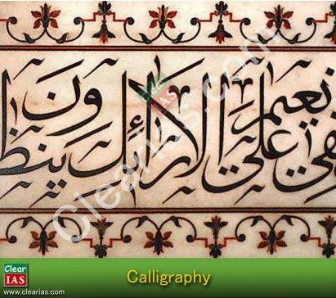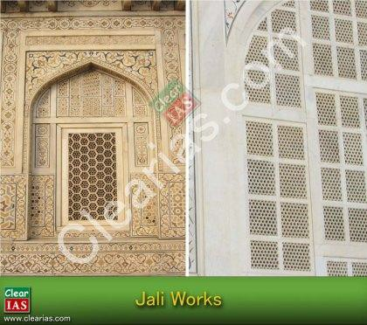

* Arabesque (surface decorations based on rhythmic linear patterns of scrolling and interlacing foliage, tendrils), calligraphy, Jalis (perforated stone or latticed screen), etc. were other decorative works.

**Constructing Materials**

* The walls in all buildings were extremely thick and were largely constructed of rubble masonry, which were easily available.
* These walls were then cased over with chunam or limestone plaster or dressed stone.
* An amazing ranges of stones were utilized for construction such as quartzite, sandstone, buffs, marbles, etc.
* Polychrome tiles were used to great advantage to finish the walls.
* From the **17th century onwards, bricks were also used** for construction and in this phase there was more reliance on local materials.

#### Forts

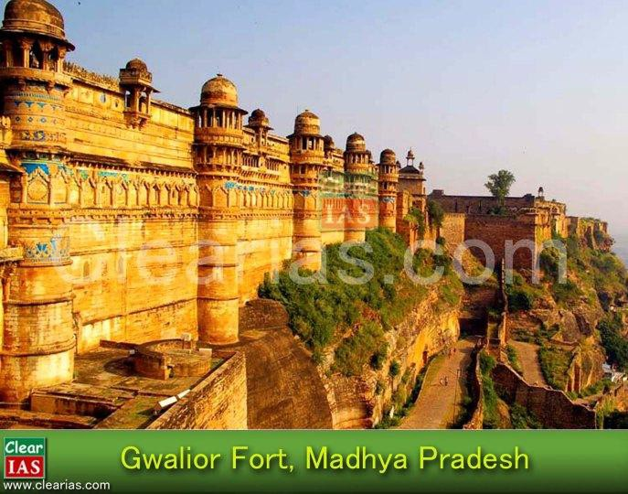

* Building monumental forts with embattlement was a regular feature in medieval times, often symbolizing the seat of power of a king.
* When such a fort was captured by an attacking army, the vanquished ruler either lost his complete power or his sovereignty. This was because he had to accept the suzerainty of the victorious king.
* Commanding heights were utilized to great advantage to construct forts.
* Another feature was concentric circles of outer walls as in Golconda that the enemy had to breach these at all stages before getting in.
* Some of the famous forts are the **Fort of Chittor (Rajasthan), Gwalior (MP), Daulatabad-earlier Devgiri (Maharashtra), and Golconda (Hyderabad).**
* **The Chittorgarh fort is the largest fort in Asia** and was occupied for the longest length of time as the seat

of power.

#### Minars

* Another form of sthamba or tower was the minar, a common feature in the sub-continent.
* The most striking minars of medieval times are the **Qutub Minar in Delhi and Chand Minar at Daulatabad.**
* The everyday use of the minar was for the **azaan or call to prayer.**
* Its phenomenal height, however, symbolized the might and power of the ruler.

***Eg: Qutub Minar***

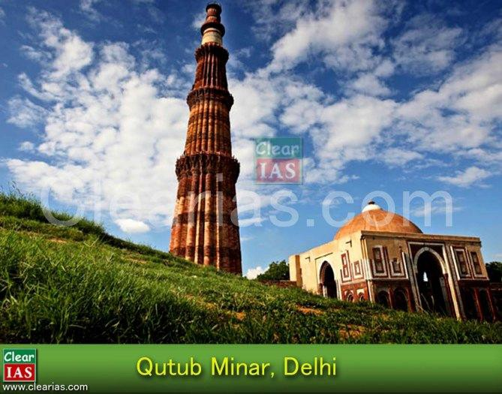

* It was built in the 13th century and the Qutub complex in which the minar is present is a UNESCO World Heritage Site.
* The construction of the bottom storey of the minar was started by **Qutub-ud-din Aibak** (Delhi Sultanate) and his successor **Iltumish** completed it by adding three more storeys.
* However **Firoz Shah Tughlaq** replaced the top storey which was damaged in a lightning and also added one more storey.
* Hence now it has five storeys and a height of nearly 234 feet (about 73 m) making it the second tallest minar in India (first is Fateh Burj, Punjab).
* The Qutub Minar also came to be associated with the much revered saint of Delhi, **Khwaja Qutubuddin Bakhtiyar Kaki.**
* The minar is a mixture of polygonal and circular shapes.
* It is largely built on **red and buff stone** with some use of marble in the upper storeys.
* It is characterized by high decorative balconies and bands of inscriptions intertwined with foliated designs.

***Eg: Chand minar***

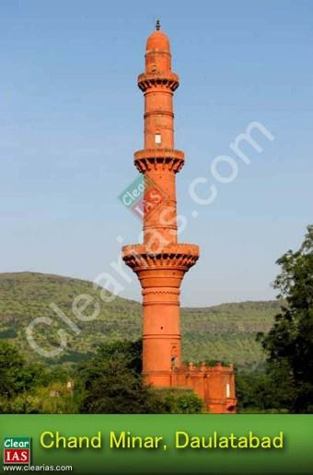

* It was built in the 15th century by Ala-ud-din Bahmani.
* It is a 210 feet high (about 30 m) tapering tower divided into four storeys.
* It is painted in peach now.
* Its façade once boasted of chevron patterning on the encaustic tile work and bold band of Quranic verses.
* Although it looked like an Iranian monument, it was the combined handiwork of local architects with those from Delhi and Iran.

#### Tombs

* Monumental structures over graves of rulers and royalty was a popular feature of medieval India.
* Some well known examples of such tombs are those of Ghyasuddin Tughlaq, Humayun, Adur Rahim Khan- i-Khanan, Akbar, and Itmaduddaula.
* The idea behind the tomb was eternal paradise as a reward for the true believer on the Day of Judgment.

This leads to the paradisiacal imagery for tombs.

* Beginning with the introduction of Quranic verses on the walls, the tomb was subsequently placed with paradisiacal elements such as garden or near a water body or both, as in the case of Taj Mahal.
* They were not only intended to signify peace and happiness in the next world, but also to showcase the majesty, grandeur and might of the person buried there.

***Eg: Taj Mahal***

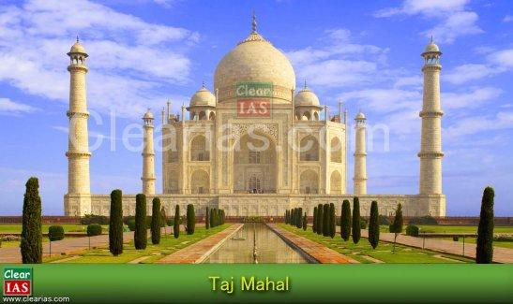

* Taj Mahal was built in Agra by Shah Jahan as a mausoleum (a kind of large tomb) for his deceased wife Mumtaz Mahal.
* It was commissioned in the year of 1632 and is a UNESCO World Heritage Site.
* Taj Mahal was the apogee of the evolutionary architectural process in medieval India.
* The Taj complex is entered through a monumental red sandstone gateway, the opening arch of which beautifully frames the mausoleum.
* The tomb is laid out in a Chahar Bagh (garden), crisscrossed with paths and water courses, interspersed with pools and fountains.
* The structure is placed on the northern extremity of the bagh instead of the middle to take the advantage of the river bank (Yamuna).
* The straight path through the bagh reaches the plinth of the tomb.
* At the corners of the terrace stand four tall minarets, one hundred and thirty two feet high.
* The main body of the building is topped with a drum and a dome and four cupolas forming a beautiful skyline.
* Towards the west of the white marble faced tomb lies a red sandstone mosque and a similar construction in the east to maintain balance.
* The marbles for the building was quarried from the **Makrana Mines, Rajasthan.**
* The inner arrangement of the mausoleum consists of a crypt below and a vaulted, octagonal tomb chamber, with a room at each angle, all connected by corridors.
* Light to every part of the building is obtained by means of carved and perforated Jalis, set in the arched recesses of the interior.
* Four types of embellishments have been used with great effect for the interior and exterior surfaces of the Taj Mahal.
* These are stone carvings in high and low relief on the walls, the delicate carving of marble into jails and graceful volutes (spiral ornament on the pillars), and the creation of arabesque with **pietra dura** on walls and tombstones and geometric designs with tessellation.
* The art of calligraphy is used with the inlay of jasper in white marble to unite Quranic verses.
* Calligraphy provides a decorative element on the walls and a continuous connection with the almighty.

***Eg: Gol Gumbad, Karnataka***

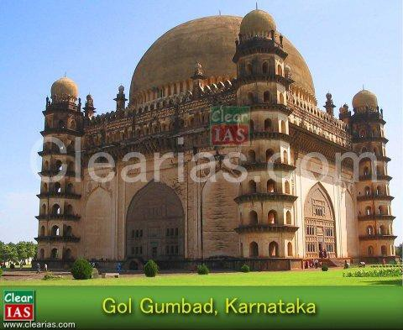

* It is situated in the Bijapur district of Karnataka.
* It is the mausoleum of Muhammed Adil Shah, the 7th sultan of the Adil Shahi Dynasty of Bijapur (1498- 1686).
* Built by the ruler himself, it is a striking edifice in spite of being unfinished.
* The tomb is a complex building such as a gateway, a Naqqar Khana, a mosque and a sarai located within a large walled garden.
* Gumbad is a square building topped with a circular drum over which rests a majestic dome, giving the building its nomenclature.
* It is built of **dark grey basalt** and decorated plaster work.
* The dome of Gol Gumbad is the largest in the world.
* The building has an amazing acoustical system. Along with the drum of the dome, there is a whispering gallery where sounds get magnified and echoed many times over.
* Gol Gumbad is a fine convergence of many styles located in medieval India.
* While its structural peculiarities of dome, arches, geometric proportions and load bearing techniques suggest Timurid and Persian styles, it is made of local material and is decorated with surface embellishments popular in Deccan.

#### Sarais

* Sarais were largely built on a simple square or a rectangular plan and were meant to provide temporary accommodation for Indian and foreign travelers, pilgrims, merchants, traders, etc.
* They were public domains which thronged with people of varied cultural backgrounds.
* This lead to cross cultural interaction, influence and syncretic tendencies in the cultural mores of the times and at the level of people.

#### Structures for common people

* One of the architectural features of medieval India was also a coming together of styles, techniques, and decorations in public and private spaces for non-royal sections of the society.
* These include buildings for domestic usage, temples, mosques, Khanqahs and dargahs, commemorative gateways, pavilions in the buildings and gardens, bazaars, etc.

Jama Masjid

* Large mosques spanning huge spaces also dotted the landscapes of the Indian sub-continent in medieval times.
* **Congregational prayers were held here every Friday** afternoon, which required the presence of minimum of forty Muslim male adults.
* At the time of prayers, a khutba was read out in the name of the ruler and his laws for the realm were also read out.
* In medieval times, a city had one Jama Masjid which, along with its immediate surroundings, became the focus of the lives of the people, both Muslim and Non-Muslim.
* This happened because a lot of commercial and cultural exchanges were concentrated here besides religious and indirect political activity.
* Generally, such a mosque was large with an open courtyard, surrounded on three sides by cloisters and the Qibla Liwan in the west.
* It was here that the mihrab and mimbar for the Imam were located.
* **People faced the mihrab** while offering prayers as it indicated the direction of the **Kaaba in Mecca.**

**Additional Note: Architecture in Mandu, Madhya Pradesh = Provincial Style**

* The city of Mandu is located in Madhya Pradesh, at an elevation of over 2000 feet and overlooks the Malwa Plateau to the north and the Narmada valley to the south.
* Mandu’s natural defence encouraged consistent habitation by Parmana Rajputs, Afghans, and Mughals.
* As the capital city of the Ghauri Dynasty (1401-1561) founded by Hoshang Shah, it acquired a lot of fame.
* Mandu was associated with the romance of Sultan Baz Bahadur and Rani Rupamati.
* The Mughals resorted to it for pleasure during the monsoon season.

***Art and Architectures of Mandu***

* Mandu is a typical representation of the medieval provincial style of art and architecture.
* It was a complex mix of official and residential-cum-pleasure palace, pavilions, light and airy, so that these buildings did not retain heat.
* Local stone and marble were used to great advantage.
* The royal enclave located in the city comprised the most complete and romantic set of buildings, a cluster of palaces and attendant structures, official and residential, built around two artificial lakes.

***Eg: The Hindola Mahal, Mandu***

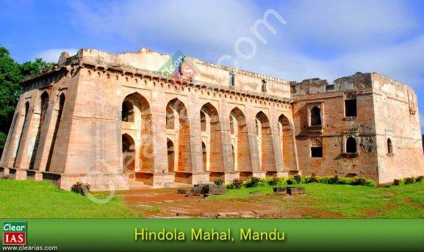

* It looks like a railway viaduct bridge with its disproportionately large buttresses supporting the walls.
* This was the audience hall of the Sultan and the place where he showed himself to his subjects.
* Batter was used very effectively to give an impression of swinging (Hindola) walls.

***Eg: Jahaaz Mahal, Mandu***

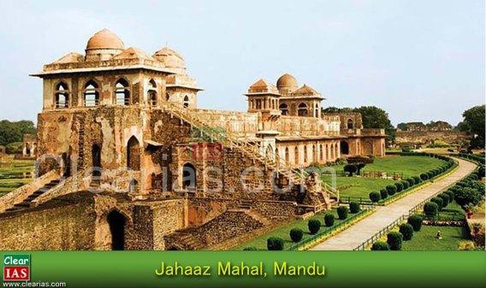

* It is an elegant two storey ‘**Ship Palace’** between two reservoirs, with open pavilion, balconies overhanging the water and a terrace.
* It was built by **Sultan Ghiyasuddin Khilji** and was possibly used as his harem and the ultimate pleasure and recreation resort.
* It had a complex arrangement of watercourses and a terrace swimming pool.

***Eg: Rani Rupamati’s Pavilion, Mandu***

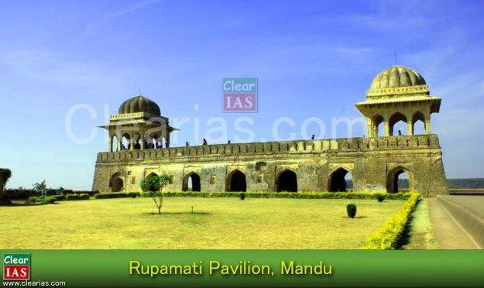

* Rani Rupamati’s double pavilion perched on the southern embattlements afforded a beautiful view of the Narmada valley.
* Baz Bahadur’s Palace had a wide courtyard ringed with halls and terrace.

***Eg: Hoshang Shah’s Tomb, Mandu***

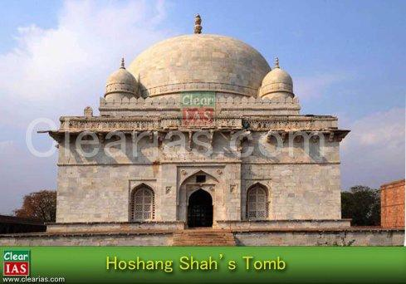

* It is a majestic structure with a beautiful dome, marble jail work, porticos, courts, and towers.
* It is regarded as an example of the robustness of Afghan structures, nut its lattice works, carved brackets and torans lend it a softer hue.

***Eg: Jama Masjid, Mandu***

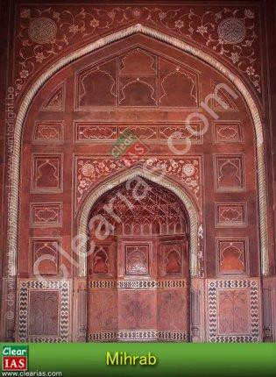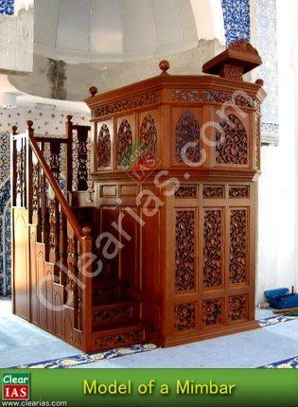

* It was built on a large scale to accommodate many worshippers for Friday prayers.
* The building is faced with red sandstone.
* The Mimbar (where Imam stands to deliver sermons) in the Quibla liwan (a long narrowed hall) is supported on carved brackets and the Mihrab has a lotus bud fringe.

**Article by: Jijo Sudarshan**

# Indian Philosophy : Orthodox and Heterodox Schools

Indian Philosophy or Hindu Philosophy is generally classified into 6 orthodox schools (āstika) and 3 heterodox (nāstika) schools. The basic difference between the two branches of Hindu Philosophy schools is said to be based on the recognition of Vedas. Orthodox schools recognize the authority of Vedas while heterodox schools don’t believe in the authority of Vedas. Out of these nine systems eight are atheistic as there is no place for God in them. Only Uttara Mimansa, which is also called Vedanta, has a place for God in it.

#### Six Orthodox Schools (Classical Schools) of Indian Philosophy

The 6 classical schools (shatdarshan) are Sankhya, Yoga, Nyaya, Vaisheshik, Purva Mimansa and Uttar Mimansa (Vedanta). Almost all Indian schools of thought accepted the theory of karma and rebirth, and the ideal of moksha is conceived as liberation from the cycle of births and deaths. Moksha/liberation is considered as the highest goal of human struggle.

#### Sankhya Philosophy

Sankhya is the oldest philosphy. It was put forward by Kapila. Sankhya philosophy provided the materialistic ontology for Nyaya and Vaisheshik, but there is very little original literature in Sankhya. It is generally believed that Sankhya Philosophy is dualistic and not monistic because it has two entities,**purush** (spirit) and **prakriti** (nature) in it. Samkhya emphasizes the attainment of knowledge of self by means of concentration and meditation. Sankhya holds that it is the self-knowledge that leads to liberation and not any exterior influence or agent. Samkhya forms the philosophical basis for Yoga. In Samkhya, the necessity of God is not felt for epistemological clarity about the interrelationship between higher Self, individual self, and the universe around us.

**Purush vs Prakriti:** In the beginning the philosophy was materialistic as it talked only about Prakrithi, but later the element of purush was also added to it. While Purusha is posited as the only sentient being, ever existent, and immaterial, Prakriti is said to be the material basis of this universe, composed of three basic elements (Gunas) – namely Tamas, Rajas, and Sattva.

**Yoga Philosophy**

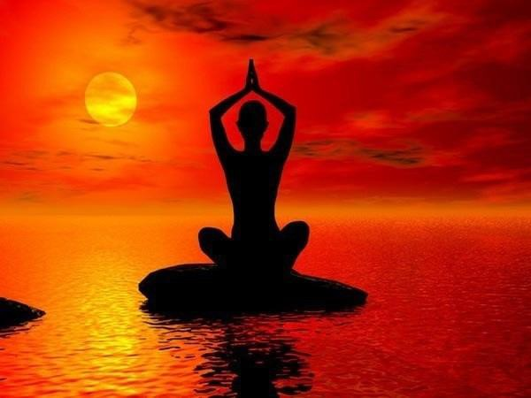

Yoga presents a method of physical and mental discipline. The Yoga presents a practical path for the realization of the self whereas the Samkhya emphasizes the attainment of knowledge of self by means of concentration and meditation. Releasing Purush from Parkriti by means of physical and mental discipline is the concept behind Yoga.

Founder of Yoga is Pathanjai. Yoga does not require belief in God, although such a belief is accepted as help in initial stage of mental concentration and control of mind.

#### Nyaya Philosophy

Nyaya Philosophy states that nothing is acceptable unless it is in accordance with reason and experience (scientific approach). Founder of this philosophy is Gautam and the principles are mentioned in Nyaya Sutras. Nyaya says that the world is real and the philosophy does not follow a monist view.

Nyaya philosophy relies on several **pramanas** i.e. means of obtaining true knowledge as its epistemology. According to it, the pradhan pramana or principal means of obtaining knowledge is**pratyaksha pramana** i.e. the knowledge obtained through the 5 senses. There are also other pramanas like anumana (inference, through which we can obtain true knowledge) and shabda pramana (a statement of an expert).

NB: Subsequent philosophers who claimed to be Nyayiks, e.g. Vatsyayan (who wrote Nyaya Bhashya), Udayan (who wrote Kusumanjali) etc. distorted the Nyaya philosophy by introducing theological elements in it. Navya Nyaya scholars like Gangesh resorted to gymnasics in logic.

#### Vaisheshik Philosophy

The classical Indian philosophy Vaisheshik, was the physics of ancient times. It propounded the atomic theory of its founder Kannada. At one time Vaisheshik was regarded as part of the Nyaya philosophy, since physics is part of science. But since physics is the most fundamental of all sciences, Vaisheshik was later separated from Nyaya and put forth as a separate philosophy. To make it short, Vaisheshik is a realistic and objective philosophy of universe.

#### Purva mimansa (mimansa)

The word Mimamsa means to analyze and understand thoroughly. Purva Mimamsa examines the teachings of the Veda in the light of karma-kanda rituals, ie karma-mimamsa system is called purva-mimamsa. Purva mimansa (or briefly mimansa) lays emphasis on the performance of the yagya for attaining various spiritual and worldly benefits. Hence this philosophy relies on the Brahmana (and samhita) part of the Vedas.

#### Uttara Mimamsa (Vedanda)

Vedanta says that the world is unreal, Maya. Vedanta is monistic, in other words, it says that there is only one reality, Brahman. Vedanta lays emphasis on brahmagyan, hence relies on the Upanishad part of the Vedas. Vedanda has its roots in Sankya Philosophy.

There are three sub-branhces for Vedanda :

1. Absolute Monism of Shankara
2. Vishishtha Advaita or qualified monism of Ramanuja
3. Dvaita of Madhva

*PS: A close examination shows that the first 4 classical systems are not entirely based on Vedas. But last two, the Purva Mimansa and the Uttar Mimansa, certainly rely on the Vedas.*

#### Three Heterodox Schools of Indian Philosophy

Schools that do not accept the authority of vedas are by definition unorthodox (nastika) systems. The following schools belongs to heterodox schools of Indian Philosophy.

#### Carvaka

It is characterised as materialistic and aesthetic school of thought. Accepted direct perception as the surest method to prove the truth of anything. Insists on joyful living. Also known as Lokayata, Carvaka is a materialistic school of thought. Its founder was Carvaka, author of the Barhaspatya Sutras in the final centuries

B.C. The original texts have been lost and our understanding of them is based largely on criticism of the ideas by other schools. As early as the 5th Century, Saddaniti and Buddhaghosa connected the Lokayatas with the Vitandas (or Sophists), and the term Carvaka was first recorded in the 7th Century by the philosopher Purandara, and in the 8th Century by Kamalasila and Haribhadra.

#### Buddhist Philosophy

It is a system of beliefs based on the teachings of Siddhartha Gautma. Buddhism is a non-theistic philosophy whose tenets are not especially concerned with the existence or non-existence of God. Four Noble Truths in Buddhism are the following.

1. There is suffering
2. There is cause of suffering
3. There is cessation of suffering
4. There is a way to cessation of suffering

Buddhists philosophy of life to get ‘Nirvana’ from suffering is based on the following eight principles:

1. Right Faith (Samyak Dristi)
2. Right Resolve (Samyak Sankalpa)
3. Right Speech (Samyak Vakya)
4. Right Action (Samyak Karmanta)
5. Right Living ( Samyak Ajiva)
6. Right Thought (Samyak Smriti)
7. Right concentration (Samyak Samadhi)

8. Right Effort (Samyak Vyayama)

#### Jain Philosophy

Already in existence by 6th century B.C , it was revived by Mahavira, the 24th Jain Tirhthankar. According to Jainism Nirvana or liberation is obtained through three jewels: Right Philosophy, Right Knowledge and Right Conduct (Tri-ratna). Right conduct implies 5 absinences: not to lie, not to steal, not to strive for luxury and not to strive for possessions, not to be unchaste and not to injure (Ahimsa).

#### Ajivika Philosophy

A related philosophy which some classify under the heterodox sytem is Ajivika Philosophy. The Ājīvikas may simply have been a more loosely-organized group of wandering ascetics (shramanas or sannyasins). Some of its prominent figures were Makkhali Gosala and Sanjaya Belatthaputta. This was an ascetic movement of the Mahajanapada period in the Indian subcontinent.

***References:***

1. [International Forum for Neovedantins.](http://www.oocities.org/neovedanta/a80.html)
2. [Philosophy basics.](http://www.philosophybasics.com/general_eastern_indian.html)

**UPSC Questions related to Hindu Philosophy**

**Qn: With reference to the history of philosophical thought in India, consider the following statements regarding Sankhya school: (2013 CSE Prelims)**

1. Sankhya does not accept the theory of rebirth or transmigration of soul.
2. Sankhya holds that it is the self-knowledge that leads to liberation and not any exterior influence or agent. Which of the statements given above is /are correct?

A – 1only B – 2 only

C – Both 1 and 2

D – Neither 1 nor 2

**Ans : B – 2 only**

**Qn. Which one of the following pairs does not form part of the six systems of Indian Philosophy? (2014 CSE Prelims)**

A – Mimamsa and Vedanta

B – Nyaya and Vaisheshika

C – Lokayata and Kapalika

D – Sankhya and Yoga

**Ans C – Lokayata and Kapalika.**

**(10) Hindu Temple Architecture: Pallava**

In the last articles in the Hindu Temple Architecture series, we have seen the development of art and architecture in temples under the [Chola,](http://www.clearias.com/hindu-temple-architecture-cholas/) [Chalukya](http://www.clearias.com/hindu-temple-architecture-chalukyas/) and [Hoysala](http://www.clearias.com/hindu-temple-architecture-hoysala/) rulers. There was a major movement under Pallavas even before the imperial Cholas, and the art and architecture under Pallavas co-existed in South India along with Cholas, Chaukyas and Pandyas. We shall see the prominent features of art and architecture of the Pallava dynasty in this article.

Pallava Architecure

The Pallava dynasty existed between the 3rd and 9th centuries CE, ruling a portion of what is today Andra Pradesh (early Pallavas) and Tamil Nadu (later Pallavas). You may note here for comparison that early Chalukyas ruled in present day Karnataka. Kanchipuram was the capital of the Pallavas from 4th to 9th century. Huen Tsang had visited this city and wrote it a glorious city.

The Pallava architecture shows the transition from the rock cut temples to the stone built temples. The earliest examples of the Pallava art are the rock cut temples of the 7th century AD, while the later examples are of structural temples built in 8th and 9th century. The lasting monolithic temples known as *rathas* and *mandapas* provide superb skill of sculptors of Pallava period. The monolithic temples (Eg: Five rathas) gave way to structural temples like the Shore temple in Mammalapuram.

Major Pallava rulers who built temples

1. Mahendravarman : Mandagapattu rock cut temple.
2. Rajsimha (Narsimhamvaraman/Kalasamudra/Mammalla) : Kailasanathar Temple, Kanchipuram, Shore Temple Mahabalipuram (Mammallapuram)

Mantapas and pillers

The mantapas and pillars of rock cut temples and ratha temples bear own distinctive characteristics.

Buddhist influence

The rock cut temples of the Mamallapuram show the influence of Buddhist rock cut caves. In ratha temples also, some ratha follows the Buddhist Vihara model central square hall supported by pillared roof. Some rathas (Bhima, Sahadeva, Ganesh) follows Chaitya model with oblong shape bearing barrel roof and Chaitya gabel.

Monolithic Indian rock cut architecture

The ratha temples or seven pagoda which are carved out in granite rock is the finest example of Indian monolithic rock cut architecture.

Free standing temples

The Pallava age shows the transition period from rock cut to structural temples. The ratha temples are attempt to free itself from the influence of rock cut ‘Chaitya’ and ‘Vihara’ . The structural detailing of the ratha temples that imitates wooden timber support, pilaster beams which are unnecessary in stone. This shows that they are not able to free totally from earlier wooden structured temples.

Gavaksha motif

It is a symbolic window throughout which deities are believed to be looked out. It is found in the Chaitya arches that consists of deities below the crown of entablature.

Base of Dravidian sikhara

The square ground storey with open verandas in Dharmaraja rathas forms the initiation of pyramidal square of Dravidian tradition. Pallava temples in Kanchi are prototype of Vimana to be developed by the Cholas in the later period.

Base of Kalasa

In the pillars of the Mammalapuram group, above the kumbha or melon capital ( a particular element in pillars that supports the below structure) a padma flares up to the palagai (abacus) and in varaha mandapa this flaring element is surrounded by thinnest abacus which later took the form of kalasa in Chola temples.

Yalis

The base of pillars of some structural temples bears architectural motif of lion later depicted by Cholas and this symbol of lion became the royal insignia of Pallavas.

Kudus

In the facades of the walls, Buddhist chaitya motif kudus is seen (later to be adopted by the Chalukya).

Decoration and ornamentation

The walls and pillars of cave temples and structural temples decoration with architectural designs are seen.

Pillars

The pillars can be studied and understood as part of three stages of development.

1. First stage : This belongs to the pillars of rock cut mantapa with 7 feet height approximately. Here, brackets are seen towards the upper part of the pillar. Here, pillar has square shaft.
2. Second stage : Here, pillars were around 50 feet height with more ornate design. It shows the combination of shaft and capital. The lion motiff is seen in the base of the shaft as well as in the capital.

3. Third stage: Here, pillars come under the mandapa of ratha temples. In this case, malasthana, a motiff with

bend of pearl festoon is seen in the shaft. It rises up to the pillar separated by an indentive structure called kumbha or melon capital above which a padma flares up to the palagai or abacus.

Regional influence

The architectural design of one ratha in mahaballipuram with square hall along with curvilinear, overhanging roof shows the influence of traditional bemgali hut. It suggest that the origin of Dravidian shikhara have had its origin from the bamboo hut.

Beginning of gopura

The architecture of gopura begins with the Pallava dynasty as the initiation is seen in shore temple of mahaballipuram.

Rock cut relief

The greatest sculptural development of the age is cutting out the cleft in Mamallapuram between the two huge granite boulders as descend of Ganga with presence of gods, demi gods, kinnar etc. It is variously known as penance of arjuna, kiratarjunia etc.

Influence of Amaravati school of art

In the relief of the Mahaballipuram, the shape of gods in the form of clouds shows the influence of Amaravati art.

Evidence of earliest portrait

In the Adivaraha cave , tow portraits of a Pallava king accompanied by his son and queens are believed to be earliest portrait sculpture after the Kushan images from Mathura.

Influence of Shaivism and Vaishnavishim

In the varaha mantapa of Adivaraha cave , a panel showing varaha lifting the earth goddesses is seen. The brahma and shiva is also sculpted around the main varaha but in small size and disposition. In the panel of a Mahaballipuram cave, Durga as Korravai is depicted. Durga as Mahismardini is also a theme of panel here.

The Descent of the Ganges /Arjuna’s Penance

The huge sculpture of “The Descent of the Ganges” also known as Arjuna’s Penance was related to the system of water supply. There are clear traces of carefully designed system of water supply from Palar River to the ancient city. The large cliff, thirty yards long and twenty three ft high, represents naga and naginis which symbolize water, adoring both sides of deities along with animals.

Animal sculpture

The animal sculpture, specially the relief of monkey below the descent of Ganga, is noticeable feature of Pallava art.

Importance of Shore Temple, Mahabalipuram

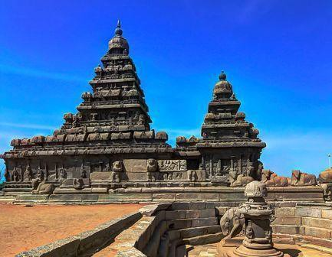

Shore Temple is a granite made temple at Mahabalipuram built during the rein of Narsimhavarman. This group of temples is a UNESCO World Heritage Site and is oldest structural temple (in contrast with rock cut temples) in India.

It is a beautiful 5 storyed temple, which is a combined complex of 3 shrines; 2 dedicated to Shiva and one to Vishnu. The Shore Temple marks the culmination of the architectural efforts that began with the cave temples and monolithic rathas. 7 Pagodas is a term associated with the Shore Temple of Mahabalipuram. It is said that 6 more temples were associated with it, all now submerged in water. The term ‘ratha’ corresponds to free standing temples.

Summary

The Dravidian style of temple architecture began with the Pallava rule. It was a gradual evolution starting from the **rock cut- cave temples** to **monolithic rathas** which finally culminated in **structural temples**.

Pallava period is an age when architecture showed grandeur and beauty. The period is also known as the age of

“poetry in stone”. The magnificent temple of Kailashnath, which is carved out in stone, bears the testimony of the period. The monolithic seven Pagodas or rathas named after Pandavas are architectural wonders, though sea- erosion has taken its toll.

* A) 1 only.
* B) 1 and 4 only.
* C) 1, 3 and 4 only
* D) All the above

# Hindu Temple Architecture : Cholas

UPSC questions related to the topic ‘culture’ are not so easy to prepare. The main reason being lack of quality study materials which explain the same in simple language. Architecture is an important area inside the culture topic. In this article, we shall see the details of the Chola Temple Architecture, which is an important part of Dravidian temple architecture. UPSC had asked a question related to this topic in[2013 mains.](http://www.clearias.com/civil-services-mains-2013-general-studies-paper-1-gs1-question-paper/) The question was

: *Chola architecture represents a high watermark in the evolution of temple architecture. Discuss*. We shall see the answer, but before going into the details of Chola architecture, let’s make our fundamentals strong.

#### Hindu Temple Architecture

Ever since the temple building process began, the architecture reflected a synthesis of arts, the ideals of dharma, beliefs, values and the way of life cherished under Hinduism. Nagara, Dravida, Vesara etc are different styles of temple architecture. Pallavas (7th century – 9th century) and Cholas (9th century -11th century) were the major kingdoms which epitomized the Dravidian Architecture. Chalukyas (7th century -11th century) followed Vesara style of architecture in the Karnataka region. Their style is also known as Karnata Dravida style. [Chalukya](http://www.clearias.com/hindu-temple-architecture-chalukyas/) [art](http://www.clearias.com/hindu-temple-architecture-chalukyas/) was followed by [Hoysala art](http://www.clearias.com/hindu-temple-architecture-hoysala/) (13th century).

#### Dravidian Architecture : Pallavas and Cholas

Pallavas used bricks, lion motifs, dwarfed gopurams etc. Things changed at the hands of Cholas. They used stones instead of bricks. Walls were decorated with sculptures and paintings of deities, kings and queens (not lion motifs). Temples have enclosed decorative walls and entrance (Gopuram). They also have an audience hall known as Mandap. The deity room is known as Garbhgriha. The pyramid like storey above the deity room is known as Vimana.

#### Chola Temple Architecture in detail

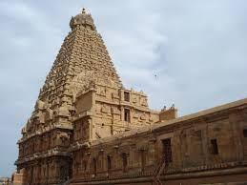

The Dravidian temple architecture started by the Pallavas got matured at the hand of the Cholas. Some prominent features of temple architecture in the Chola dynasty are enunciated here.

Niche

These are characteristic architectural designs of Chola temples carved in temple walls.

Devakusthas

These are decorative niches of chola temple walls where deities are sculpted.

Pilasters

These magnificent architectural designs are carved as projection in walls with placing of deities within it. The pilasters are positioned in both sides of the main devakusthas.

Kumbhapapanjara and kushtapan

These are narrow niches in chola temple walls with special design for placing sculpted images.

Kudus

These are two lion heads which crowns the curved roof of the pilasters.

Mythical motiff

Makar along with warrior heads positions below all the decorative devices.

Torus

It is a rounded structure placed on the basement of temple sculpture or motiff sometimes decorated with ribs.

Yazhi

The base of the walls of chola temples are decorated with lines of mythical animals called yazhi.

Mandapa features

Arthamandapa, nandi mandapa with special decoration are characteristics of Chola temple architecture.

Parivardevatas

Besides the main shrine, Chola temples were evidences of subsidiary shrines for other deities called parivardevatas which were highly decorative.

Dikapalas

These are some prominent directions transparent in Chola temple with architectural design for placing of deities.

Inscription

The walls of Chola temples are seen with inscriptions with architectural design.

#### Comparison between Pallava and Chola Architecture

* Yali – Pallava used yali or lion motif at the base of the pillar

Chola abandoned it and used yazhi at base or kudus in other parts of the pillar.

* Dwarapala – In pallava architecture dvarapalas are comparatively benign.

In chola architecture dwarapala became fierce with protruding tusk.

* Gopuram – The gopurams in pallava dynasties were comparatively dwarfed.

But in chola dynasty they became enlarged with high enclosure walls.

* Finial – The finial in Pallava dynasy was a little swelling in the top of the vimana.

But in Chola dynasty it became beautiful vase with artistic design.

#### Significance of Chola Architecture

Apart from the discussed features, Chola temples had a beautiful shikara stone at the top. It had elaborate and carefully made carvings. It is a marvel how these structures weighing in tonnes is placed without the help of cranes. During their reign, Cholas made temples in Nagaeshwvara, Brihadeshwvara, Airavateshwara and Chidambaram. Other kingdoms in South India and Sri Lanka followed their style.

# Hindu Temple Architecture : Chalukyas

In the last article, we have seen the broad outline of temple architecture styles in India (Nagara, Dravida and Vesara) and [Chola architecture](http://www.clearias.com/hindu-temple-architecture-cholas/) in particular. Under Dravidian architecture, we have also seen the comparison between Pallava and Chola architecture. In this post, let us see the Chalukya architecuture in detail. Chalukyan architecture is a combination of Nagara and Dravida and hence a perfect example for Vesara architecture. The Chalukya temples stand in South India with its gorgeous beauty. Some features of Chalukya architecture are mentioned below.

#### Noticeable features of Chalukya temples

When we talk about Chalukyas, remember that there are at-least two Chalukyas. Chalukayas of Badami (Vatapi) ruled Karnataka region around 7th century AD. They were followed by Western Chalukyas (Kalyani Chalukyas) by around 11th century AD.

The Chalukya temples are noticeable for three basic plans. They are :

1. Design of the floor
2. Projection of architectural articulation
3. Sculpture.

#### Design of the floor

It indicates the plan of salla, subsidiary shrines, their plan, design of pradakshina path. The structure and architecture of a temple depends on these plans.

#### Architectural design

Various designs like miniature towers, projection of pilasters come under this head. The temple surfaces follow a distinctive architectural design with projections and recesses. The walls portrays frequent projections and recesses that reflect a very magical beauty in the eyes of the viewers. The articulation of pillars and mantapas are beyond description.

The noticeable aspect is that though ornamentation of Chalukya temples bears elements of Nagara and Dravidian tradition but they have combined the elements in so prudent way that they become unique and distinctive feature of their own.

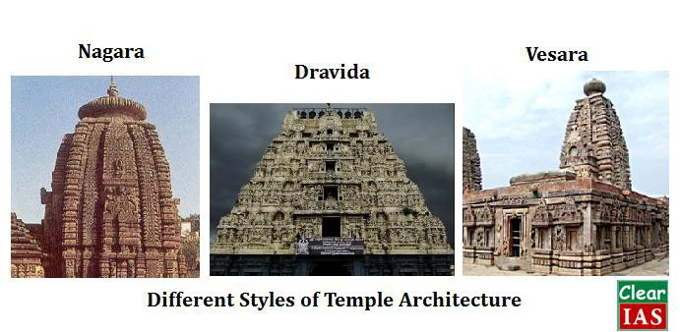

#### Vesara style

The Vesara style also called the Chalukyan type possessed the Dravidian vimana and the Nagara- type faceted walls.

#### Influence of Nagara tradition

1. The plan of shrine, subsidiary shrine, panchayatan style bears similarity to Nagara school.
2. The plan of vestibule joining the sanctum to mantapa bears resemblance to orissan temples.
3. The most of the temple pillars in Karnataka region bears similarity to sekhari and bhumija type of pillars in northern india.
4. The stepped diamond plan that is a plan of design arrangement as seen in Chalukya temples is from northern

region.

1. The most of the temples in kalyani portrays Nagara articulation projecting stepped diamond or stellate plan.

#### Influence of Dravida tradition

The Dravida influence is mainly visible in vimana of the Chalukya temples in first part of the Chalukya rule.

#### Combination of Nagara and Dravida style

1. **Vesara sikhar or kadamba sikhara:** It is a shikhara of Chalukya temple showing northern shikhara shikhara and southern vimana features.
2. **Ornamentation:** Miniature decorative towers and ornamentation of walls in Chalukya temples show combination of both Nagara and Dravida style.

#### Special departure from Nagara and Dravida tradition

In case of entrance hall to shrine Chalukya temple bears special uniqueness. It has two or more than two entrances while

* There is a small closed mantapa to the shrine in Nagara temples.
* There is an enlarged, open and closed mantapa in Dravida temples.

#### Own distinctive features

**Ornamentation :** In case of ornamentation of temple walls and pillars, Chalukya temple shows indigenous quality.

**Transformation of Dravida tower :** The Chalukya builders modified the Dravida towers by minimizing the height of each storey and arranging them in descending order of height from base to top with much ornamentation in each storey.

**Transformation of Nagara tower :** Instead of inclined storey here modification is seen in the vertical shape of the tower.

**Two special features of Chalukya temples – Mantapa and Pillers :**

Mantapa : The mantapa has two types of roof – domical ceilings (the dome like ceilings standing on four pillars are very attractive) or Square ceilings (these are vigorously ornamented with mythological pictures).

Pillars : As mentioned earlier, the miniature decorative pillars of Chalukya temples stands with its own artistic value.

#### Characteristics of temple architecture of Chalukya

1. The pillars of Chalukya temple are monolithic shaft whose height determines the height of mantapa and temples.
2. Chalukya architects did not use mortar. It allows ventilation of light to the innermost part of the temples.
3. The vestibules were ornamented with artificial lights which eliminated darkness as well as added some kind of mystic feelings.
4. The doorway panels of Chalukya temples are highly decorated that consist of pilaster, moulded lintel,

cornice top.

1. Arabesque is a muslim art design bearing linear artistic decoration with pattern of flower, leaves, branches or twisted branches. This design is seen in triangular spaces of domicile ceilings.
2. Chhajja, a double curved projective eave, is generally seen in Chalukyan temples. Muktesvara temple is an example of it.
3. Cornice is used in Chalukya temple for downward movement of rainwater or to save from scorching heat.
4. Use of soapstone for projection in walls carvings is common feature in Chalukya temples.
5. The Chalukya temples are mainly dedicated to different hindu deities like durga, shiva, vishnu etc.
6. Chalukya architecture has both cave temples design and structured temple design.
7. Chalukya architects used stellate plan or northern stepped diamond plan for architectural design.
8. The decorative pillars with its intricate design of western Chalukya architecture is also known to gadag style of architecture.
9. The Karnata Dravida tradition of architecture initiated by Chalukya of Badami get matured under the hand of Hoysala. The broken ornamentation of walls with projection and recesses was followed by Hoysala artist. Chalukya architecture is also called the precursor of Hoysala art.

#### Questions to try :

1. Narrate the influence of Muslim art in Chalukya temple architecture. (100 words)
2. Write a short note on the decoration of Chalukya architecture. (150 words)
3. Chalukya temples are perfect Vesara style but with its uniqueness. Narrate.
4. Write short note – (a) gadag style (b) karnata Dravida tradition
5. Chalukya architecture is the precursor of Hoysala art– narrate.
6. **Hindu Temple Architecture : Hoysala**

In our article series on Indian culture, we have so far seen the [temple architecture peculiarities of Chola](http://www.clearias.com/hindu-temple-architecture-cholas/)and [Chalukya](http://www.clearias.com/hindu-temple-architecture-chalukyas/) [Dynasty.](http://www.clearias.com/hindu-temple-architecture-chalukyas/) In this post, we shall see the temple architecture features of Hoysala dynasty. The Karnata Dravidian tradition developed in the 7th century under the patronage of Badami Chalukya got matured under Western Chalukya (Kalyani Chalukya) in the 11nth century. The Chalukya style got perfection as an independent style under Hoysala rule in the 13nth century.

Noticeable features of Hoysala art

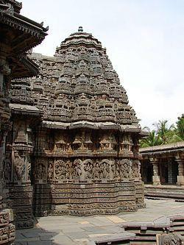

* **Makartorana** : It leads to the mantapa of the temples. It is made with sculpted images of makara in lintel form that overhead one to the temple.
* **Mantapa** : Hoysala temples have features of both open (outer mantapa) and closed mantapa (innner mantapa). The ceilings of the mantapa are highly ornate bearing mythological figures and floral design.
* **Pillars** : The mantapas of Hoysala temples have circular pillars. Each pillar bear four brackets in the top with sculpted figures.
* **Cella (vimana)** : The characteristic feature of vimana in Hoysala temples is that they are plain inside while outside is profusely elaborated.
* **Shrine** : The Hoysala temples generally bears one or more shrines. The temples are classified as ekakuta (one shrine), dvikuta (two shrines) etc relating to the number of shrines.
* **Development of kalasa** : The Hoysala temples bear a very nice vase shaped water pot that stands on the top most portion of the temple tower.
* **Salabhanjika** : It is the peculiar feature of Hoysala sculpture. The origin of this mythical woman figure trace back its orgin from the Buddhist sculpture. Salabhanjika or madanika is a mythical women figure with stylized feminine characters who stands near a tree or grasping a branch of a tree. Sometimes, they are portrayed engaging in artistic activities like music, dance etc. These sculpted figures are seen in each four bracket that places in the top of pillars of Hoysala temples. Besides this, each side of the makartorana is heavily sculpted with figures of salabhanjika.
* **Kirtimukh** : The figure of kirtimukhh ornates the vimana of some Hoysala temples.
* **Mythical presentation** : No other dynasty had been able to present Hindu mythology in sculpted and architectural form than the Hoysala dynasty. The pictures from Ramayana, Mahabharata and Puranas are very vigorously decorated in the walls of the Hoysala temples. At the entrance of the makartorana, various scenes are depicted from the Hindu mythology in sequential manner in clockwise direction.
* **General decoration** : Besides mythical presentation, the walls of Hoysala temples are decorated with live panels of musicians, dancers, animals etc.
* **Artistic plan** : The shrine of the Hoysala temples are generally seen in stellate shaped though sometimes staggered square plan is visible.
* **Erotica** : In some temples of Hoysala dynasty erotic sculptures are seen swayed by sakta tradition prevailing that time.

#### Influence of Chola and Chalukya art

The decoration of the Western Chalukyas (Kalyani) influenced the Hoysala decoration. The pillar image called “Sthambha buttalikas” seen in Hoysala art bears evidence of Chola and Chalukya art. In Chennakeshava temple, the image of Mohini seen in one of the pillars in the mantapa bears the fine example of Chola art in Hoysala art.

#### A special difference between Hoysala and Chalukya art

The Hoysala artists ornamented both top and surface of the pillars while Chalukya artists left the top plain and decorated only the surface.

#### Questions to try (100 words)

1. The Hindu temple architecture under Hoysalas is marked by the influence of Buddhist art too. Comment.
2. What is makara? Narrate its importance in indian architecture in its zoomorphic form.
3. Write a short note on the decoration of Hoysala temples.
4. What is Salabhanjika? Explain its relevance in Hindu temple architecture.
5. Influence of Chola and Chalukya in Hoysala art
6. Short note on : Makartorana
7. Short note on : Sthambha buttalika
8. Short note on : Stellate plan
9. Short note on : Mohini in indian sculpture
10. **Ancient India**

**(1) Indian History Chronology: Ancient India to Modern India**

**Indian History Chronology:** Indian History is a topic of interest to many including foreigners because of the cultures and civilizations existed in this sub-continent. History of India can be studied under political, cultural, religious or economic heads. Chronologically, Indian History can be classified into three periods – Ancient India, Medieval India and Modern India.

Ancient India (Pre-historic to AD 700)

There were activities of proto humans (*Homo erectus*) in the Indian subcontinent 20 lakh years (2 million years) ago, and of *Homo sapiens* since 70,000 BC. But they were gathers/hunters.

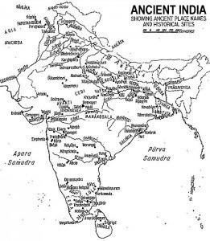

Ancient India : Courtesy Government of India

The first inhabitants of Indian subcontinent might have been tribals like Nagas (North-East), Santhals (East- India), Bhils (Central India), Gonds (Central India), Todas (South India) etc. Most of them are speakers of the Austric, pre-Dravidian languages, such as Munda and Gondvi. Dravidians and Aryans are believed to be immigrants who came later to the sub-continent.

Ancient India can be studied under other heads like Paleolithic, Mesolithic, Neolithic and Chalcolithic period – based on the type of stone/ metal tools people used.

***Paleolithic Period (2 million BC – 10,000 BC)***

* Fire
* Tools made up of lime stone
* Ostrich Eggs
* Important Paleolithic sites : Bhimbetka (M.P), Hunsgi, Kurnool Caves, Narmada Valley (Hathnora, M.P), Kaladgi Basin

***Mesolithic Period (10,000 BC – 8,000 BC)***

* Major Climatic Change happened
* Domestication of animals ie Cattle rearing started
* Microliths found at Brahmagiri (Mysore), Narmada, Vindya, Gujarat

***Neolithic Period (8000 BC – 4,000 BC)***

* Agriculture Started
* Wheel discovered
* Inamgaon = An early village
* Important Neolithic Sites : Burzahom(Kashmir), Gufkral(Kashmir), Mehrgarh(Pakistan), Chirand(Bihar), Daojali Hading(Tripura/Assam), Koldihwa(UP), Mahagara(UP), Hallur(AP), Paiyampalli(AP), Maski, Kodekal, Sangana Kaller, Utnur, Takkala Kota.
* NB: Megalithic Sites: Brahmagiri, Adichanallur

***Chalcolithic Period (4000 BC – 1,500 BC)***

* Copper Age. Can be considered part of Bronze Age. (Bronze = Copper + Tin)
* [Indus Valley Civilization](http://www.clearias.com/indus-valley-civilization/) (BC 2700 – BC 1900).
* Also cultures at Brahmagiri, Navada Toli (Narmada region), Mahishadal (W.Bengal), Chirand (Ganga region)

***Iron Age (BC 1500 – BC 200)***

* Vedic Period (Arrival of Aryans ie. BC 1600 – BC 600) – Nearly 1000 years (Basic books of Hinduism, ie Vedas were composed, might have written down later.)
* Jainism and Buddhism
* Mahajanapadas – Major Civilization after Indus Valley- On banks of river Ganga
* Magadha empire – Bimbisara of Haryanka Kula
* Sisunga dyanasy – Kalasoka (Kakavarnin)
* Nanda empire – Mahapadma-nanda, Dhana-nanda
* Persian- Greek : Alexander 327 BC

***Mauryan Empire (321-185 BC)***

Chandra Gupta Maurya, Bindusara, Asoka

***Post Mauryan Kingdoms (Middle Kingdoms):***

* Sunga (181-71 BC), Kanva (71-27BC), Satavahanas (235-100BC), Indo-Greeks, Parthians (19-45AD), Sakas (90BC-150AD), Kushanas(78AD)
* South Indian Kingdoms – Chola, Chera, Pandyas (BC 300)

***Gupta Kingdom (300AD – 800AD) : Classical Period***

Samudra Gupta (Indian Napoleon)

***Post Guptas or Contemporary Guptas***

* Harshvardana, Vakatakas, Pallavas, Chalukyas. Also, Hunas, Maitrakas, Rajputs, Senas and Chauhans.

**Medieval India (AD 700 – AD 1857)**

* AD: 800-1200: Tri partite struggle – Prathiharas, Palas and Rashtrakutas
* Attack of Muhammed Bin Kassim (AD 712)
* Rise of Islam and Sufism
* Mohammed Ghazni (AD 1000-27)Mohammed Ghori (AD 1175-1206)

* Kingdoms of South India During Medieval India – Bhamini and Vijayanagara

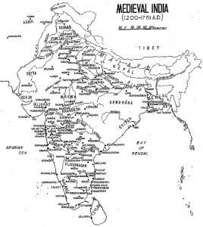

Medieval India – Courtesy Government of India

***Delhi Sultanate (1206 AD – 1526 AD)***

1. Slave Dynasty
2. Kilji Dynasty
3. Tuglaq Dynasty
4. Sayyid Dynasty
5. Lodi Dyanasty

Mughals (AD 1526 – AD 1857)

* Great Mughals
* Later Mughals
* Arrival of Europeans
* Other Kingdoms of North India – Marathas, Sikhs

#### Modern India (AD 1857 +)

* First War of Indian Independence (1857)
* Formation of Indian National Congress (1885)
* Formation of Muslim League (1906)
* Non Co-operation Movement (1920)
* Civil Disobedience Movement (1930)
* Quit India Movement (1942)
* Partition of India (1947)
* Constitutional Development of India (1946 – 1950)
* Economic Development of India
* Wars – India-Pak – Formation of Bangladesh; India- China
* New Economic Policy of 1991
* Nuclear, Space and Defense Development

History Schools

* *Orientalist School – West Patronizing the East Culture – Not active now*
* *Cambridge School – Downplays ideology*
* *Nationalist School – Importance to Congress and Gandhi; Hindu Nationalists for Hindutva version*
* *Marxists School – Class conflict*
* *Subaltern School – Caste conflict*

# (2) Indus Valley Civilization

Indus Valley Civilization was the first major civilization in south Asia, which spread across a vast area of land in present day India and Pakistan (around 12 lakh sq.km). The time period of mature Indus Valley Civilization is estimated between BC. 2700- BC.1900 ie. for 800 years. But early Indus Valley Civilization had existed even before BC.2700.

#### Features of Indus Valley Civilization

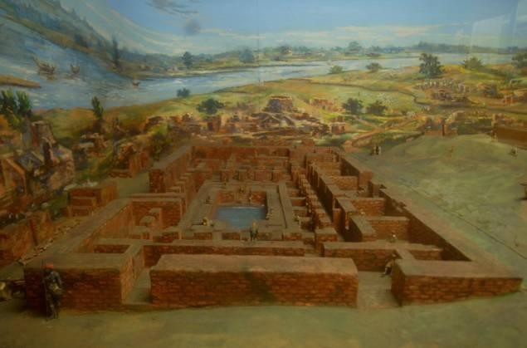

* BC. 2700- BC.1900 ie for 800 years.
* On the valleys of river Indus.
* Also known as Harappan Civilization.
* Beginning of city life.
* Harappan Sites discovered by – Dayaram Sahni (1921) – Montgomori district, Punjab, Pakistan.
* Mohanjodaro discovered by – R. D. Banerji – Larkana district, Sind, Pakistan.
* City was divided into Citadel(west) and Lower Town(east).
* Red pottery painted with designs in black.
* Stone weights, seals, special beads, copper tools, long stone blades etc.
* Copper, bronze, silver, gold present.
* Artificially produced – Faience.
* Specialists for handicrafts.
* Import of raw materials.
* Plough was used.
* Bodies were buried in wooden coffins, but during the later stages ‘H symmetry culture’ evolved where bodies were buried in painted burial urns.
* Sugar cane not cultivated, horse, iron not used.

Indus Valley Sites and Specialties

***Harappa***

* Seals out of stones
* Citadel outside on banks of river Ravi

***Mohenjodaro***

* Great Bath, Great Granary, Dancing Girl, Man with Beard, Cotton, Assembly hall
* Term means ” Mount of the dead”
* On the bank of river Indus
* Believed to have been destructed by flood or invasion(Destruction was not gradual).

***Chanhudaro***

* Bank of Indus river. – discovered by Gopal Majumdar and Mackey (1931)
* Pre-harappan culture – Jhangar Culture and Jhukar Culture
* Only cite without citadel.

***Kalibangan***

* At Rajastan on the banks of river Ghaggar, discovered by A.Ghosh (1953)
* Fire Altars
* Bones of camel
* Evidence of furrows
* Horse remains ( even though Indus valley people didn’t use horses).
* Known as third capital of Indus Empire.

***Lothal***

* At Gujarat near Bhogava river, discovered by S.R. Rao (1957)
* Fire Altars
* Beside the tributary of Sabarmati
* Store house
* Dockyard and earliest port
* double burial
* Rice husk
* House had front entrance (exception).

***Ropar***

* Punjab, on the banks of river Sutlej. Discovered by Y.D Sharma (1955)
* Dog buried with humans.

***Banawali***

* Haryana
* On banks of lost river Saraswathi
* Barley Cultivation.

Dholavira

* Biggest site in India, until the discovery of Rakhigarhi.
* Located in Khadir Beyt, Rann of Kutch, Gujarat. Discovered by J.P Joshi/Rabindra Singh (1990)
* 3 parts + large open area for ceremonies
* Large letters of the Harappan script (sign boards).

Religion of Indus Valley People

* Pashupathi Mahadev (Proto Siva)
* Mother goddess
* Nature/ Animal worship
* Unicorn, Dove, Peepal Tree, Fire
* Amulets
* Idol worship was practiced ( not a feature of Aryans)
* Did not construct temples.
* Similarity to Hindu religious practises. (Hinduism in its present form originated later)
* No Caste system.

Indus Valley Society and Culture

* Systematic method of weights and measures ( 16 and its multiples).
* Pictographic Script, Boustrophedon script – Deciphering efforts by I. Mahadevan
* Equal status to men and women
* Economic Inequality, not an egalitarian society
* Textiles – Spinning and weaving
* 3 types – burial, cremation and post cremation were there, though burial was common.
* Majority of people Proto-australoids and Mediterraneans (Dravidians), though Mongoloids, Nordics etc were present in the city culture. Read more on [races of India.](http://www.preservearticles.com/2011101115155/short-essay-on-the-racial-classification-of-indian-people.html)

Reasons for Decline of Indus Valley Civilization

Though there are various theories, the exact reason is still unknown. As per a recent study by IIT Kharagpur and Archaeological Survey of India, a weaker monsoon might have been the cause of decline of Indus Valley Civilization. Environmental changes, coupled with loss of power of rulers (central administration) of Indus valley to sustain the city life might be the cause (Fariservis Theory). There might be resource shortage to sustain the population, and then people moved towards south India. Another theory by [Dr Gwen Robbins Schug](http://zeenews.india.com/news/nation/violence-disease-caused-end-of-indus-valley-civilization_906432.html) states that inter-personal violence, infectious diseases and climate change had played a major role in the demise of the Indus Valley Civilization.

**Other theories:**

* Aryan Invasion : Motimer Wheeler
* Tectonic Movements/ Flood – Robert Raikes
* Change of course of river Indus – Lambrick.

# Ancient India: Customs and Practices (NCERT)

NCERT texts are a must read for every UPSC aspirant and are available for free download from [ncert.nic.in](http://www.ncert.nic.in/) website. Almost every UPSC topper has repeated the importance of reading NCERT school texts. These are texts which help to build the fundamentals. In this article, we will be dealing with the important points filtered out from NCERT texts (our starting point is NCERT history text for standard 6). We plan to cover main points from NCERT texts for different classes and subjects in our future posts.

#### NCERT History Text: Standard 6

The reference material for this post is NCERT History text for Class 6 (Our past -1). Only main points from each chapter is compiled below. Our advice is to first go through the respective NCERT text and use this compilation then for quick revision. We believe that this listing will come handy during exam time.

#### What, Where, How and When?

* Narmada: earliest people who lived here were skilled gatherers; they knew about the vast wealth of plants in the surrounding forests, and collected roots, fruits for food; also hunted animals.
* Sulaiman and Kirthar hills: current Sindh; where women and men first began to grow crops such as wheat and barley about 8000 years ago; rearing animals.
* Garo Hills & Vindhya: where agriculture developed; rice was first grown to the north of the Vindhyas.
* Indus: 4700 years ago, some of the earliest cities flourished on the banks
* Son, a Ganga tributary: Magadha rulers were very powerful, and set up a large kingdom.

#### On the trail of the earliest people

* Factory Sites: places where stone was found and where people made tools are known as factory sites.
* Habitation-cum-factory: sometimes, people lived here for longer spells of time.
* Kurnool Site: current A.P; traces of ash have been found here. This suggests that people were familiar with the use of fire.
* Paleolithic: importance is finding of stone tools; period extends from 2 million years ago to about 12,000 years ago;long stretch of time is divided into the Lower, Middle and Upper Palaeolithic. This long span of time covers 99% of human history.
* Mesolithic: environmental changes; 12,000 years ago till about 10,000 years ago; stone tools are generally tiny, and are called microliths. Microliths were probably stuck on to handles of bone or wood to make tools such as saws and sickles. At the same time, older varieties of tools continued to be in use.
* Ostrich in India: palaeolithic period; large quantities shells were found at Patne in Maharashtra; designs engraved on some pieces.

#### From gathering to growing food

**Settled life:**

* In Burzahom (in present-day Kashmir) people built pit-houses, which were dug into the ground, with steps leading into them.
* These may have provided shelter in cold weather.
* Stone tools from sites were different from the earlier Palaeolithic tools and that is why they are called Neolithic.
* Many kinds of earthen pots have also been found.
* However, still places got huneters and gatherers.
* In some cases people tried to combine these activities.
* Climate of the world was changing, and so were plants and animals that people used as food.
* They look after plants and also grow – farmers.
* First animal to be tamed was the wild ancestor of the dog; later relatively gentle animals to come near the camps where they lived such as sheep, goat, cattle; protect these animals from wild attacks – herders
* Domestication was a gradual process, began about 12,000 years ago.

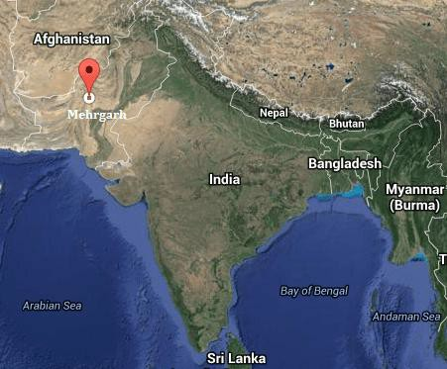

**Customs and practices**

* Many farmers and herders live in groups called tribes.
* Women do most of the agricultural work, including preparing the ground etc.
* Children often look after plants, driving away animals.
* Some men are regarded as leaders. They may be old and experienced, or young, brave warriors, or priests.
* Tribes have rich and unique cultural traditions; have their own gods and goddesses.

**Mehrgarh Site**

* Located near Bolan Pass [current Balochistan]; most important routes into Iran.
* One of the earliest villages that we know about.
* Women and men learnt to grow barley and wheat, and rear sheep and goats.
* Earlier excavation found were of wild animals deer and pig suggesting they were hunters. But later level excavation found bones of sheep and goat which make them herders. So first Mehrgarh were hunters later they became herders.
* Remains of square or rectangular houses.
* Belief that there is some form of life after death was visible in their burial grounds found.

**Daojali Hading**

* This site is on hills near the Brahmaputra Valley.
* Stone tools, including mortars and pestles, have been found indicating they were agriculturalists.
* Jadeite, a stone that may have been brought from ChinaTools made of
* fossil wood too in usage.

# Ancient India: Early Cities and Republics (NCERT)

NCERT texts are a must read for every UPSC aspirant and are available for free download from [ncert.nic.in](http://www.ncert.nic.in/) website. Almost every UPSC topper has repeated the importance of reading NCERT school texts. These are texts which help to build the fundamentals. In this article, we will be dealing with the important points filtered out from NCERT school text for Standard 6 History. We plan to cover main points from NCERT texts for different classes and subjects in our future posts.

#### NCERT History Text: Standard 6

The reference material for this post is NCERT History text for Class 6 (Our past -1). Only main points from each chapter is compiled below. Our advice is to first go through the respective NCERT text and use this compilation then for quick revision. We believe that this listing will come handy during exam time.

#### In the earliest cities

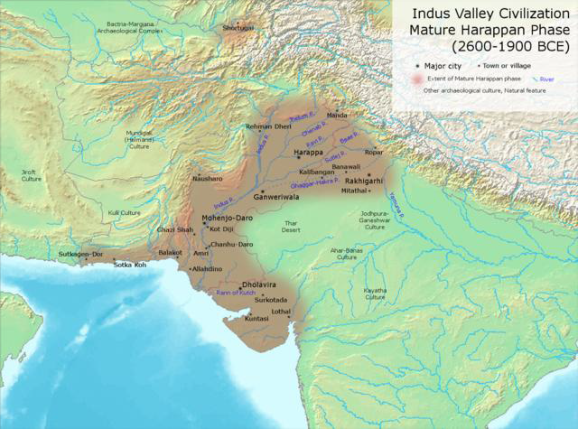

**Harappa**

* These cities developed about 4700 years ago.
* Many of these cities were divided into two or more parts.
* The part to the west was smaller but higher: citadels
* The part to the east was larger but lower: lower town
* The bricks were laid in an interlocking pattern and that made the walls strong.
* Special buildings were constructed on the citadel. For example, in Mohenjodaro, a tank: Great Bath.
* Kalibangan and Lothal had fire altars, where sacrifices may have been performed.
* Mohenjodaro, Harappa and Lothal had elaborate store houses.
* Houses were either one or two storeys high, with rooms built around a courtyard.
* Most houses had a separate bathing area, and some had wells to supply water.
* Many of these cities had covered drains.
* All three — houses, drains and streets — were probably planned and built at the same time.
* Most of the things are made of stone, shell and metal, including copper, bronze, gold and silver.
* Copper and bronze were used to make tools, weapons, ornaments and vessels.
* Gold and silver were used to make ornaments and vessels.
* Harappans also made seals out of stone which are rectangular and had an animal carved on them.
* Made pots with beautiful black designs.
* Cotton was probably grown at Mehrgarh from about 7000 years ago.
* Perhaps some women and men may have been specialists to perform crafts.
* The Harappans probably got copper from present-day Rajasthan, and even from Oman.
* Tin may have bought from present-day Afghanistan and Iran.
* Gold could have come all the way from present-day Karnataka.
* A new tool, the plough, was used to dig the earth for turning the soil and planting seeds but wooden plough not found while excavation.
* As this region does not receive heavy rainfall, some form of irrigation may have been used.
* Dholavira was located on Khadir Beyt in the Rann of Kutch, where there was fresh water and fertile soil.
* Dholavira was divided into three parts but other Harappan cities 2 parts.
* Large letters of the Harappan script that were carved out of white stone and perhaps inlaid in wood.

Normally seals found on small objects so the above discovery was an unique one.

* Lothal stood beside a tributary of the Sabarmati.
* Here raw materials such as semi-precious stones were easily available.
* A dockyard at Lothal, where boats and ships came in from the sea and through the river channel.

#### Early Republic

**Janapadas**

* The rajas who perform big ritual sacrifices.
* The word janapada literally means the land where the jana[people] set its foot, and settled down.
* Excavations of janapadas, settlements, were found at Purana Qila in Delhi, Hastinapur near Meerut, and Atranjikhera, near Etah (the last two are in Uttar Pradesh).
* The people lived in huts, and kept cattle as well as other animals.
* They also grew a variety of crops — rice, wheat, barley, pulses, sugarcane, sesame and mustard.
* Special type of pottery found at these sites is known as Painted Grey Ware of simple lines and geometric patterns.

**Mahajanapadas**

* 2500 years ago, some janapadas became more important than others: mahajanapadas.
* Most had a capital city, many of these were fortified
* The new rajas now began maintaining armies.
* Soldiers were paid regular salaries.
* Changes in agriculture around this time were seen.
* One was growing use of iron ploughshares. Here more grain could be produced than with wooden plough.
* Second, people began transplanting paddy. This meant that instead of scattering seed on the ground, saplings were grown and then planted in the fields.

**Magadha**

* Rivers such as Ganga, Son made the transport easier. Water supplies for both drinking and agriculture.
* There were iron ore mines in the region which was able to make strong tools and weapon.
* Bimbisara and Ajatasatru, the two powerful rulers who used all means to conquer other janapadas.
* Mahapadma Nanda, extended his control up to the north-west part of subcontinent.
* Magadha’s capital was shifted from Rajagriha (present Rajgir) to Pataliputra (present Patna)
* Alexander of Macedonia reached upto the banks of river Beas in light of conquering Magadha, but his soldiers refused due to fear of Magadha’s elephant and chariot armies.

**Vajji**

* It was having distinct govt from Mahajanapadas.
* Govt was known as *gana* or *sangha.*
* Vaishali(Bihar) was its capital.
* This institution had many rulers (1000s)not one.
* They were called *Raja.* These rajas performed rituals together. They also met in assemblies for future course of action if needed.
* Women, dasas and kammakaras [landless agri labourers] could not participate in these assemblies.
* Both the Buddha and Mahavira belonged to ganas.
* These institution lasted for 1500 years, powerful Rajas tried to conquer sanghas.
* But the Gupta era started when last Sangha ruler was defeated.

**(5) Ancient India: Hinduism, Buddhism and Jainism (NCERT)**

NCERT texts are a must read for every UPSC aspirant and are available for free download from [ncert.nic.in](http://www.ncert.nic.in/) website. Almost every UPSC topper has repeated the importance of reading NCERT school texts. These are texts which help to build the fundamentals. In this article, we will be dealing with the important points filtered out from NCERT school text for Standard 6 History. We plan to cover main points from NCERT texts for different classes and subjects in our future posts.

#### NCERT History Text: Standard 6

The reference material for this post is NCERT History text for Class 6 (Our past -1). Only main points from each chapter is compiled below. Our advice is to first go through the respective NCERT text and use this compilation then for quick revision. We believe that this listing will come handy during exam time.

#### New Questions and Ideas

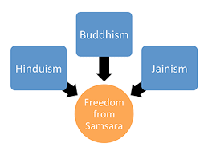

* Due to Mahajanapadas, cities were flourishing and lifestyles were changing in villages.
* Now here, many thinkers were trying to understand these changes in society. They want to know true meaning of life

**Buddha**

* Buddha belonged to a small gana known as the Sakya gana, and was a kshatriya.
* He finally decided to find his own path to realisation, and meditated for days under a peepal tree at Bodh Gaya in Bihar, where he attained enlightenment. After that, he was known as the Buddha or the Wise One.
* Sarnath, near Varanasi, where he taught for the first time.
* He passed away at Kusinara.
* The Buddha taught that life is full of suffering and unhappiness. This is caused because we have cravings and desires.
* The Buddha described this as thirst or tanha. He taught that this constant craving could be removed by following moderation in everything.
* He also taught people to be kind, and to respect the lives of others, including animals.
* He believed that the results of our actions (called karma), whether good or bad, affect us both in this life and the next.
* Taught in the language of the ordinary people, Prakrit.
* He also encouraged people to think for themselves.

[**Also read: Medieval India: Delhi Sultanate (NCERT)**](http://www.clearias.com/medieval-india-delhi-sultanate/)

**Upanishads**

* Same time or perhaps earlier than Buddha, other thinkers also tried to find answers to difficult questions like “life after death”, performing of “ritual sacrifices ” etc.
* There were something permanent that last even after death. They named it atman or the individual soul and the brahman or universal soul.
* They believed that ultimately, both the atman and the brahman were one.
* Many of their ideas were recorded in the Upanishads. These were part of the later Vedic texts.
* Recorded texts contain conversation between teachers and students, through simple dialogues.

**Jainism**

* Most famous thinker of the Jainas, Vardhamana Mahavira was a contemporary of Buddha.
* He was a kshatriya prince of the Lichchhavis, a group that was part of the Vajji sangha.
* He taught a simple doctrine: men and women who wished to know the truth must leave their homes.
* They must follow very strictly the rules of ahimsa, which means not hurting or killing living beings.
* It was very difficult for most men and women to follow these strict rules like remain nude or maitaining celibacy eg: farmers find it difficult to follow because they cant weed out insects.
* Ordinary people could understand the teachings because in Prakrit language.
* Jainism was supported mainly by traders.

**The sangha**

* Both the Mahavira and the Buddha felt that only those who left their homes could gain true knowledge.

They arranged for them to stay together in the sangha, an association of those who left their homes.

* The rules made for the Buddhist sangha were written down in a book called the Vinaya Pitaka.
* Men and women who joined the sangha led simple lives.
* Those who joined the sangha included brahmins, kshatriyas, merchants, labourers, barbers, courtesans, children and slaves.

**Monasteries**

* The only time both Buddhists and Jainists stayed in one place was during the rainy season, when it was very difficult to travel.
* These shelters were called viharas.
* The earliest viharas were made of wood, and then of brick. Some were even in caves that were dug out in hills, especially in western India.

**System of ashramas**

* Same time of Buddha and Jain, brahmins developed this ashramas.
* It is used as for a stage of life instead of people live and meditate.
* Four ashramas were recognised: brahmacharya, grihastha, vanaprastha and samnyasa.
* Generally, women were not allowed to study the Vedas, and they had to follow the ashramas chosen by their husbands.

# (6) Ancient India: Maurya and Post-Maurya Rulers (NCERT)

NCERT texts are a must read for every UPSC aspirant and are available for free download from [ncert.nic.in](http://www.ncert.nic.in/) website. Almost every UPSC topper has repeated the importance of reading NCERT school texts. These are texts which help to build the fundamentals. In this article, we will be dealing with the important points filtered out from NCERT school text for Standard 6 History. We plan to cover main points from NCERT texts for different classes and subjects in our future posts.

#### NCERT History Text: Standard 6

The reference material for this post is NCERT History text for Class 6 (Our past -1). Only main points from each chapter is compiled below. Our advice is to first go through the respective NCERT text and use this compilation then for quick revision. We believe that this listing will come handy during exam time.

#### Asoka, The Emperor

* The Mauryas were a dynasty, more than 2300 years ago, with three important rulers — Chandragupta[founder], his son Bindusara, and Bindusara’s son, Ashoka.
* Chandragupta was supported by a wise man named Chanakya or Kautilya. Many of Chanakya’s ideas were written down in a book titled Arthashastra.
* Megasthenes was an ambassador who was sent to the court of Chandragupta by the Greek ruler of West Asia named Seleucus Nicator.
* Ashoka was one of the greatest rulers known to history and on his instructions inscriptions were carved on pillars, as well as on rock surfaces.
* Most of Ashoka’s inscriptions were in Prakrit and were written in the Brahmi script.
* People in different parts of the empire spoke different languages.

**Ruling the empire**

* As the empire was so large, different parts were ruled differently.
* The area around Pataliputra was under the direct control of the emperor. This meant that officials were appointed to collect taxes.
* Spies were kept a watch on the officials.
* Other areas or provinces was ruled from a provincial capital such as Taxila or Ujjain.
* Here Royal Princes were often send as governors, local customs and rules were followed.

**Ashoka’s dhamma**

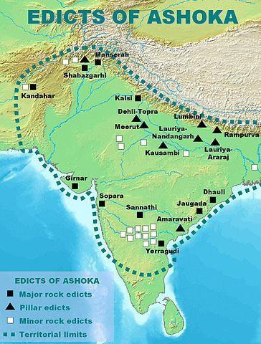

* After Kalinga[current coastal Odisha] he gave up war.
* He started to execute Dhamma[prakrit term for Dharma]
* Ashoka’s dhamma did not involve worship of a god, or performance of a sacrifice. He felt its his duty to instruct his subjects through teachings of Budhha.
* He appointed officials, known as the dhamma mahamatta who went from place to place teaching people about dhamma.
* Besides, Ashoka got his messages inscribed on rocks and pillars, instructing his officials to read his message to those who could not read it themselves.
* Also sent messengers to spread ideas about dhamma to other lands, such as Syria, Egypt, Greece and Sri Lanka.

**Great Wall of China**

* Somewhat before the time of the Mauryan empire, about 2400 years ago, began to built this wall.
* It was meant to protect the northern frontier of the empire from pastoral people.
* Additions to the wall were made over a period of 2000 years because the frontiers of the empire kept shifting.

#### Vital Villages, Thriving Towns

* The use of iron began in the subcontinent around 3000 years ago.
* The kings and kingdoms could not have existed without the support of flourishing villages.
* Some of the earliest works in Tamil, known as Sangam literature, were composed around 2300 years ago.

These texts were called Sangam because they were supposed to have been composed and compiled in assemblies (known as sangams) of poets that were held in the city of Madurai.

* Jataka s were stories that were probably composed by ordinary people, and then written down and preserved by Buddhist monks.
* We have hardly any remains of palaces, markets, or of homes of ordinary people. Perhaps some are yet to be discovered by archaeologists.
* Another way of finding out about early cities is from the accounts of sailors and travellers who visited them.
* Crafts include extremely fine pottery, known as the Northern Black Polished Ware. It is generally found in the northern part of the subcontinent, so the name. It is usually black in colour, and has a fine sheen.
* Many crafts persons and merchants now formed associations known as shrenis.
* These *shrenis* of crafts persons provided training, procured raw material, and distributed the finished product.
* *Shrenis* also served as banks.

#### Traders, Kings and Pilgrims

* Sangam poems mention the muvendar. This is a Tamil word meaning three chiefs, used for the heads of three ruling families, the Cholas, Cheras, and Pandyas. They became powerful in south India around 2300 years ago.
* Each of the three chiefs had two centres of power: one inland, and one on the coast. Of these six cities, two were very important: Puhar or Kaveripattinam, the port of the Cholas, and Madurai, the capital of the Pandyas.
* The chiefs did not collect regular taxes. Instead, they demanded and received gifts from the people.
* Around 200 years later a dynasty known as the Satavahanas became powerful in western India.
* The most important ruler of the Satavahanas was Gautamiputra Shri Satakarni.
* He and other Satavahana rulers were known as lords of the dakshinapatha, literally the route leading to the south.

**Silk Route & Kushans**

* Some people from China who went to distant lands on foot, horseback, and on camels, carried silk with them. The paths they followed came to be known as the Silk Route.
* Some kings tried to control large portions of the route. This was because they could benefit from taxes, tributes and gifts that were brought by traders travelling along the route. In return, they often protected the traders who passed through their kingdoms from attacks by robbers.
* The best-known of the rulers who controlled the Silk Route were the Kushanas, who ruled over central Asia and north-west India around 2000 years ago.
* Their two major centres of power were Peshawar and Mathura. Taxila was also included in their kingdom.
* During their rule, a branch of the Silk Route extended from Central Asia down to the seaports at the mouth of the river Indus, from where silk was shipped westwards to the Roman Empire.
* The Kushanas issued gold coins. These were used by traders along the Silk Route.

**Spread of Buddhism**

* The most famous Kushana ruler was Kanishka, who ruled around 1900 years ago.
* He organised a Buddhist council, where scholars met and discussed important matters.
* Ashvaghosha, a poet who composed a biography of the Buddha, the Buddhacharita, lived in his court. He and other Buddhist scholars now began writing in Sanskrit.
* A new for m of Buddhism, known as Mahayana Buddhism, now developed.
* Here it got 2 distinct features: (1) earlier, the Buddha’s presence was shown in sculpture by using certain signs. Now statues are made. From Mathura and Taxila. (2) regarded with belief in*Bodhisattvas*. Earlier once they attained Enlightenment they could live in complete isolation and meditate in peace. Now they remained in the world to teach and help other people. This type of worship prvailed throughout Central Asia, China, and later to Korea and Japan.
* Traders probably halted in cave monasteries during their travels.
* The older form of Buddhism, known as Theravada Buddhism was more popular in areas like Sri Lanka, Myanmar, Thailand, and other parts of Southeast Asia including Indonesia.
* The famous Chinese Buddhist pilgrims were Fa Xian, who came to the subcontinent about 1600 years ago, Xuan Zang came around 1400 years ago and I-Qing, who came about 50 years after Xuan Zang.

**Bhakti**

* The worship of certain deities, which became a central feature of later Hinduism, gained in importance were the contemporaries of other religion
* Anybody, whether rich or poor, belonging to the so-called ‘high’ or ‘low’ castes, man or woman, could follow the path of Bhakti.
* The idea of Bhakti is present in the Bhagavad Gita.
* Those who followed the system of Bhakti emphasised devotion and individual worship of a god or goddess, rather than the performance of elaborate sacrifices
* Once this idea gained acceptance, artists made beautiful images of these deities.

**(7) Ancient India: Gupta and Post-Gupta (NCERT)**

This article on ancient India covers Gupta and post-Gupta rulers. The compilation based on NCERT texts will also help you learn the cultural history of India.

#### NCERT History Text: Standard 6

The reference material for this post is NCERT History text for Class 6 (Our past -1). Only main points from each chapter is compiled below. Our advice is to first go through the respective NCERT text and use this compilation then for quick revision. We believe that this listing will come handy during exam time.

#### New Empires and Kingdoms

**Guptas**

* Information about their history through inscriptions and coins.
* Changragupta was followed by Samudragupta.
* Samudragupta, Gupta ruler (1700 years ago, ie AD 300). Harisena was his court poet.
* Chandragupta, his father, was the first ruler of the Gupta dynasty to adopt the grand title of maharaj- adhiraja, a title that Samudragupta also used.
* “Prashasti” = inscription ‘in praise of’. Prashasti about Samudragupta was inscribed on the Asokan piller at Allahabad (Prayag).
* Four different kinds of rulers in different parts of India/Nepal/Srilanka either surrendered to him or made alliances. (Eg: Aryavartha, Dakshinapatha, gana sanghas etc).
* Main centers of Guptas: Prayag (Allahabad, UP), Ujjain (Avanti, MP) and Pataliputra (Patna, Bihar).
* Samudragupta’s son = Chandragupta II. Kalidasa and Aryabhata adorned his court. He overcame the last Sakas.

**Harshavardhana & Harshacharita**

* Information about their history through biographies.
* He belonged to Pushyabhuti Dynasty when Gupta dynasty was fading.
* His court poet, Banabhatta, wrote his biography, the Harshacharita, in Sanskrit.
* Xuan Zang, spent a lot of time at Harsha’s court and left a detailed account of what he saw.
* Harsha took over the kingdom of Kanauj, and then led an army against the ruler of Bengal.
* Although he was successful in the east, and conquered both Magadha and Bengal, he was not as successful elsewhere.
* He tried to cross the Narmada to march into the Deccan, but was stopped by a ruler belonging to the Chalukya dynasty, Pulakeshin II.

**The Pallavas, Chalukyas and Pulakeshin**

* The Pallavas and Chalukyas were the most important ruling dynasties in south India during this period.
* The kingdom of the Pallavas around their capital, Kanchipuram, to the Kaveri delta, while that of the Chalukyas [Aihole, the capital ] was centred around the Raichur Doab, between the rivers Krishna and Tungabhadra.
* The Pallavas and Chalukyas frequently raided one another’s lands which were properous ones.
* The best-known Chalukya ruler was Pulakeshin II. We know about him from a prashasti, composed by his court poet Ravikirti.Ultimately, both the Pallavas and the Chalukyas gave way to new rulers belonging to the Rashtrakuta and Chola dynasties.
* Land revenue remained important for these rulers, and the village remained the basic unit of administration
* There were military leaders who provided the king with troops whenever he needed them. These men were known as samantas.
* The inscriptions of the Pallavas mention a number of local assemblies. These included the sabha, which was an assembly of brahmin land owners.
* And the nagaram was an organisation of merchants.
* The Chinese pilgrim Fa Xian noticed the plight of those who were treated as untouchables by the high and mighty.

#### Buildings, Paintings and Books



* Iron pillar – during the time of Chandra – Gupta.
* Stupas (mound) – Relic casket may contain bodily remains of the Buddha or his followers or the things they used. Pradakshina patha was laid around the stupa. (Eg: Sanchi, Amaravathi)
* Cave temples.
* Rock cut temples.
* Hindu temples: Garbhagriha = place where the image of the chief diety was placed. Shikara = tower made on the top of garbhagriha to mark this out as a sacred place. Mandapa = hall where people could assemble.
* Examples of early temples : Bhitargaon, UP (AD 500) – made of baked brick and stone, Mahabalipuram – monolithic temples, Aihole Durga temple (AD 600).
* PS: Association of ivory worked paid for one the beautiful gateways at Sanchi.
* Jain monastery in Orissa.
* Paintings – Ajanata caves – Buddhist monks.
* Books – Silappadikaram (by Ilango Adikal, AD 200) and Manimekalai (by Sattanar, AD 600), Meghaduta (by Kalidasa).
* Puranas – were meant to be heard by every body. Believed to be compiled by Vyasa.

Jataka and Panchatantra storiesC- Medieval India

1. **Medieval India: Tripartite Struggle and Cholas (NCERT)**

Well, we have covered the main points from NCERT text for Standard 6 History in our last 5 posts. All the 5 parts dealt with ‘Ancient India’. From today, we shall see part-by-part the main points from Standard 7 NCERT History text. The objective of the next set of articles would be to present main points from ‘Medieval India’, in an easy to revise form. Thanks for the encouragement from readers – online and offline – we plan to do the compilation of NCERT for Modern History too. Now straight to the topics.

#### NCERT History Text: Standard 7 (Medieval India Topics)

In this post we see the tripartite struggle between Pratiharas, Palas and Rashtrakutas during the medieval period. We will also learn about imperial Cholas.

The reference material for this post is NCERT History text for Class 7 (Our past -1). Only main points from the chapters are compiled below. These points might come quite handy during preparation of Prelims and Mains, to get a quick grasp of the subject.New Kings and Kingdoms

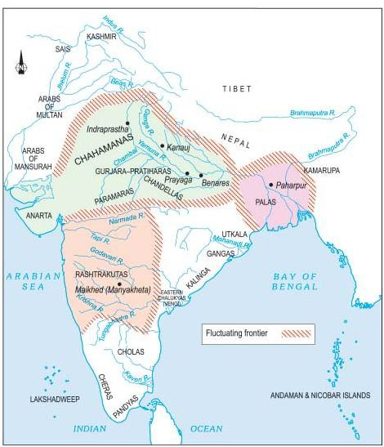

* Many dynasties emerged during 7th century.
* By the 7th century there were big landlords or warrior chiefs in different regions of the subcontinent.
* Existing kings often acknowledged them as their subordinates or samantas. As these samantas gained power and wealth, they declared themselves to be maha-samanta, maha- mandaleshvara (the great lord of a “circle” or region) and so on.
* Sometimes they asserted their independence from their overlords.
* Rashtrakutas in the Deccan is one such instance. Initially they were subordinate to the Chalukyas of Karnataka. In the mid-eighth century, Dantidurga, a Rashtrakuta chief, overthrew his Chalukya overlord.
* In each states, resources were obtained from the producers, that is, peasants, cattle-keepers, artisans, who were often persuaded or compelled to surrender part of what they produced.
* *Prashastis* contain details that may not be literally true. But they tell us how rulers wanted to depict themselves – as valiant, victorious warriors, for example.
* However author named Kalhana composed Sanskrit poems in 12th century and he was critical about the rulers and their policies.
* Kanauj in the Ganga valley was a prized area. For centuries, rulers belonging to the Gurjara-Pratihara, Rashtrakuta and Pala dynasties fought for control over Kanauj. Historians often describe it as the **“*tripartite struggle*”**.
* Rulers also tried to demonstrate their power and resources by building large temples.
* Sultan Mahmud of Ghazni, Afghanistan [ruled 997-1030] and extended control over Central Asia, Iran and north-west parts of subcontinent used to attack these temples including Somnath of Gujarat.
* Al-Biruni, Gazni’s trusted scholar was made to write about to subcontinent he conquered. This arabic wrok Kitanb-al-Hind sought help from Sankrit scholars too.
* Chauhans /Chahamanas, who ruled over the region around Delhi and Ajmer.
* They attempted to expand their control to the west and the east, where they were opposed by the Chalukyas of Gujarat and the Gahadavalas of western Uttar Pradesh.
* The best-known Chahamana ruler was Prithviraja III (1168-1192), who defeated an Afghan ruler named Sultan Muhammad Ghori in 1191, but lost to him the very next year, in 1192.

**The Cholas**

* Vijayalaya, who belonged to the ancient chiefly family of the Cholas from Uraiyur, captured the delta from the Muttaraiyar in the middle of the ninth century. He built the town of Thanjavur and a temple for goddess Nishumbhasudini there.
* The successors of Vijayalaya conquered neighbouring regions and the kingdom grew.
* Rajaraja I, considered the most powerful Chola ruler, became king in AD 985 and expanded the control.
* Rajaraja’s son Rajendra I continued his policies and even raided the Ganga valley, Sri Lanka and countries of Southeast Asia, developing a navy for these expeditions.
* The big temples of Thanjavur and Gangaikonda- cholapuram, built by Rajaraja and Rajendra.
* Chola temples often became the nuclei of settlements which grew around them. And these temples were not only places of worship; they were the hub of economic, social and cultural life as well.
* Many of the achievements of the Cholas were made possible through new developments in agriculture.
* Settlements of peasants, known as *ur*, became prosperous with the spread of irrigation agriculture. Groups of such villages formed larger units called *nadu*.
* The village council and the nadu had several administrative functions including dispensing justice and collecting taxes.
* Rich peasants of the *Vellala* caste exercised considerable control over the affairs of the nadu under the supervision of the central Chola govt.

# Medieval India: Delhi Sultanate (NCERT)

Well, Indian History continues In this article on Medieval India, we plan to cover the Delhi Sultanate. The reference material for this post is NCERT History text for Class 7 (Our past -1). Only main points from the chapters are compiled below. These points might come quite handy during preparation of Prelims and Mains, to get a quick grasp of the subject.



#### Delhi as the center of attraction

When did Delhi became strategically important as center of political importance? Who were the major rules of Delhi during medieval period? Hopefully you will get answers to these questions in this post.

* Delhi became an important city only in the 12th century.
* Delhi first became the capital of a kingdom under the **Tomara Rajputs**, who were defeated in the middle of the twelfth century by the Chauhans .

#### Rajput Dynasty

1. Tomaras [early twelfth century – 1165]

2. Ananga Pala [1130 -1145]

3. Chauhans [1165 -1192]

4. Prithviraj Chauhan [1175 -1192]

#### Delhi Sultans

* By the 13th century Sultanates transformed Delhi into a capital that controlled vast areas of the subcontinent.
* “Histories”, *tarikh* (singular) / *tawarikh* (plural), written in Persian, the language of administration under the Delhi Sultans by learned men: secretaries, administrators, poets and courtiers who lived in cities (mainly Delhi) and hardly ever in villages.
* Objectives of these writings : (a) They often wrote their histories for Sultans in the hope of rich rewards (b) they advised rulers on the need to preserve an “ideal” social order based on birthright and gender distinctions (c) their ideas were not shared by everybody.
* In 1236 Sultan Iltutmish’s daughter, Raziyya, became Sultan. Nobles were not happy at her attempts to rule independently. She was removed from the throne in 1240.

#### Early Turkish [1206-1290]

1. Qutbuddin Aybak [1206 -1210]
2. Shamsuddin Iltutmish [1210 -1236]

3. Raziyya [1236 -1240]

4. Ghiyasuddin Balban [1266 -1287]

#### The expansion of the Delhi Sultanate

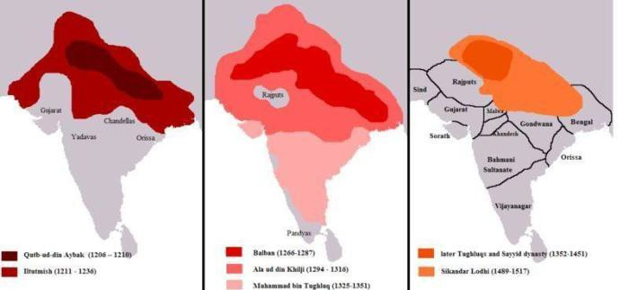

Delhi Sultanate – Boundaries

* In the early 13th century the control of the Delhi Sultans rarely went beyond heavily fortified towns occupied by garrisons.
* The Sultans seldom controlled the *hinterland*, the lands adjacent to a city or port that supply it with goods and services, of the cities and were therefore dependent upon trade, tribute or plunder for supplies.
* Controlling garrison towns in distant Bengal and Sind from Delhi was extremely difficult.
* The state was also challenged by Mongol invasions from Afghanistan and by governors who rebelled.
* The expansion occurred during the reigns of Ghiyasuddin Balban, Alauddin Khalji and Muhammad Tughluq.

#### Khalji Dynasty [1290 – 1320]

1. Jalaluddin Khalji [1290 – 1296]
2. Alauddin Khalji [1296 -1316]

#### Tughluq Dynasty [1320 – 1414]

1. Ghiyasuddin Tughluq [1320-1324]
2. Muhammad Tughluq [1324 -1351]
3. Firuz Shah Tughluq [1351 -1388]

* So, what the first thing Sultans did were consolidating these hinterlands of the garrison towns. During these campaigns forests were cleared in the Ganga-Yamuna doab and hunter- gatherers and pastoralists expelled from their habitat.
* These lands were given to peasants and agriculture was encouraged. New fortresses and towns were established to protect trade routes and to promote regional trade.
* Secondly , expansion occurred along the “external frontier” of the Sultanate. Military expeditions into southern India started during the reign of Alauddin Khalji and culminated with Muhammad Tughluq.

Administration & Consolidation

* Rather than appointing aristocrats as governors, the early Delhi Sultans, especially Iltutmish, favoured their special slaves purchased for military service, called *bandagan* .
* The Khaljis and Tughluqs continued to use bandagan and also raised people of humble birth, who were often their clients, to high political positions.
* Slaves and clients were loyal to their masters and patrons, but not to their heirs.
* Authors of Persian *tawarikh* criticised the Delhi Sultans for appointing the “low and base-born” to high offices.
* Military commanders were appointed as governors of territories . This land is called *iqta* and their holder called *iqtadar* or *muqti .* The duty of muqti was to lead military campaigns and maintain law and order in their iqtas.
* But still large parts of the subcontinent remained outside the control of the Delhi Sultans.
* The Mongols under Genghis Khan invaded Transoxiana in north-east Iran in 1219 and the Delhi Sultanate during the reign of Alauddin Khalji and Muhammad Tughluq .

A.Khalji’s defensive policy against Genghis

* As a defensive measure, Alauddin Khalji raised a large standing army.
* Constructed a new garrison town named Siri for his soldiers.
* In order to feed soldiers, produce collected as tax from lands was done and paddy has got fixed tax as 50% of the yield.
* Alauddin chose to pay his soldiers salaries in cash rather than iqtas. He made sure merchants sell supplies to these soldiers according to prescribed prices .
* So here A.Khalji’s administrative measure were highly praised due to effective intervention in markets to have prices unders control .
* He successfully withstood the threat of Mongol invasions .

M.Tughluq offensive policy against Genghis

* The Mongol army was defeated earlier. M.Tughluq still raised a large standing army.
* Rather than constructing a new garrison town he emptied the residents of a Delhi city named Delhi-i Kuhna and the soldiers garrisoned there.
* Produce from the same area was collected as tax and additional taxes to feed the large army. This coincided with famine in the area. .
* Muhammad Tughluq also paid his soldiers cash salaries. But instead of controlling prices, he used a “token” currency.

This cheap currency could be counterfeited easily because it was made of “bronze”.

* His campaign into Kashmir was a disaster. He then gave up his plans to invade Transoxiana and disbanded his large army .
* His administrative measures created complications. The shifting of people to Daulatabad was resented. The raising of taxes and famine in the Ganga-Yamuna belt led to widespread rebellion. And finally, the “token” currency had to be recalled.

#### 15th & 16th Century Sultanates: Sayyid, Lodi and Suri Sayyid Dynasty [1414 – 1451]

* Khizr Khan 1414 -1421

#### Lodi Dynasty [1451 – 1526]

* Bahlul Lodi 1451 -1489

#### Suri Dynasty [1540-1555]

* Sher Shah Suri [1540-1545] captured Delhi.
* For the first time during the Islamic conquest the relationship between the people and the ruler was systematized, with little oppression or corruption.
* He challenged and defeated the Mughal emperor Humayun (1539 : Battle of Chausa, 1540 : Battle of Kannauj)
* Sher Shah introduced an administration that borrowed elements from Alauddin Khalji and made them more efficient.
* Sher Shah’s administration became the model followed by the great emperor Akbar (1556-1605) when he consolidated the Mughal Empire.
* His tomb is at Sasaram [Bihar]

1. **Medieval India: Mughal Dynasty (NCERT)**

Back after a short break! Our team members have been working on Clear IAS Prelims Mock Tests – timed test series with performance analysis, the only one of its kind – which will be launched soon! Also, a detailed analysis of Budget is in the making. As of now, let’s focus back to our free online study materials on Indian History.

In this article on Medieval India, we plan to cover the Mughal Dynasty. The reference material for this post is NCERT History text for Class 7 (Our past -1). Only main points from the chapters are compiled below. These points might come quite handy during preparation of Prelims and Mains to get a quick grasp of the subject.

#### The Mughal Dynasty

* From the latter half of the 16th century they expanded their kingdom from Agra and Delhi until in the 17th century they controlled nearly all of the subcontinent.
* They imposed structures of administration and ideas of governance that outlasted their rule, leaving a political legacy that succeeding rulers of the subcontinent could not ignore.

#### Babur

* The first Mughal emperor (1526- 1530)
* Political situation in north-west India was suitable for Babur to enter India .
* Sikhandar Lodi died in 1517 and Ibrahim Lodi succeded him. I.Lodhi tried to create strong centralised empire which alarmed Afghan chiefs as well as Rajaputs.
* So in 1526 he defeated the Sultan of Delhi, Ibrahim Lodi and his Afghan supporters, at (First) Panipat (War) and captured Delhi and Agra.
* The establishment of an empire in the Indo-Gangetic valley by Babur was a threat to Rana Sanga.
* So in 1527 – defeated Rana Sanga, Rajput rulers and allies at Khanwa [a place west of Agra].
* Babur’s advent was significant :
* Kabul and Qandhar became integral part of an empire comprising North India . Since these areas had always acted as staging place for an invasion of India and provide security from external invasions
* These two areas mentioned above helped to strengthen India’s foreign trade with China and Mediterranean seaports .
* His war tactics were very expensive since he used heavy artillery which ended era of small kingdoms because these smaller ones cant afford it .
* He introduced a concept of state which has to be based on strength and prestige of Crown instead of religious interference. This provided a precedent and direction to his successors .

#### Humayun [1530-1540, 1555-1556]

* Humayun divided his inheritance according to the will of his father. His brothers were each given a province.
* Sher Khan defeated Humayun which made him forced to flee to Iran.
* In Iran Humayun received help from the Safavid Shah. He recaptured Delhi in 1555 but died in an accident the following year.

#### Akbar [1556-1605]

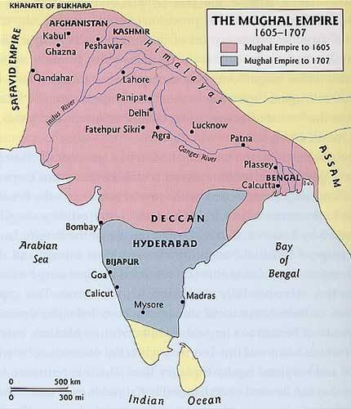

* His reign can be divided into three periods :

1. 1556-1570 : Military campaigns were launched against the Suris and other Afghans, against the neighbouring kingdoms of Malwa and Gondwana, and to suppress the revolt of Mirza Hakim and the Uzbegs. In 1568 the Sisodiya capital of Chittor was seized and in 1569 Ranthambhor.
2. 1570-1585 : military campaigns in Gujarat were followed by campaigns in the east in Bihar, Bengal and Orissa.
3. 1585-1605 : expansion of Akbar’s empire. Qandahar was seized from the Safavids, Kashmir was annexed,

as also Kabul . Campaigns in the Deccan started and Berar, Khandesh and parts of Ahmadnagar were annexed.

#### Jahangir [1605-1627]

* Military campaigns started by Akbar continued.
* The Sisodiya ruler of Mewar, Amar Singh, accepted Mughal service. Less successful campaigns against the Sikhs, the Ahoms and Ahmadnagar followed.

#### Shah Jahan [1627-1658]

* Mughal campaigns continued in the Deccan under Shah Jahan.
* The Afghan noble Khan Jahan Lodi rebelled and was defeated.
* In the north-west, the campaign to seize Balkh from the Uzbegs was unsuccessful and Qandahar was lost to the Safavids.
* Shah Jahan was imprisoned by his son Aurangazeb for the rest of his life in Agra.

#### Aurangzeb [1658-1707]

* In the north-east, the Ahoms [a kingdom in Assam near Brahmaputra valley] were defeated in 1663, but they rebelled again in the 1680s. Because Ahoms successfully resisted Mughal expansion for long time and they dont want to give up their sovereignty which they were enjoying for 600 years .
* Campaigns in the north-west against the Yusufzai and the Sikhs were temporarily successful.
* Mughal intervention in the succession and internal politics of the Rathor Rajputs of Marwar led to their rebellion.
* Campaigns against the Maratha chieftain Shivaji were initially successful. However, escaped from Aurangzeb’s prison Shivaji declared himself an independent king and resumed his campaigns against the Mughals.
* Prince Akbar[II] rebelled against Aurangzeb and received support from the Marathas and Deccan Sultanate.
* After Akbar’s rebellion Aurangzeb sent armies against the Deccan Sultanates. Bijapur[Karnataka] was annexed in 1685 and Golcunda [Telangana] in 1687.
* From 1698 Aurangzeb personally managed campaigns in the Deccan against the Marathas who started guerrilla warfare.
* Aurangzeb also had to face the rebellion in north India of the Sikhs, Jats and Satnamis . The Satnamis were sect of Hinduism and they were resented against Aurangzeb’s strict Islamic policies – which included reviving the hated Islamic Jiziya tax (poll tax on non-Muslim subjects), banning music and art, and destroying Hindu temples .

#### Mughal relations with other rulers

* The Mughal rulers campaigned constantly against rulers who refused to accept their authority.
* However, as the Mughals became powerful many other rulers also joined them voluntarily. eg : Rajaputs.
* The careful balance between defeating but not humiliating their opponents [but not with Shivaji by Aurangzeb] enabled the Mughals to extend their influence over many kings and chieftains.

#### Mansabdars and Jagirdars

* As the empire expanded to encompass different regions the Mughals recruited diverse bodies of people like Iranians, Indian Muslims, Afghans, Rajputs, Marathas and other groups.
* Those who joined Mughal service were enrolled as mansabdars – an individual who holds a mansab, meaning a position or rank.
* It was a grading system used by the Mughals to fix rank, salary and military responsibilities.
* The mansabdar’s military responsibilities required him to maintain a specified number of sawar or cavalrymen.
* Mansabdars received their salaries as revenue assignments – jagirs which were somewhat like iqtas. But unlike muqtis, mansabdars dint administer jagirs, instead only had rights to collect the revenue that too by their servants while manasbdars themselves served in some other part of the country.
* In Akbar’s reign these jagirs were carefully assessed so that their revenues were roughly equal to the salary of the mansadar.
* But by Auragzeb’s reign, there was a huge increase in the number of mansabdars which meant a long wait before they received a jagir.
* So shortage of jagirdars was witnessed and whoever got jagirs they extracted more revenue than allowed .
* Aurangzeb couldn’t control this development and the peasantry therefore suffered tremendously.

#### Zabt and Zamindars

* To sustain Mughul administration , rulers relied on extracting taxes from rural produce[peasantry].
* Mughal used one term – zamindars – to describe all intermediaries, whether they were local headmen of villages or powerful chieftains who collect these taxes for rulers.
* Careful survey was done to evaluate crop yields .
* On the basis of this data , tax was fixed.
* Each province was divided into revenue circles with its own schedule of revenue rates for individual crops.

This revenue system was known as zabt.

* However, rebellious zamidars were present . They challenged the stability of the Mughal Empire from the end of the 17th century through peasant revolt.

#### Akbar Nama & Ain-i Akbari

* Abul Fazl wrote a three volume history of Akbar’s reign titled, Akbar Nama .
* The first volume dealt with Akbar’s ancestors .
* The second recorded the events of Akbar’s reign.
* The third is the Ain-i Akbari. It deals with Akbar’s administration, household, army, the revenues and geography of his empire. It provides rich details about the traditions and culture of the people living in India. It also got statistical details about crops, yields, prices, wages and revenues.

#### Akbar’s policies

* The empire was divided into provinces called subas, governed by a *subadar* who carried out both political and military functions.
* Subadar was supported by other officers such as the military paymaster (bakhshi), the minister in charge of religious and charitable patronage (sadr), military commanders (faujdars) and the town police commander (kotwal).
* Each province had a financial officer or *diwan*.
* Akbar’s nobles commanded large armies and had access to large amounts of revenue.
* Akbar’s discussions on religion with the ulama, Brahmanas, Jesuit priests who were Roman Catholics, and Zoroastrians took place in the ibadat khana.
* He realised that religious scholars who emphasised ritual and dogma were often bigots. Their teachings created divisions and disharmony amongst his subjects. This eventually led Akbar to the idea of sulh-i kul or “universal peace”.
* Abul Fazl helped Akbar in framing a vision of governance around this idea of sulh-i kul.
* This principle of governance was followed by Jahangir and Shah Jahan as well.

17th century and after

* Despite economical and commercial prosperity inequalities were a glaring fact. Poverty existed side by side with the greatest opulence.
* At the time of Shahjahan’s reign highest ranking mansabdars were nominal and they are the ones who receive maximum salaries than others .
* The scale of revenue collection[tax] left very little for investment [in tools and supplies] in the hands of the primary producers – the peasant and the artisan.
* As the authority of the Mughal emperor slowly declined, his servants emerged as powerful centres of power in the regions. They constituted new dynasties and held command of provinces like Hyderabad and Awadh but still were loyal to Mughals.
* By the 18th century the provinces of the empire had consolidated their independent political identities.

# (4) Medieval India: Rulers and Buildings (NCERT)

In this article on Medieval India, we plan to cover the topic ‘Rulers and Buildings – Medieval India’. The reference material for this post is NCERT History text for Class 7 (Our past -1). Only main points from the chapters are compiled below. These points might come quite handy during preparation of Prelims and Mains to get a quick grasp of the subject.

Rulers and Buildings – Medieval India

* Between the 8th and the 18th centuries kings and their officers built two kinds of structures: First were forts, palaces and tombs. Second were structures meant for public activity including temples, mosques, tanks, wells, bazaars.
* By making structures for subjects’ use and comfort, rulers hoped to win their praise.
* Construction activity was also carried out by others, including merchants. However, domestic architecture – large mansions (havelis) of merchants – has survived only from the eighteenth century.

**Engineering Skills and Construction**

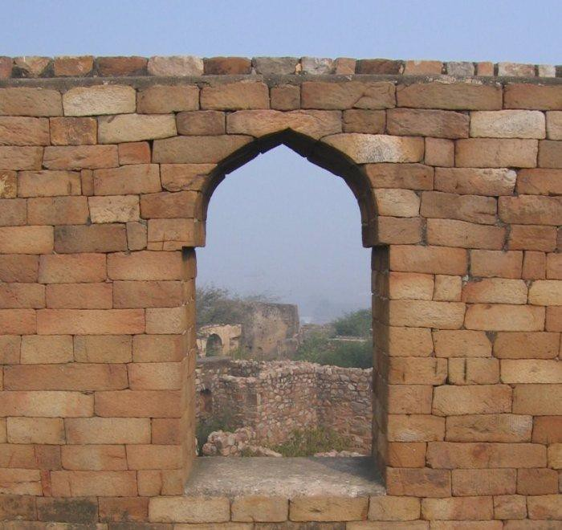

* Monuments provide an insight into the technologie used for construction.
* Between the 7th and 10th centuries architects started adding more rooms, doors and windows to buildings using “**trabeate**” or “**corbelled**” design.
* Corbelled: roofs, doors and windows were made by placing a horizontal beam across two vertical columns. From the 12th century onwards certain changes were visible .
* “**Arcuate**“ type design started to appear. Here the weight of the superstructure above doors and windows was carried by the arches . The “keystone” at the centre of the arch transferred the weight of the superstructure to the base of the arch.
* Limestone cement was increasingly used in construction. This was very high quality cement .

Building Temples, Tanks and Mosques

* Hindu rulers took gods’ name. Eg: Rajarajeshvara temple was built by King Rajarajadeva for the worship of his god, Rajarajeshvaram.
* Muslim Sultans and Padshahs did not claim to be incarnations of god but Persian court chronicles described the Sultan as the “Shadow of God”.
* Water availability: Sultan Iltutmish [13th century] won respect for constructing a large reservoir just outside Dehli-i kuhna. It was called the **hauz-i Sultani** or the “King’s Reservoir”.

Religious construction: Why were temples constructed and destructed?

* As each new dynasty came to power, kings/emperors wanted to emphasise their moral right to be rulers.
* So constructing places of worship provided rulers with the chance to proclaim their close relationship with God, especially important in an age of rapid political change.
* Because kings built temples to demonstrate their devotion to God and their power and wealth, it is not surprising that when they attacked one another’s kingdoms, they often targeted these buildings. (Eg: Pandyan king Shrimara Shrivallabha, Chola king Rajendra I, Sultan Mahmud of Ghazni etc.)

Gardens, Tombs and Forts

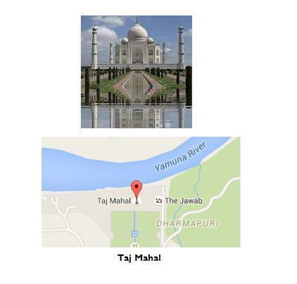

* Under the Mughals, architecture became more complex.
* During Babur reign formal gardens, placed within rectangular walled enclosures and divided into four quarters by artificial channels. These gardens were known as **chahar bagh,** four gardens.
* The central towering dome and the tall gateway (pishtaq) became important aspects of Mughal architecture, first visible in Humayun’s tomb.
* Associated with the chahar bagh there was tradition known as “eight paradises” or hasht bihisht – a central hall surrounded by eight rooms.
* During Shah Jahan’s reign that the different elements of Mughal architecture were fused together in a harmonious synthesis. The ceremonial halls of public and private audience (***diwan-i khas*** or***am***) were carefully planned. These courts were also described as ***chihil sutun*** or forty-pillared halls, placed within a large courtyard.
* Shah Jahan’s audience halls were specially constructed to resemble a mosque. The pedestal on which his throne was placed was frequently described as the **qibla**, the direction faced by Muslims at prayer.
* The connection between royal justice and the imperial court was emphasised by Shah Jahan in his newly constructed court in the Red Fort at Delhi.
* Court in Redfort by Shahjahan got a series of **pietra dura** [a Roman Art by inlaying of pieces of coloured stones resulting into some images] inlays that depicted the legendary Greek god Orpheus playing the lute[a string instrument]
* The construction of Shah Jahan’s audience hall aimed to communicate that the king’s justice would treat the high and the low as equals where all could live together in harmony.
* Shah Jahan adapted the river-front garden [a variation of chahar bagh] in the layout of the Taj Mahal.
* Only specially favoured nobles were given access to the river. All others had to construct their homes in the city away from the River Yamuna.

Region and Empire

* There was also a considerable sharing of ideas across regions: the traditions of one region were adopted by another. In Vijayanagara, for example, the elephant stables of the rulers were strongly influenced by the style of architecture found in the adjoining Sultanates of Bijapur and Golcunda.
* In Vrindavan, near Mathura, temples were constructed in architectural styles that were very similar to the Mughal palaces in Fatehpur Sikri.
* Mughal rulers were particularly skilled in adapting regional architectural styles in the construction of their own buildings.

Sample questions to think from UPSC Mains perspective

1. While studying history of India during Medieval period, it can be seen that most rulers spend considerable time and effort in building religious structures or buidlings. Critically analyse the social and political reasons behind.
2. Mughal rulers were particularly skilled in adapting regional architectural styles in the construction of their own buildings. Explain.

Sample questions to think from UPSC Prelims perspective

Qn: Among the following statements given below, identify the correct statements:

1. The central towering dome and the tall gateway (pishtaq) became first visible in Akbar’s tomb.
2. In case of corbelled design – roofs, doors and windows were made by placing a horizontal beam across two vertical columns.
3. In arcuate type design the weight of the superstructure above doors and windows was carried by the arches. Choice:

* A – 1 only
* B – 2 only
* C – 2 and 3 only
* D – All the above

**D- Modern India –**

**(1) Land Revenue Systems in British India: Zamindari, Ryotwari and Mahalwari** For UPSC, Land Revenue Systems in British India is always a hot topic for Prelims and Mains. And as per the new syllabus ‘land reforms in India’ is specifically mentioned for GS Mains, and the relevance just got multiplied. Now let’s have a quick look at the different methods of land revenue collection systems which existed in India.

**Land Revenue Systems Before British Rule :**

Tax from the land was a major source of revenue for the kings and emperors from ancient times. But the ownership pattern of land had witnessed changes over centuries. During Kingship, land was divided into Jagirs, Jagirs were alloted to **Jagirdars**, these Jagirdars split the land they got and allocated to sub- ordinate **Zamindars**. Zamindars made **peasants** cultivate the land, in-return collected part of their revenue as tax.

#### Land Revenue Systems in British India :

Three major systems of land revenue collection existed in India. They were – Zaminidari, Ryotwari and Mahalwari.

Zamindari System

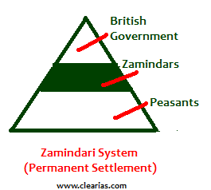

* Zamindari System was introduced by Cornwallis in 1793 through Permanent Settlement Act.
* It was introduced in provinces of Bengal, Bihar, Orissa and Varanasi.
* Also known as Permanent Settlement System.
* Zamindars were recognized as owner of the lands. Zamindars were given the rights to collect the rent from the peasants.
* The realized amount would be divided into 11 parts. 1/11 of the share belongs to Zamindars and 10/11 of the share belongs to East India Company.

Ryotwari System

* Ryotwari System was introduced by Thomas Munro in 1820.
* Major areas of introduction include Madras, Bombay, parts of Assam and Coorgh provinces of British India.
* In Ryotwari System the ownership rights were handed over to the peasants. British Government collected taxes directly from the peasants.
* The revenue rates of Ryotwari System were 50% where the lands were dry and 60% in irrigated land.

Mahalwari System

* Mahalwari system was introduced in 1833 during the period of William Bentick.
* It was introduced in Central Province, North-West Frontier, Agra, Punjab, Gangetic Valley, etc of British India.
* The Mahalwari system had many provisions of both the Zamindari System and Ryotwari System.
* In this system, the land was divided into Mahals. Each Mahal comprises one or more villages.
* Ownership rights were vested with the peasants.
* The villages committee was held responsible for collection of the taxes.

Land Reforms in India After Independence

**Zamindari Abolition Act** was passed by UP, Tamil Nadu, Bihar, Madhya Pradesh, etc. Surplus lands were confiscated from zamindars. Later **Land Ceilings Act** was passed by different states, fixing an upper limit for private land holdings of a family. [Land reforms in India](http://www.clearias.com/land-reforms-in-india/) is discussed in detail in the highlighted link.

# (2) Historical Background of Indian Constitution

Before 1947, India was divided into two main entities – The British India which consisted of 11 provinces and the Princely states ruled by Indian princes under subsidiary alliance policy. The two entities merged together to form the Indian Union, but many of the legacy systems in British India is followed even now. The historical underpinnings and evolution of the India Constitution can be traced to many regulations and acts passed before Indian Independence.

Indian System of Administration

Indian democracy is Parliamentary form of democracy where executive is responsible to the Parliament. The Parliament has two houses – Loksabha and Rajyasabha. Also the type of governance is Federal, ie there is separate executive and legislature at Center and States. We also have self governance at local government levels. All these systems owe their legacy to the British administration. Let us see the historical background of Indian Constitution and its development through years.

Regulating Act of 1773

* The first step taken by the British Parliament to control and regulate the affairs of the East India Company in India.
* It designated the **Governor** of Bengal (Fort William) as the **Governor-General (of Bengal).**
* Warren Hastings became the first Governor-General of Bengal.
* Executive Council of the Governor-General was established (Four members). There was no separate legislative council.
* It subordinated the Governors of Bombay and Madras to the Governor-General of Bengal.
* The Supreme Court was established at Fort William (Calcutta) as the Apex Court in 1774.
* It prohibited servants of the company from engaging in any private trade or accepting bribes from the natives.
* Court of Directors (governing body of the company) should report its revenue.

**Pitt’s India Act of 1784**

* Distinguished between commercial and political functions of the company.
* Court of Directors for Commercial functions and Board of Control for political affairs.
* Reduced the strength of the Governor General’s council to three members.
* Placed the Indian affairs under the direct control of the British Government.
* The companies territories in India were called “the British possession in India”.
* Governor’s councils were established in Madras and Bombay.

#### Charter Act of 1813

* The Company’s monopoly over Indian trade terminated; Trade with India open to all British subjects.

#### Charter Act of 1833

* **Governor-General (of Bengal)** became as the Governor-General of India.
* First Governor-General of India was Lord William Bentick.
* This was the final step towards centralization in the British India.
* Beginning of a Central legislature for India as the act also took away legislative powers of Bombay and Madras provinces.
* The Act ended the activities of the East India Company as a commercial body and it became a pure administrative body.

#### Charter Act of 1853

#### The legislative and executive functions of the Governor-General’s Council were separated.

* 6 members in Central legislative council. Four out of six members were appointed by the provisional governments of Madras, Bombay, Bengal and Agra.
* It introduced a system of open competition as the basis for the recruitment of civil servants of the Company (Indian Civil Service opened for all).

#### Government of India Act of 1858

* The rule of Company was replaced by the rule of the Crown in India.
* The powers of the British Crown were to be exercised by the Secretary of State for India
* He was assisted by the **Council of India**, having 15 members
* He was vested with complete authority and control over the Indian administration through the Vice roy as his agent
* The Governor-General was made the Viceroy of India.
* Lord Canning was the first Viceroy of India.
* Abolished Board of Control and Court of Directors.

#### Indian Councils Act of 1861

* It introduced for the first time Indian representation in the institutions like Viceroy’s executive+legislative council (non-official). **3 Indians entered Legislative council**.
* Legislative councils were established in Center and provinces.
* It provided that the Vice-roys Executive Council should have some Indians as the non-official members while transacting the legislative businesses.
* It accorded statutory recognition to the portfolio system.
* Initiated the process of decentralisation by restoring the legislative powers to the Bombay and the Madras Provinces.

#### India Council Act of 1892

* Introduced indirect elections (nomination).
* Enlarged the size of the legislative councils.
* Enlarged the functions of the Legislative Councils and gave them the power of discussing the Budget and addressing questions to the Executive.

#### Indian Councils Act of 1909

1. This Act is also known as the Morley- Minto Reforms.
2. Direct elections to legislative councils; first attempt at introducing a representative and popular element.
3. It changed the name of the Central Legislative Council to the Imperial Legislative Council.
4. The member of Central Legislative Council was increased to 60 from 16.
5. Introduced a system of communal representation for Muslims by accepting the concept of ‘separate electorate’.
6. **Indians for the first time in Viceroys executive council**. (Satyendra Prasad Sinha, as the law member)

#### Government of India Act of 1919

* This Act is also known as the Montague-Chelmsford Reforms.
* The Central subjects were demarcated and separated from those of the Provincial subjects.
* The scheme of dual governance, ‘Dyarchy’, was introduced in the Provincial subjects.
* Under dyarchy system, the provincial subjects were divided into two parts – transferred and reserved. On reserved subjects Governor was not responsible to the Legislative council.
* The Act introduced, for the first time, **bicameralism at center**.
* **Legislative Assembly** with 140 members and **Legislative council** with 60 members.
* Direct elections.
* The Act also required that the three of the six members of the Viceroy’s Executive Council (other than Commander-in-Chief) were to be Indians.
* Provided for the establishment of Public Service Commission.

#### Government of India Act of 1935

* The Act provided for the establishment of an All-India Federation consisting of the Provinces and the Princely States as units, though the envisaged federation never came into being.
* Three Lists : The Act divided the powers between the Centre and the units in items of three lists, namely the Federal List, the Provincial List and the Concurrent List.
* The Federal List for the Centre consisted of 59 items, the Provincial List for the provinces consisted of 54 items and the Concurrent List for both consisted of 36 items
* The residuary powers were vested with the Governor-General.
* The Act abolished the Dyarchy in the Provinces and introduced ‘Provincial Autonomy’.
* It provided for the adoption of Dyarchy at the Centre.
* Introduced bicameralism in 6 out of 11 Provinces.
* These six Provinces were Assam, Bengal, Bombay, Bihar, Madras and the United Province.
* Provided for the establishment of Federal Court.
* Abolished the Council of India.

#### Indian Independence Act of 1947

* It declared India as an Independent and Sovereign State.
* Established responsible Governments at both the Centre and the Provinces.
* Designated the Viceroy India and the provincial Governors as the Constitutional (normal heads).
* It assigned dual functions (Constituent and Legislative) to the Constituent Assembly and declared this dominion legislature as a sovereign body.

#### Points to be noted

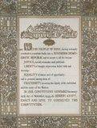

* Laws made before Charter Act of 1833 were called **Regulations** and those made after are called **Acts.**
* Lord Warren Hastings created the office of District Collector in 1772, but judicial powers were separated from District collector later by Cornwalis.
* From the powerful authorities of unchecked executives, the Indian administration developed into a responsible government answerable to the legislature and people.
* The development of portfolio system and budget points to the separation of power.
* Lord Mayo’s resolution on financial decentralization visualized the development of local self-government institutions in India (1870).
* 1882: Lord Ripon’s resolution was hailed as the ‘Magna Carta’ of local self government. He is regarded as the ‘Father of local self-government in India’.
* 1921: Railway Budget was separated from the General Budget.
* From 1773 to 1858, the British tried for the centralization of power. It was from the 1861 Councils act they shifted towards devolution of power with provinces.
* 1833 Charter act was the most important act before the act of 1909.
* Till 1947, the Government of India functioned under the provisions of the 1919 Act only. The provisions of 1935 Act relating to Federation and Dyarchy were never implemented.
* The Executive Council provided by the 1919 Act continued to advice the Viceroy till 1947. The modern executive (Council of Ministers) owes its legacy to the executive council.
* The Legislative Council and Assembly developed into Rajyasabha and Loksabha after independence.